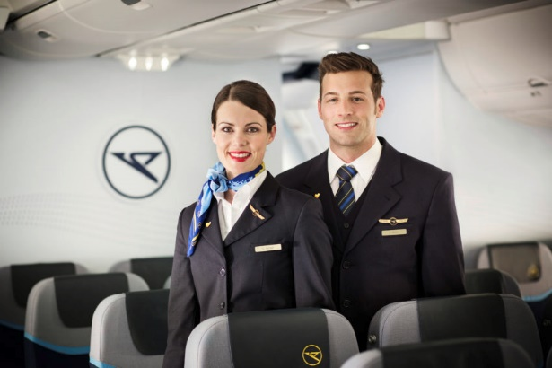
Job title: Cabin Crew

Job title: Cabin Crew | Air cabin crew help make sure that airline passengers have a comfortable, safe and pleasant flight.
Entry requirements: | You can get this job through:  - a college course  - an apprenticeship  - applying directly  You could do a college course like a Level 2 Certificate in Air Cabin Crew or study a cabin crew module as part of a broader travel and tourism course.  Entry requirements  You may need:  - GCSEs at grades 9 to 4 (A* to C) in English and maths  You could start by doing a cabin crew advanced apprenticeship.  This will usually take one year to complete. You'll do on-the-job training and spend time with a college or training provider.  Entry requirements  You'll usually need:  - 5 GCSEs at grades 9 to 4 (A* to C), usually including English and maths, for an advanced apprenticeship  You could apply directly to airlines for a cabin crew job. Entry requirements vary but good customer service skills will be expected.
Skills required: | You'll need:  - customer service skills for working with passengers  - excellent verbal communication skills  - patience and the ability to remain calm in stressful situations  - to enjoy working with other people  - knowledge of public safety and security  - the ability to accept criticism and work well under pressure  - sensitivity and understanding for dealing with customers’ needs  - a desire to help people and a friendly manner  - Being able to use a computer terminal or hand-held device may be beneficial for this job.
What you'll do: | Before a flight you could be:  - taking part in a meeting about the flight and its schedule  - checking that there are enough supplies on the plane and that emergency equipment is working properly  - greeting passengers  - demonstrating emergency equipment and procedures  During a flight you might be:  - making sure passengers are comfortable  - serving food and drinks, and selling duty-free items  - making announcements  - reassuring passengers in the event of an emergency, and making sure they follow safety procedures  At the end of a flight you'll often be:  - making sure passengers leave the plane safely  - writing a flight report, including details about any unusual incidents
What you’ll earn: | - Starter: £12,000  - Experienced: £30,000  These figures are a guide.
Working hours, patterns and environment: | - You could work on an aircraft.  - Your working environment may be physically demanding and cramped.  - You may need to wear a uniform.  - 30 to 40 hours a week  - Evenings, Weekends and Bank Holidays
Career path and progression: | With experience, you could progress to cabin crew supervisor or a senior air cabin crew role.  You could also work in a ground-based role like cabin crew training, recruitment, passenger services, marketing or sales.

