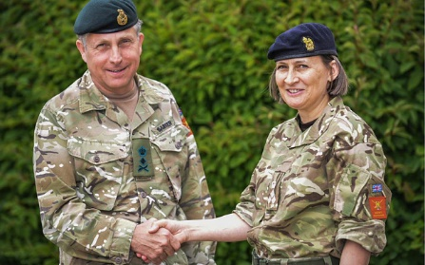
Job title: Army Officer
Job title: Army Officer | Army officers command, manage and motivate teams of soldiers.
Entry requirements: | You can do a degree course before you apply for officer training although it's not essential.  Entry requirements  You'll usually need:  - 2 to 3 A levels for a degree  You could work towards this role at college by doing a relevant subject like Level 2 or 3 Diploma in Public Services. This would teach you some of the skills and knowledge you need in this career.  Entry requirements  You'll usually need:  - 2 or more GCSEs at grades 9 to 3 (A* to D) for a level 2 course  - 4 or 5 GCSEs at grades 9 to 4 (A* to C) for a level 3 course  You can work towards this role by starting with an intermediate apprenticeship as a HM Forces Serviceperson.  You'll need to apply directly to the army to find the best apprenticeship route for you.  Entry requirements  To do this apprenticeship, you'll need:  - some GCSEs, usually including English and maths, for an intermediate apprenticeship
Skills required: | You'll need:  - leadership skills to manage and motivate soldiers  - excellent verbal communication skills  - thinking and reasoning skills for making quick decisions  - persistence and determination  - patience and the ability to remain calm in stressful situations  - concentration skills and fast reactions  - the ability to accept criticism and work well under pressure  - the ability to work well with others in a team  - to be able to use a computer and the main software packages competently  You'll need to:  - meet the British army nationality and residency rules  - pass a fitness test  - pass a full army medical  - pass security checks  - pass enhanced background checks
What you'll do: | You could work in a combat role as:  - an infantry platoon commander leading a team of trained soldiers on operations  - a helicopter pilot officer with responsibility for your crew and ground troops  - a tank troop officer in charge of men and their vehicles  - an artillery troop officer leading a team of soldiers  You might work in medicine and healthcare as:  - an adult nurse caring for injured soldiers  - a dental officer for army personnel and their families  - a veterinary officer working with military animals  You could also be:  - a logistic troop commander managing the supply of things like petrol and ammunition  - an engineering troop commander managing engineering projects  - an intelligence officer specialising in intelligence and security  - a military police officer managing military police soldiers  - a chaplain giving support and guidance to soldiers and their families
What you’ll earn: | - Starter: £26,504  - Experienced: £40,826  These figures are a guide.
Working hours, patterns and environment: | - You could work at a military base or in a warzone.  - Your working environment may be physically and emotionally demanding and outdoors in all weathers.  - You may need to wear a uniform and protective clothing.  - You will work a variable amount of hours, away from home, at any time.
Career path and progression: | - With training and experience, you could rise up through the ranks from lieutenant to captain, major, colonel and beyond.  - On leaving active service, you could use your skills, qualifications and experience to go into a new career, for example in management, planning or teaching. The Officers' Association gives advice and support to officers on finding a career outside the army.  - The Career Transition Partnership, Quest and Troops to Teachers also have more information on career options outside the armed forces.

