School covid testing - reporting a lateral flow test result

What is this for? This guide shows school staff, students, households and support or childcare bubbles how to report the covid-19 lateral flow test result so that it is linked with the school.

Why does this matter? This helps Lancashire County Council to provide the Covid-19 support needed to keep our schools safe and open.

- On your phone, tablet or computer, go to: https://www.gov.uk/report-covid19-result
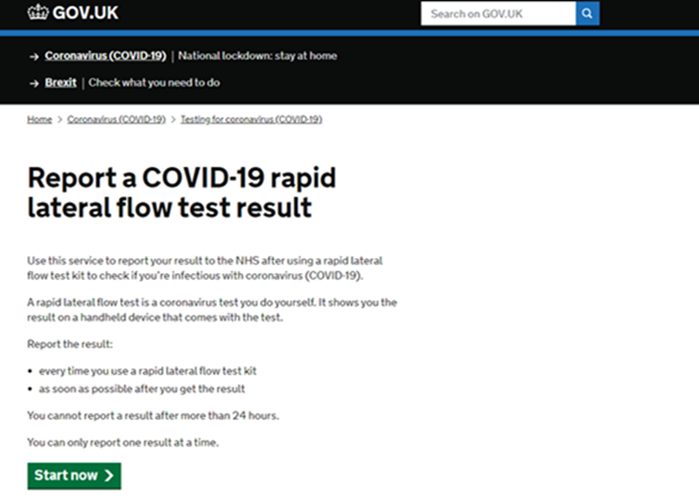

- Fill in whether you are reporting your own test result or someone else's.
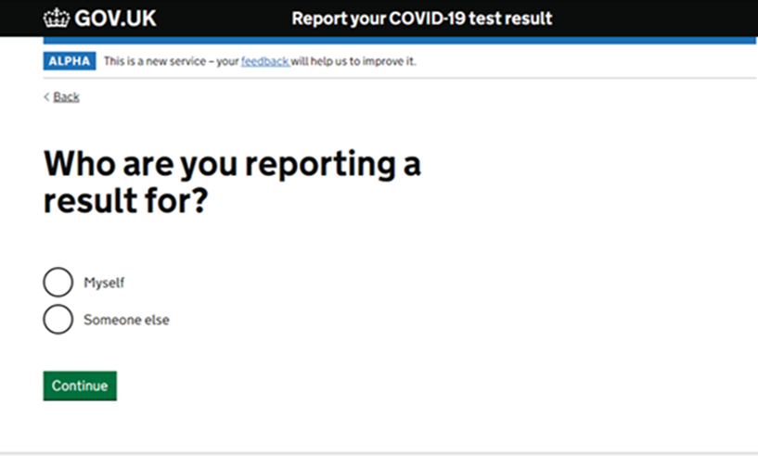

- Either set up an account, sign in or submit the test result without an account.
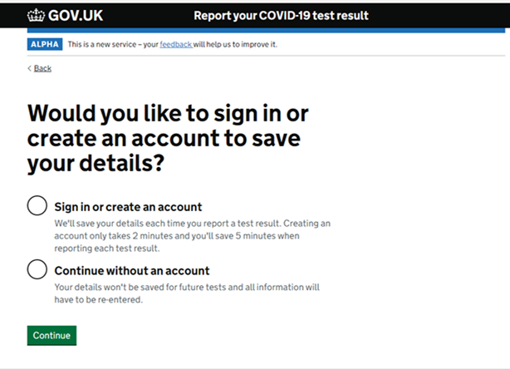

- Choose "A school (including nursery), college or other educational provider"
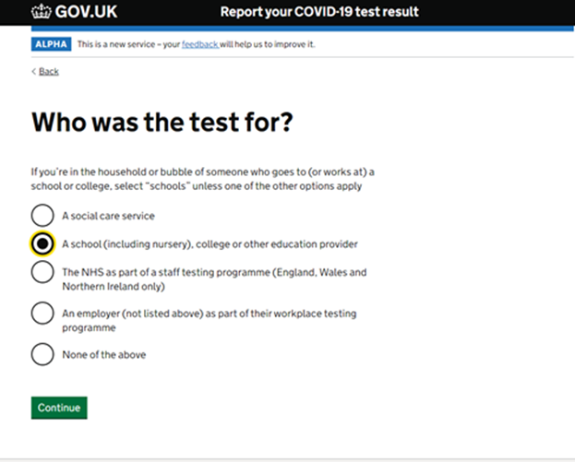

- Choose the option for you or the person whose test result is being reported.
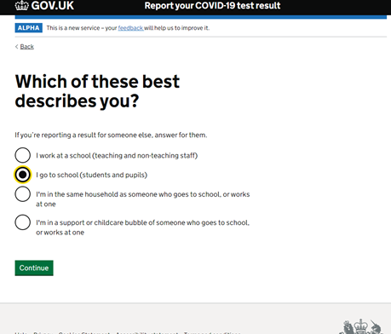
- Search by the name or postcode of the school and choose your school.
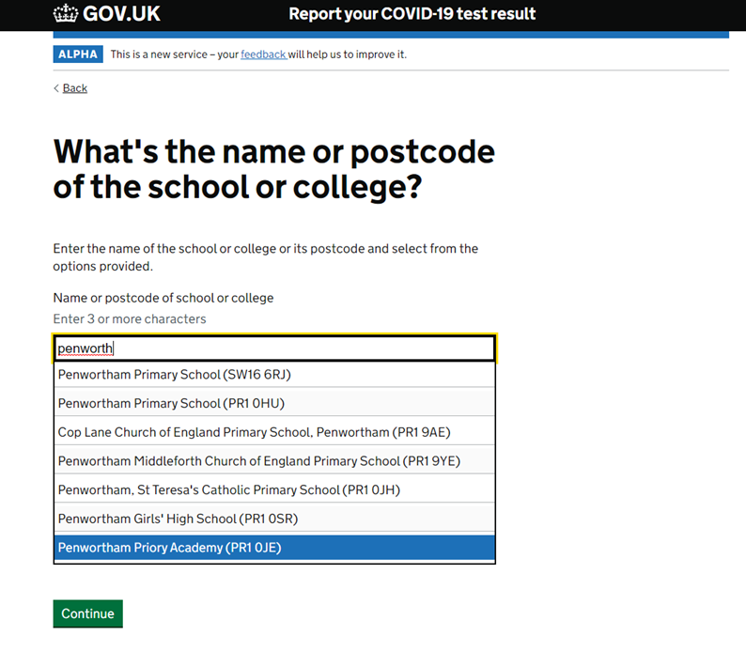

- Complete the rest of the form including when the test was taken, the test strip number and personal details (if you didn't set up an account). These steps are not shown.

- Fill in the result of the test
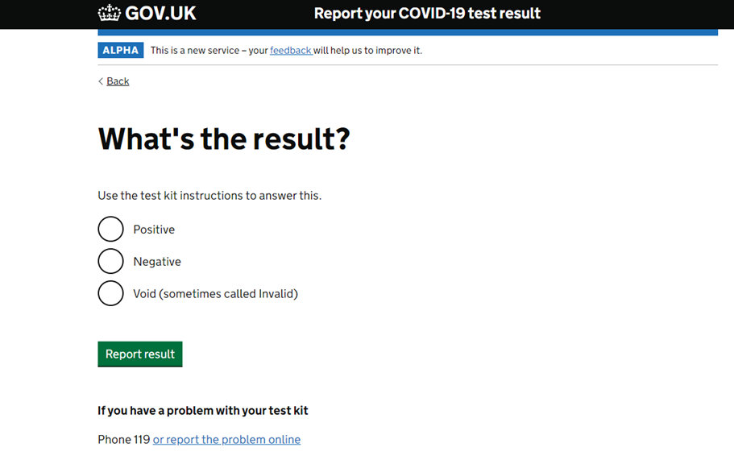
- Check your answers
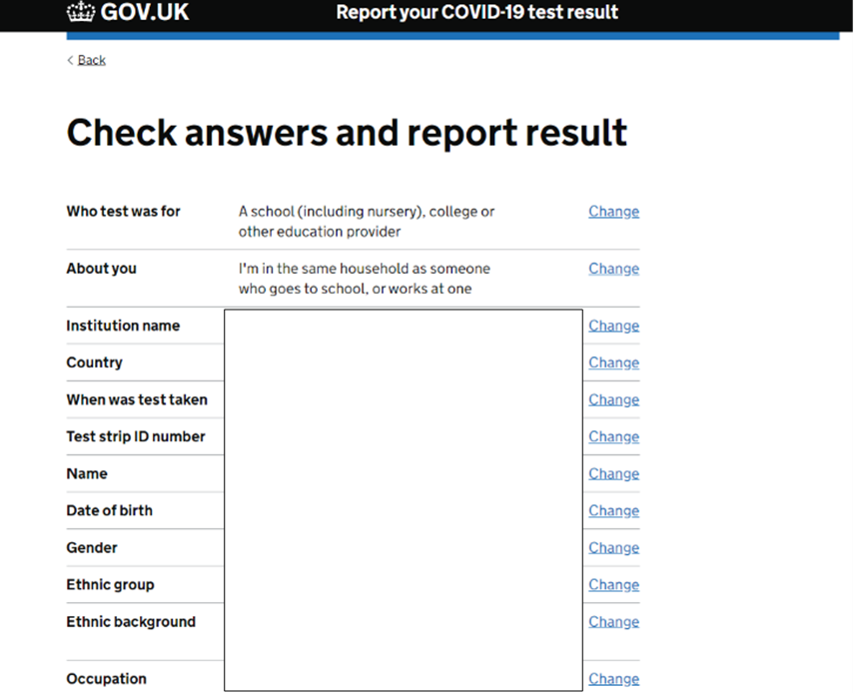
- Complete security check and submit result.
