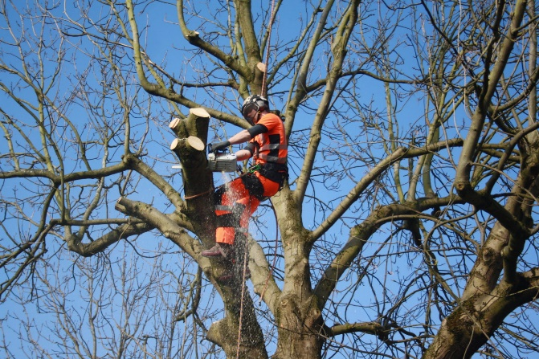
Job title: Arboriculture Officer

Job title: Tree Officer | Arboricultural officers maintain and manage trees for local councils or arboricultural contractors.
Entry requirements: | You can get into this job through:  University - It may help if you have a foundation degree, higher national diploma or degree in a relevant subject, like:  - forestry  - arboriculture  - countryside management  - forest management  - woodland ecology and conservation  Entry requirements  You'll usually need:  - 1 or 2 A levels for a foundation degree or higher national diploma  - 2 to 3 A levels for a degree  College - You could do a college course, which would teach you some of the skills and knowledge you need in this job. Relevant subjects include:  - Level 2 Diploma in Work-based Trees and Timber  - Level 3 Diploma in Work-based Trees and Timber  Entry requirements  You'll usually need:  - 2 or more GCSEs at grades 9 to 3 (A* to D) for a level 2 course  - 4 or 5 GCSEs at grades 9 to 4 (A* to C) for a level 3 course
Skills required: | You'll need:  - knowledge of geography  - the ability to use your initiative  - to be thorough and pay attention to detail  - the ability to work well with others  - ambition and a desire to succeed  - administration skills  - knowledge of teaching and the ability to design courses  - knowledge of maths  - to be able to use a computer and the main software packages competently
What you'll do: | Your day-to-day tasks may include:  - advising on planning applications, to take account of tree protection laws  - managing trees in parks, open areas and at the side of roads, organising tree surveys, recording tree locations  - planning tree planting schemes  - supervising tree care and tree planting contracts with site visits  - giving demonstrations and talks on arboriculture and woodlands to schools and other community groups  - training junior colleagues and volunteers
What you’ll earn: | - Starter: £22,000  - Experienced: £35,000  These figures are a guide.
Working hours, patterns and environment: | - You could work in woods, forests or gardens or in an office.  - Your working environment may be at height and outdoors in all weathers.  - 41 to 43 hours a week – evenings and weekends occasionally
Career path and progression: | - You could become self-employed.  - With qualifications you could teach as a lecturer at a college or university.

