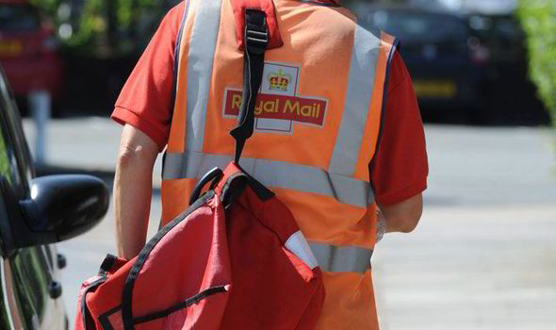
Job title: Postman or Postwoman
Job title: postman or postwoman | Postmen and postwomen sort letters and packages for delivery to homes and businesses.
Entry requirements: | You could do an express delivery operative intermediate apprenticeship, if you want to work as a delivery driver.  Entry requirements  You'll usually need:  - some GCSEs, usually including English and maths, for an intermediate apprenticeship  You can apply directly for delivery work. You don't need any specific qualifications, but your interview will usually include aptitude tests. These are to check that you can read addresses correctly and recognise misaddressed mail.  Royal Mail often recruits temporary staff for the Christmas period from September each year. This can be a useful way for you to get some experience and apply for permanent jobs as they come up.
Skills required: | You'll need:  - customer service skills  - to be thorough and pay attention to detail  - the ability to work on your own  - patience and the ability to remain calm in stressful situations  - the ability to accept criticism and work well under pressure  - the ability to work well with others  - excellent verbal communication skills  - knowledge of English language  - to be able to carry out basic tasks on a computer or hand-held device
What you'll do: | Your day-to-day duties may include:  - sorting mail on a sorting frame, getting it into address order  - operating automated equipment  - delivering mail on foot, by a bicycle or by van  - getting customer signatures for registered post and recorded deliveries  - picking up mail from post boxes, post offices and businesses  - dealing with wrongly addressed or returned mail  - moving mail to and from processing centres, delivery offices, railway stations and airports
What you’ll earn: | - Starter: £13,500  - Experienced: £25,000  These figures are a guide.
Working hours, patterns and environment: | - You could work from a vehicle or on the road.  - 41 to 43 hours a week, early mornings.
Career path and progression: | With experience, you could be promoted to higher grades like supervisor and manager. You could move into parcel deliveries, courier jobs or customer care and administration.

