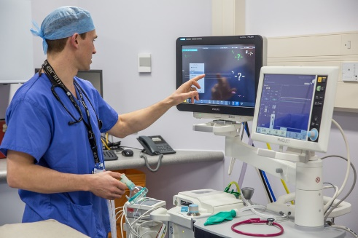
Job title: Aerospace Engineer

Job title: Aerospace Engineer | Aerospace engineers design, build and maintain planes, spacecraft and satellites
Entry requirements: | You can do a foundation degree, higher national diploma or degree in aerospace engineering, avionics, or a related subject like:  - electrical or electronic engineering  - mechanical engineering  - manufacturing or product engineering  - physics or applied physics  - software engineering or mathematics  Entry requirements  You'll usually need:  - 1 or 2 A levels for a foundation degree or higher national diploma  - 2 or 3 A levels, including maths for a degree  You can do a higher national certificate (HNC) or diploma (HND) in engineering before applying for a job with an aerospace company. Subjects include:  - Level 4 HNC Diploma in Mechanical Engineering  - Level 5 HND Diploma in Aeronautical Engineering  - Level 5 HND Diploma in Electrical Engineering  Entry requirements  You may need:  - 1 or 2 A levels, a level 3 diploma or relevant experience for a level 4 or level 5 course  You can do a degree apprenticeship as an aerospace engineer.  Entry requirements  You'll usually need:  - 4 or 5 GCSEs at grades 9 to 4 (A* to C) and college qualifications like A levels for a higher or a degree apprenticeship
Skills required: | You'll need:  - knowledge of engineering science and technology  - maths knowledge  - design skills and knowledge  - to be thorough and pay attention to detail  - excellent verbal communication skills  - science skills  - analytical thinking skills  - the ability to read English  - you will be expected to use a computer confidently as part of this job.
What you'll do: | Your day-to-day duties will depend on your role but may include:  - developing navigation, communications or weapons systems  - researching ways to make fuel-efficient parts, such as wings, fuselage and engines  - using CAD software for design  - testing prototypes  - collecting and analysing test data  - planning and supervising the fitting of aircraft and components  - signing off projects under strict industry regulations  - scheduling and supervising maintenance
What you’ll earn: | - Starter: £20,000  - Experienced: £60,000  These figures are a guide.
Working hours, patterns and environment: | - You could work on an aircraft, at a client's business, in a factory or in an office.  - Your working environment may be cramped.  - 39 to 41 hours a week – evenings and weekends occasionally
Career path and progression: | With experience, you could specialise in a particular field like:  - aerodynamics  - fuel efficiency  - space technology  - investigating air accidents  - You could also move up to become a project manager or consultant aerospace engineer.

