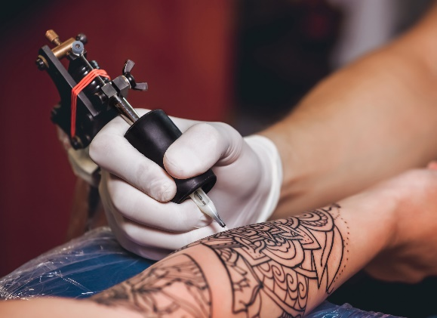
Job title: Tattooist
Job title: Tattooist | Tattooists create permanent artwork on their clients' bodies.
Entry requirements: | You could start as an assistant by finding a tattooist who is willing to take you on and train you.  It may be possible to work as a customer service assistant in a larger studio, answering enquiries and booking appointments. From there, you could become a trainee as opportunities come up.  You'll need:  - an interest in tattooing  - artistic ability  - a portfolio of your artwork and design ideas to showcase your talents  Career tips  Many tattooists have experience or qualifications in art and design.
Skills required: | You'll need:  - design skills and knowledge  - the ability to work well with your hands  - concentration skills  - excellent verbal communication skills  - to be thorough and pay attention to detail  - the ability to accept criticism and work well under pressure  - to be flexible and open to change  - the ability to use your initiative  - to be able to use a computer and the main software packages competently
What you'll do: | Your day-to-day duties might include:  - advising clients on suitable tattoos  - making sure the chosen design is exactly what the client wants  - checking that clients understand that the tattoo is permanent  - copying the chosen design onto the customer’s skin, either by drawing freehand or using a transfer  - following the design lines with an electrically-operated needle, which injects ink under the skin  - making sure all equipment is sterilised and clean, and following strict hygiene and health and safety procedures
What you’ll earn: | Variable Salary
Working hours, patterns and environment: | - You could work in a studio.  - You may need to wear protective clothing.  - 30 to 4o hours a week, days, evenings and weekends
Career path and progression: | You could open your own tattoo studio.

