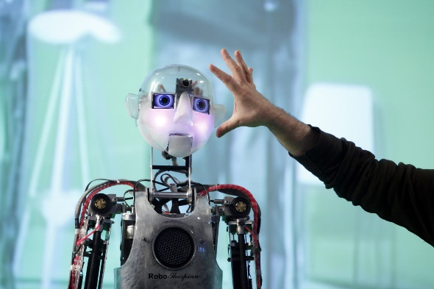
Job title: Robotics Engineer
Job title: Robotics Engineer | Robotics engineers design and build machines to do automated jobs in industries like manufacturing, aerospace and medicine.
Entry requirements: | You can do a degree or postgraduate qualification in:  - artificial intelligence and robotics  - mechatronics  - robotics engineering  - mechanical engineering  - electronics engineering  - computer science  - mathematics  You can also work in the development of artificial intelligence if you have a qualification in psychology or cognitive science.  Entry requirements  You'll usually need:  - 2 or 3 A levels, including maths and physics  - a degree in a relevant subject for postgraduate study  You can do a college course, which may help you to find a job as a robotics technician. Relevant courses include:  - Level 3 Certificate in Robotics and Automation  - Level 4 Diploma in Computing  - Higher National Certificate in Electrical or Electronic Engineering  - With further training, you can qualify as an engineer.  Entry requirements  You'll usually need:  - 4 or 5 GCSEs at grades 9 to 4 (A* to C) for a level 3 course  - 1 or 2 A levels, a level 3 diploma or relevant experience for a level 4 or level 5 course  You could do a degree apprenticeship in a robotics specialism. Apprenticeship examples include:  - control and technical support engineering  - software development  - manufacturing engineering  - embedded electronic systems design  Entry requirements  You'll usually need:  - 4 or 5 GCSEs at grades 9 to 4 (A* to C) and college qualifications like A levels for a degree apprenticeship
Skills required: | You'll need:  - knowledge of engineering science and technology  - knowledge of computer operating systems, hardware and software  - maths knowledge  - design skills and knowledge  - excellent verbal communication skills  - the ability to use, repair and maintain machines and tools  - thinking and reasoning skills  - complex problem-solving skills  - to be able to use a computer and the main software packages confidently
What you'll do: | Your exact duties will depend on what part of a project you work on but may include:  - understanding what customers want to automate  - designing processes and parts using computer aided design  - building and testing prototypes  - analysing data from robot sensors and cameras  - finding and fixing faults  - researching news ways to use robots and artificial intelligence  - demonstrating finished products to customers
What you’ll earn: | - Starter: £27,500  - Experienced: £55,500  These figures are a guide.
Working hours, patterns and environment: | - 37 to 40 hours a week, usually 9am to 5pm.
Career path and progression: | - You could become a lead engineer, with overall responsibility for managing a project.  - You could also specialise in a particular area of robotics, for example self-driving vehicles, space exploration, surgical instruments or deep ocean research.

