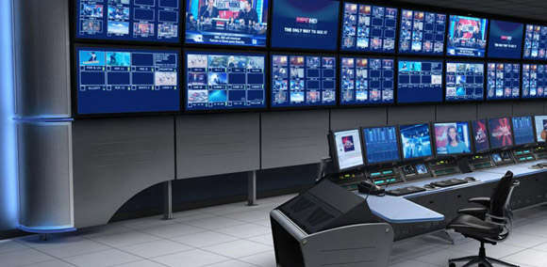
Job title: Broadcast Engineer

Job title: Broadcast Engineer | Broadcast engineers make sure television, radio and online programmes are broadcast at the right times and are high quality.
Entry requirements: | You can get into this job through:  University - You'll need a degree to apply for a graduate training schemes. Useful subjects include:  - broadcast engineering  - broadcast technology  - electronics  - physics  - computer science  Entry requirements  You'll usually need:  - 5 GCSEs at grade 4 (C) or above, including English and maths  - 2 to 3 A levels for a degree  - You can get started by doing a degree apprenticeship as a broadcast and media systems engineer.  Apprenticeship - This apprenticeship is a recognised qualification for Professional Registration with the Engineering Council at either ICT Technician (ICTTech) or Engineering Technician (EngTech) level.  Entry requirements  You'll usually need:  - 5 GCSEs at grades 9 to 4 (A* to C) including English and maths and science  - 2 A levels including maths or science  Or you can start on an in-house engineering training scheme like the BBC's degree apprenticeship.
Skills required: | You'll need:  - to be thorough and pay attention to detail  - knowledge of computer operating systems, hardware and software  - the ability to work well with others  - broadcasting and telecommunications knowledge  - the ability to accept criticism and work well under pressure  - to be flexible and open to change  - ambition and a desire to succeed  - knowledge of media production and communication  - being able to use a computer terminal or hand-held device may be beneficial for this job.
What you'll do: | Your duties could include:  - setting up studio equipment for transmission and editing  - designing and setting up audio and video circuits  - installing multimedia hardware, software and other digital broadcast technology systems  - setting up and operating links between studios and OB units  - editing programmes live as they’re being transmitted or recorded  - testing and servicing equipment  - finding and repairing technical faults
What you’ll earn: | - Starter: £20,000  - Experienced: £50,000  These figures are a guide.
Working hours, patterns and environment: | - You could work at a tv studio, at a film studio or in a workshop.  - Your working environment may be you'll travel often and outdoors in all weathers.  - 40 to 44 hours a week – evenings and weekends occasionally
Career path and progression: | - With experience, you could move into management.  - You could also work freelance.

