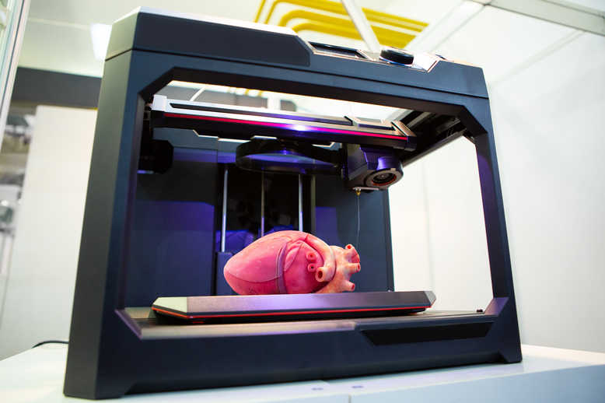
Job title: 3D Printing Technician
Job title: | 3D printing technicians manufacture products, including biomedical implants, car parts, aerospace components and fashion accessories.
Routes and Entry requirements: | University  You could do a foundation degree, higher national diploma or a degree in a relevant subject like:  - 3D design  - product design  - engineering  - materials science  You'll usually need:  - 1 or 2 A levels, or equivalent, for a foundation degree or higher national diploma  - 2 to 3 A levels, or equivalent, for a degree  College  You could take a course in creative design, model making or engineering. This could help you to find a job with a manufacturing or 3D printing company. Courses include:  - Level 2 Certificate in Computer-Aided Design and Manufacturing  - Level 3 Certificate in 3D Design  - Level 3 Diploma in Engineering Technology  - T level in Digital Production, Design and Development  You may need:  - 4 or 5 GCSEs at grades 9 to 4 (A* to C), or equivalent, including English, maths and computing  - 4 or 5 GCSEs at grades 9 to 4 (A* to C), or equivalent, including English and maths for a T level  Apprenticeship  You could do an advanced apprenticeship in digital engineering.  You'll usually need:  - 5 GCSEs at grades 9 to 4 (A* to C), or equivalent, including English and maths, for an advanced apprenticeship  Work  You may be able to start as an assistant in a 3D print workshop and take training on the job to become a technician. Skills and qualifications in model making, printing, technology or design will be useful.
Skills required: | You'll need:  - knowledge of manufacturing production and processes  - knowledge of engineering science and technology  - the ability to operate and control equipment  - to be thorough and pay attention to detail  - analytical thinking skills  - the ability to work well with others  - knowledge of maths  - the ability to analyse quality or performance  - to be able to use a computer and the main software packages confidently
What you'll do: | Your day-to-day duties may include:  - taking customer orders and giving job quotes  - advising customers on which materials to use  - creating digital models and prototypes based on customer requirements  - operating 3D scanning and printing machinery  - applying finishes to products  - checking quality  - servicing and repairing equipment
What you’ll earn: | £18,000 Starter to £33,000 Experienced
Working hours, patterns and environment: | - Typical hours 37 to 42 a week  - You could work between 8am and 6pm on a rota  - You could work at a manufacturing plant, in a factory or at a research facility.  - Your working environment may be noisy.  - You may need to wear safety clothing and use safety equipment.
Career path and progression: | You could move into research, investigating new materials for use in 3D printing and how to make them commercially workable. You could also train to work in 3D printing software and hardware development.  You might work for a company that specialises in printing particular items, for example custom-made prosthetics, construction prototypes, or models of archaeological remains and historical buildings.  There are also opportunities in print equipment sales and training.

