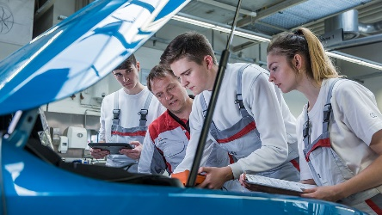
Shift Technician (mechatronics) Apprentice
Perspex

An exciting opportunity has become available for a committed and ambitious individual to begin their apprenticeship and training path to become a Shift Technician.

Apprenticeship summary

- Weekly wage - £153.55
- Working week - To be confirmed at Interview - Total hours per week: 37.00
- Expected duration - 4 years
- Apprenticeship level – Advanced - Level 3 (A level)

Your role will involve:
- Providing engineering support to ensure the fault free and safe operation of the plant
- Assisting in the installation, maintenance, testing and repair of equipment and machinery
- Identifying areas for improvement in relation to efficiencies and cost effectiveness
- Attending regular external training and implementing what has been learnt within the job role
- Committing to your personal development by embracing all in-house and external training provided
- What are we expecting?
- Full commitment whilst at external training sessions and on-the-job
- A pro-active and positive attitude to your own learning and development
- Experience of a manufacturing and/or engineering environment
- Strong understanding and compliance to all Health and Safety procedures
- GCSE passes in five or more subjects including Maths and Science
- To successfully complete each academic year within the apprenticeship

During the 4 year apprenticeship programme, you will be taught by professional and knowledgeable external trainers, whilst also being provided with support and mentoring from experienced Perspex employees. This is a great pathway for an individual to take that has a genuine interest and ambition to begin an Engineering career.

Requirements and prospects

Desired skills
- Problem solving
- Accuracy
- Ability to use differing tools and equipment

Personal qualities
- Must possess an interest in Engineering
- Good timekeeping and attendance

Desired qualifications
- Minimum of 5 GCSEs grade C or above including English, maths. Science and Technology is desirable. Other equivalent qualifications are acceptable

Future prospects

Engineers work in high-tech, dynamic environments using state of the art equipment. They are inventors, designers and problem solvers, people who make a difference to the way we live. As trained professionals, engineers are well paid and highly respected. Many get top jobs and even run their own companies. If you enjoy working as part of a team, like solving problems and have a practical flair, you will find engineering has a lot to offer.

Things to consider

Please do not contact Company direct. PLEASE NOTE; we reserve the right to close any vacancies from further applications when we have received a suitable number of applications from which to make a shortlist. Please ensure you apply ASAP if you wish to be considered for this role.

About the employer
Perspex International is a global leader in the design, development and manufacture of acrylic-based products.

Employer – Perspex - https://www.perspex.com/ Orchard Mill Duckworth Street, Darwen BB3 1AT

Training provider - TRAINING 2000 LIMITED
Applications for this apprenticeship are being processed by Training 2000 Ltd
Contact - Christopher Cumpstey 01254 54659
- L2 Diploma in Advanced Manufacturing (Foundation Competence)
- L3 Diploma in Advanced Manufacturing Engineering (Development Competencies) Mechatronics Maintenance Technician
- L3 Diploma or Extended Diploma in Advanced Manufacturing Engineering (Development Knowledge)

Apprenticeship standard - Engineering Technician - Level 3 (A level)

