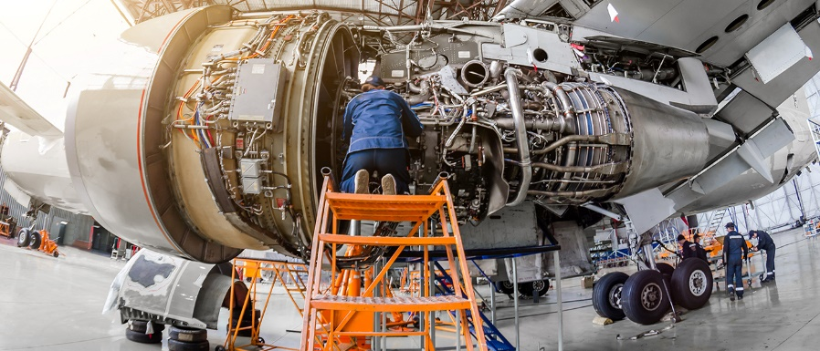
Job title: Aerospace Engineer
Job title:  (Also known as an Aeronautical engineer) | Aerospace engineers design, build and maintain planes, spacecraft and satellites.
Routes and  Entry requirements: | University  You can do a foundation degree, higher national diploma or degree in aerospace engineering, avionics, or a related subject like:  - electrical or electronic engineering  - mechanical engineering  - manufacturing or product engineering  - physics or applied physics  - software engineering or mathematics  You'll usually need:  - 1 or 2 A levels, or equivalent, for a foundation degree or higher national diploma  - 2 or 3 A levels, or equivalent, including maths  College  You can do a higher national certificate (HNC) or diploma (HND) in engineering before applying for a job with an aerospace company. Subjects include:  - Level 4 HNC Diploma in Mechanical Engineering  - Level 5 HND Diploma in Aeronautical Engineering  - Level 5 HND Diploma in Electrical Engineering  You may need:  - 1 or 2 A levels, a level 3 diploma or relevant experience for a level 4 or level 5 course  Apprenticeship  You can do a degree apprenticeship as an aerospace engineer.  You'll usually need:  - 4 or 5 GCSEs at grades 9 to 4 (A* to C) and A levels, or equivalent, for a higher or degree apprenticeship  Work  You can join a company as an engineering technician and do training on the job to qualify as an engineer.  Direct application  You can apply for jobs directly if you've got qualifications and experience, for example from working in electrical or electronics engineering.
Skills required: | You'll need:  - knowledge of engineering science and technology  - maths knowledge  - design skills and knowledge  - to be thorough and pay attention to detail  - excellent verbal communication skills  - science skills  - analytical thinking skills  - the ability to read English  - to be able to use a computer and the main software packages competently
What you'll do: | Your day-to-day duties will depend on your role but may include:  - developing navigation, communications or weapons systems  - researching ways to make fuel-efficient parts, such as wings, fuselage and engines  - using CAD software for design  - testing prototypes  - collecting and analysing test data  - planning and supervising the fitting of aircraft and components  - signing off projects under strict industry regulations  - scheduling and supervising maintenance
What you’ll earn: | £20,000 Starter to £60,000 Experienced
Working hours, patterns and environment: | - Typical hours 39 to 41 a week  - You could work evenings / weekends occasionally  - You could work in an aircraft hangar, on an aircraft, at a client's business, in a factory or in an office.  - Your working environment may be cramped.
Career path and progression: | With experience, you could specialise in a particular field like:  - aerodynamics  - fuel efficiency  - space technology  - investigating air accidents  You could also move up to become a project manager or consultant aerospace engineer

