Topic: The American Dream

Books
Audiobooks are highlighted
Title | Author | Where | Description | Image | Dewey/Classification
United States of America | Hurley, Michael | School Library | This book briefly examines the history, people, and environment of the United States of America. | 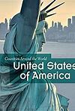 | 917.3
U.S.A. | Zenfell, M E | School Library | This is an illustrated recent survey on the USA which is part of a new series on countries around the world. The book provides essential background information about the States - their location, geography and climate, the history of the people, their customs, traditions and religions |  | 917.3
Americas, The | Lye, K | School Library | North America, South and Antarctica: History, Wealth, Languages, Ways of life, Religion, Ethnic groups, Land and Climate. | 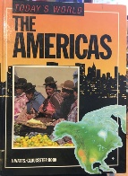 | 910  091
North America (Illustrated Atlas) | Porter, Malcolm  & Lye, K. | School Library | (Illustrated Atlas)  Maps, flags, data, diagrams and illustrations |  | 912
Of Mice & Men | John Steinbeck | Lancashire Libraries  https://fe.bolindadigital.com/wldcs_bol_fo/b2i/productDetail.html?productId=PRU_191667&fromPage=1&b2bSite=5070 | Streetwise George and his big, childlike friend Lennie are drifters, searching for work in the fields and valleys of California | 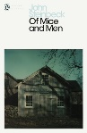 | Fiction
The Grapes of Wrath | John Steinbeck | Lancashire Libraries  https://fe.bolindadigital.com/wldcs_bol_fo/b2i/productDetail.html?productId=PRH_772119&fromPage=1&b2bSite=5070 | Set against the backdrop of America's Great Depression and Dust Bowl, a family of farmers from Oklahoma head west in search of work, only to discover thousands like them are also on the move |  | Fiction
An American  Dream | Norman Mailer | Lancashire Libraries  https://fe.bolindadigital.com/wldcs_bol_fo/b2i/productDetail.html?productId=PRU_592978&fromPage=1&b2bSite=5070 | Mailer peels away the layers of our social norms to reveal a world of pure appetite and relentless cruelty. An American Dream grabs the reader by the throat and refuses to let go. | 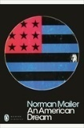 | Fiction
Classic Stories of the American West | Bret Harte, Stephen Crane and Jack London | Blackburn Libraries  https://fe.bolindadigital.com/wldcs_bol_fo/b2i/productDetail.html?productId=BSA_652335&fromPage=1&b2bSite=5614 | This collection features a selection of classic short stories and poems by legendary Western authors Stephen Crane, Bret Harte, and Jack London. | 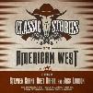 | Fiction
Third World America | Huffington, Arianna | Blackburn Libraries  https://fe.bolindadigital.com/wldcs_bol_fo/b2i/productDetail.html?productId=HCP_043733&fromPage=1&b2bSite=5614 | It’s the dark flipside of the American Dream – an American Nightmare of their own making. |  | No-Fiction  Politics & Current Affairs, Business
America the Philosophical | Romano Carlin | Blackburn Libraries  https://fe.bolindadigital.com/wldcs_bol_fo/b2i/productDetail.html?productId=RHC_363781&fromPage=1&b2bSite=5614 | A bold, insightful book that rejects the myth of America the Unphilosophical, arguing that America today towers as the most philosophical culture in the history of the world, an unprecedented marketplace of truth and argument that far surpasses ancient Greece or any other place one can name.
Made In America | Bryson, Bill | Blackburn Libraries  https://fe.bolindadigital.com/wldcs_bol_fo/b2i/productDetail.html?productId=RDH_091942&fromPage=1&b2bSite=5614 | Bill Bryson being very funny about his native land.  An Informal History of the English Language in the United States | 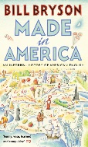 | Comedy, Lifestyle - Travel > Travel Writing
Made In America | Bryson, Bill | Lancashire Libraries  https://fe.bolindadigital.com/wldcs_bol_fo/b2i/productDetail.html?productId=BOL_102587&fromPage=1&b2bSite=5070 | An informed and fond look at the history of Americans through their popular culture and language. | 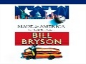
Fear and loathing in Las Vegas | Thompson, Hunter. S | Lancashire Libraries  https://fe.bolindadigital.com/wldcs_bol_fo/b2i/search.html?b2bSite=5070&searchBy=ALL&q=Fear+and+loathing+in+las+vegas | Hunter S. Thompson is roaring down the desert highway to Las Vegas with his attorney, the Samoan, to find the dark side of the American Dream | 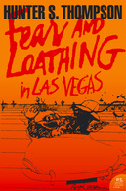
The Audacity of Hope | Obama, B. | Blackburn Libraries  https://fe.bolindadigital.com/wldcs_bol_fo/b2i/productDetail.html?productId=PUA_380235&fromPage=1&b2bSite=5614 |  | 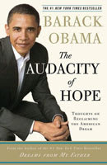
Invisible Man | Ellison, R | Blackburn Libraries  https://fe.bolindadigital.com/wldcs_bol_fo/b2i/productDetail.html?productId=PUA_371139&fromPage=1&b2bSite=5614 | Published prior to the Civil Rights Movement, Invisible Man brutally deconstructed The American Dream as exclusive only to white men, and mostly rich ones at that. | 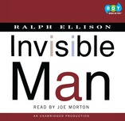

Film/Documentary

BBC Videos
Documentary - The Origins of the American Dream
https://www.bbc.co.uk/sounds/play/p053t5sl

Susie Dent of Countdown fame – explores Americanisms in British English – should we love not loathe?
https://www.bbc.co.uk/sounds/play/b08qxd02

Noam Chomsky – Noam Chomsky talked about his book Requiem for the American Dream: The 10 Principles of Concentration of Wealth and Power, in which he takes a critical look at income inequality and concentrated wealth in the United States today. He was interviewed by Amy Goodman.
https://www.c-span.org/video/?427191-1/noam-chomsky-discusses-requiem-american-dream

Book link about books
https://www.bestcollegesonline.com/blog/20-best-books-about-the-american-dream/

