Apprentice Aluminium Fabricator - Architectural Glazing and Facades Ltd
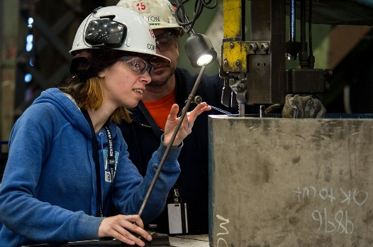
Apprenticeship summary
- Weekly wage - £200.00
- Working week - Monday - Thursday: 7:30am - 4:30pm, Friday: 7:30am - 1:30pm, 30 minutes lunch, 2x 15 minutes break - Total hours per week: 40.00
- Expected duration - 18 months
- Apprenticeship level - Intermediate
- Reference number - VAC001556851
Duties/responsibilities to include:
- Learning the construction of aluminium windows, doors, and curtain walling
- Adhering to health and safety regulations
- Keeping work area clean and tidy

Requirements and prospects
Desired skills
- Must have good practical ability and a good knowledge of Health & Safety
Personal qualities
- Keen and willing to learn
- Punctual and reliable
- Work well as part of a team and on own initiative
- Have an interest in this type of work
- Good practical skills
Future prospects
Progression into full time employment.

About the employer
Architectural Glazing & Facades Ltd is an innovative company whose team has over 35 years experience in the commercial and bespoke residential glazing industries. Please browse our site to find out more About Us, explore our Projects and Products and get in Contact if there’s anything we can do to assist.
Employer
Architectural Glazing and Facades Ltd
http://www.agfltd.co.uk/
Address - Unit 27 Higher Walton Mill, Cann Bridge Street, Preston, PR5 4DJ

Training provider
NORTH LANCS. TRAINING GROUP LIMITED(THE)
Applications for this apprenticeship are being processed by North Lancs Training Group Ltd
Contact - North Lancs Training Group 01254 395 355 recruitment@nltg.co.uk
- Training to be provided - Intermediate level 2 Apprenticeship in Glass Occupations, including NVQ and functional skills maths and English. Work based learning.
Apprenticeship framework - Glass Industry

