Apprentice Football Coach at First Kick Football – Christopher Ganner
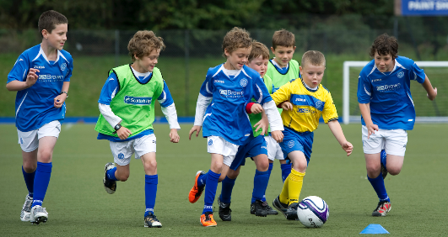
The coaching department requires a sports coaching apprentice who will assist with the delivery of sports and physical activities to children and young people.
This apprenticeship requires you to apply through the employer's website.
Closing date: 24 Jan 2020
Apprenticeship summary
- Weekly wage - £136.50

- Working week - Monday to Friday 35 hours per week including day-release in college.
- Expected duration - 15 months
- Apprenticeship level - Intermediate Level 2 (GCSE)
- Reference number - VAC001515461
Vacancy Description
The apprentice coach will primarily work in the evenings on our football courses assisting in the delivery of fun based coaching sessions to primary school children and assist in delivering a variety of sports and physical activities on our holiday clubs in the school holidays
The coach may also be required to assist in the delivery of sport and physical activities to children and young people, both in school curriculum time following the PE National Curriculum and/or set programs of study and also deliver a range of OSHL, (Out of School Hours Learning) extracurricular activities before school, at lunch times, after school
Coaching Experience is not essential as all training will be provided. We are looking for candidates who are enthusiastic and motivated to learn

Requirements and prospects
Desired skills
- Must be reliable with strong time management skills
- Good communication skills
Personal qualities
- Self-motivated, passion for sports coaching and inspiring young people through engagement and participation in physical activity and sport
- Interactive and confident
Desired qualifications
- Must attend initial assessment session at Creative Sport & Leisure - Unit 27, Buckshaw Village, PR7 7JN
- Grade A* - C/4-9 in GCSE, or equivalent, maths and English
Future prospects
- Successful applicants will be fast tracked to be active members of the coaching team within a 1 year training period
Things to consider
- Successful candidates will undergo constant ‘in-house’ training, personal development and will be expected to attend additional external training in order to enhance their skills used within their job. Applicants will be asked to attend a 3 stage formal interview process to include telephone, formal interview and delivery of a practical activity/session to a group of primary aged children
- Working hours include: Weekends, early mornings, late evenings
- You will need to have either your own transport or be willing to work towards a driving licence

About the employer
First Kick have been successfully running as a sports coaching organisation since 2012. Our mission is to get children more active through specifically designed sports and activity programmes. Not only do we offer physical benefits in our programmes but also focus on the social and emotional wellbeing of each child.
First Kick offer nursery and school programmes along with out of school programmes which include football classes, dance & gymnastics classes, holiday clubs, parties and more.
Employer - Christopher Ganner Address - 9a Hennel Lane, Preston, PR5 4LA

Training provider - Creative Sport & Leisure Limited –
Applications are being processed by Creative Sport & Leisure Limited
Contact - Neil Williams 01772623632 neil.williams@creativesportleisure.co.uk
- Level 2 Community Activator Coach Standard
- Functional Skills maths, English and ICT if required
Apprenticeship standard - Community Activator Coach - Level 2 (GCSE)

