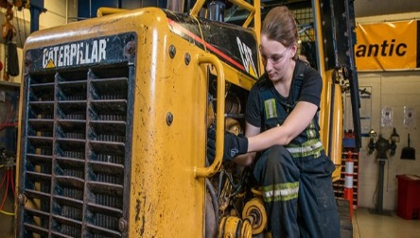
Apprentice Heavy Vehicle Technician JDS Trucks (Renault)
At Renault we pride ourselves on producing world class vehicles with excellent performance and impeccable reliability. We train our staff to the same high standards via our Technician Apprentice Programme - considered to be the best in the industry.
This apprenticeship requires you to apply through the employer's website.
Weekly wage - £166.00
Working week - Monday - Friday: 8:00am - 4:30pm - Total hours per week: 40.00
Expected duration - 3 years Apprenticeship level – Advanced Level 3 (A level)
Reference number - VAC001609262
Areas of responsibility include:
- To attain high levels of morale and focus to ensure the highest possible levels of productive efficiency, quality of workmanship and production finish in order to sustain growth in customer confidence in the service provided by the Dealer point
- Ensure the Dealer point works to the criteria laid down in the Company Health and Safety policy
- Assist technician to carry out repairs according to Renault procedures in a safe and responsible manner
- Learn how to use Renault special tools safely and efficiently
- Wear personal protective equipment (PPE) when required
- Assist with cleaning the workshop
- Comply with warranty procedures during repairs and with warranty material on completion of repair
- Ensure that the company’s time recording procedures are complied with
- Ensure job cards are completed accurately
- Ensure all vehicle defects are reported to workshop Supervisor
- Attend college courses regularly and achieve the standards required by the course
- Attend any technical or development training that is made available
General duties:
- Work with the team to ensure a strong top team ethos
- Support the development of character, skills, attitude and superior individual and team performance
- Ensure that you conduct yourself in a business-like and professional manner
- Ensure that the workshop facilities, equipment and tools are kept clean, tidy and maintained, reflecting the Renault image of an efficient and modern retail Dealer point

Desired skills
- To be able to effectively communicate at all levels both written and verbally
- To be able to work on developing new or enhancing existing processes
- To be able to adapt and take on new skills and approaches
Personal qualities
- Have a real interest in the retail motor industry
- Be willing to provide an excellent service to our customers
- The right attitude, determination and commitment
Desired qualifications
If you have the desire and passion to work in the motor industry, GCSE grades Grade D/3 or above (or equivalent) or can demonstrate a reasonable level of knowledge in mathematics, English and Science.
Future prospects - Progression to higher qualifications and possible full-time position.

About the employer
JDS Trucks is one of the biggest Renault truck & van dealerships in the UK. With three branches in the North West, we put our customers first by working together as partners, building lifelong relationships and providing a first-class service throughout the lifetime of a vehicle.
Jds Trucks Ltd -https://jdstrucks.uk/ - Navigation Garage, Forrest Street, Blackburn, BB1 3BB

Training provider - STEPHENSON COLLEGE - Applications for this apprenticeship are being processed by Stephenson College - Contact - Maddie Wood mwood@stephensoncoll.ac.uk
Block Release at Stephenson College includes:
- Apprenticeship Standard Heavy Vehicle Service and Maintenance Technician - Bus, Coach and HGV
- Functional skills in maths and English (if required)
Apprenticeship standard - Heavy vehicle service and maintenance technician - Level 3 (A level)

Employer's Application Instructions
Please select 'HGV' to fill out the application form. This apprenticeship requires you to apply through the employer's website. Apply now - Closing date: 30 Sep 2020

