Attendance Analysis – Autumn Term 2020

Impact of COVID pandemic

Our attendance can be analysed against national figures and it shows that our attendance has been around national figures – slightly lower for disadvantaged students and slightly better for those who are not identified as being disadvantaged.
Disadvantaged:
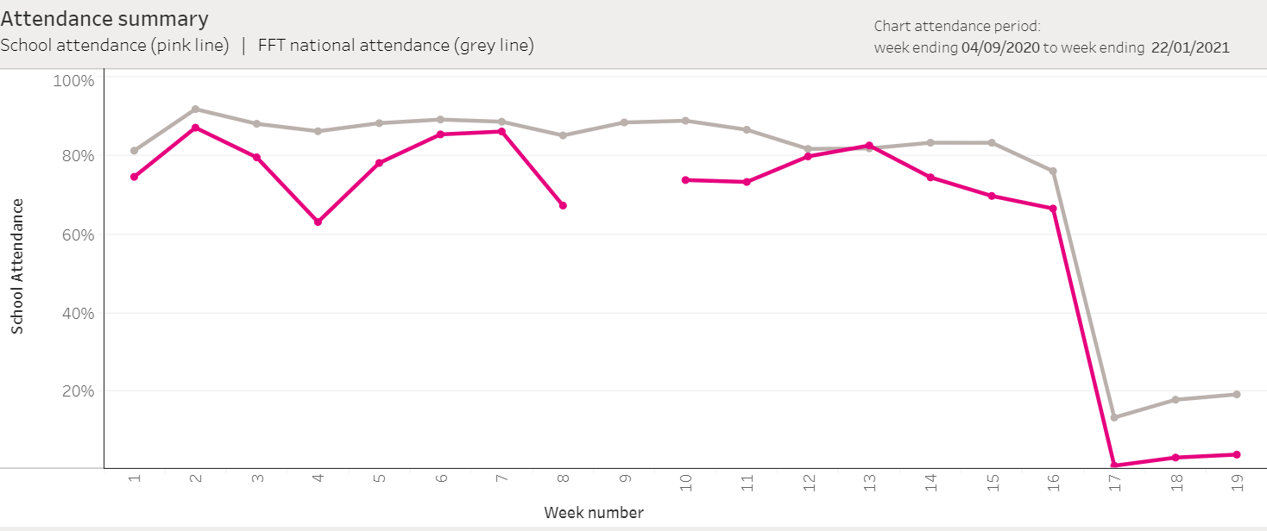
Not disadvantaged:
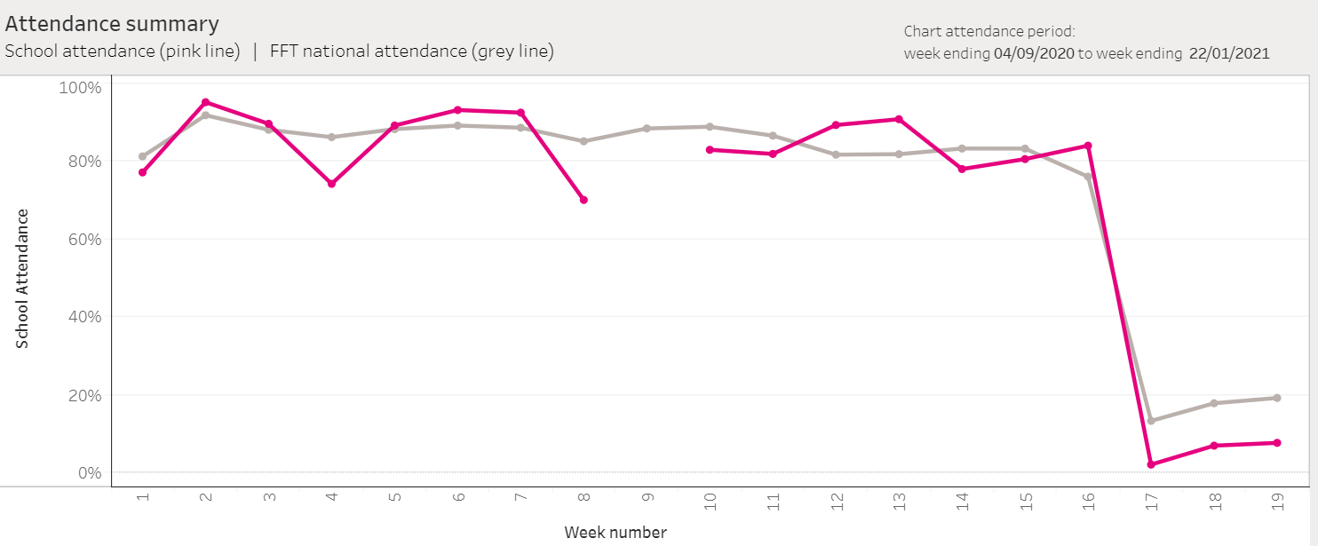

By looking at national government statistics it is possible to compare our attendance with that of all Lancashire secondary schools and with all schools in the North West of England:

%
0
%
10
%
20
%
30
40
%
%
50
%
60
%
70
%
80
%
90
%
100
1
2
3
4
5
6
7
8
9
10
11
12
13
Attendance analysis
-
Autumn term 2020
North West (all)
Lancashire (Secondary)
WLD attendance (X absent)
This shows that our attendance is broadly in line with local and national averages under these pandemic conditions. We will continue our focus on our most disadvantaged students, working with each individual and family to ensure the best possible attendance at school.

