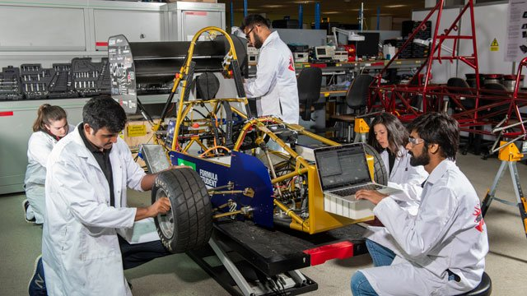
Job title: Automotive Engineer
Job title: | Automotive engineers design, develop, test and build cars and motorbikes.
Routes and Entry requirements: | University  You’ll usually need a foundation degree, higher national diploma or degree, before joining a company training scheme.  Relevant subjects include:  - mechanical engineering  - electrical or electronic engineering  - design engineering  - manufacturing engineering  - automotive engineering  A course with a work placement or an internship will be especially useful.  You'll usually need:  - at least 1 A level, or equivalent, for a foundation degree  - between 1 and 3 A levels, or equivalent, for a higher national diploma or degree  Apprenticeship  You could get into this job through a manufacturing engineer degree apprenticeship or product design and development engineer degree apprenticeship.  You'll usually need:  - 4 or 5 GCSEs at grades 9 to 4 (A* to C) and A levels, or equivalent, for a degree apprenticeship
Skills required: | You'll need:  - maths knowledge  - knowledge of engineering science and technology  - design skills and knowledge  - knowledge of physics  - to be thorough and pay attention to detail  - analytical thinking skills  - the ability to use, repair and maintain machines and tools  - thinking and reasoning skills  - to be able to use a computer and the main software packages competently
What you'll do: | You might work on:  - body, chassis and engine systems  - electrical and electronic instrumentation and control systems  - thermodynamics, aerodynamics and fluid mechanics  - fuel technology and emissions  - You could work in:  - design – turning ideas into blueprints for development and testing, taking into account safety, cost-effectiveness, environmental impact and look  - development – building and testing prototypes using computer simulations and physical models to assess components' strengths, weaknesses, performance and safety  - production – planning the production run, including redesigning machine tools, equipment and processes to make new parts, monitoring costs and production schedules, and overseeing quality control
What you’ll earn: | £20,000 Starter to £45,000 Experienced
Working hours, patterns and environment: | - Typical hours (a week) 39 to 41  - You could work evenings, on shifts  - You could work in an office, at a research facility or at a manufacturing plant.
Career path and progression: | With experience, you could progress to senior engineer roles, project team management, general management or consultancy.

