Title | Author | Cover | Where?
Animals and Insects Under The Microscope | Woodward, J. & Horton, C. | 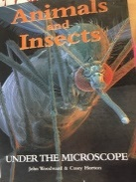 | School library
Extraordinary Bugs | Gray, Leon | 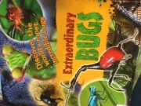 | School library
Insects and Spiders | Readers Digest  Robertson Matthew, Doyle Sandra | 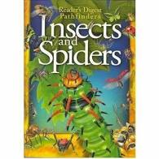 | School library
I can draw Creepy Crawlies | Longhurst Terry | 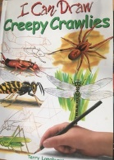 | School library
Insects | Horton Casey | 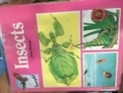 | School library
Ugly Bugs  Horrible Science | Arnold, Nick | 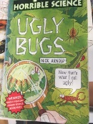 | School library
Insects |  | 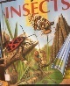 | School library
Wings | Bantock, Nick | 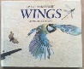 | Art Room Book

Topic: Entomology

Books

Web Resources

The British Museum – Explorers’ Notes, Drawings and Illustrations
https://artsandculture.google.com/exhibit/the-russegger-atlas/RgISf32f0DOwLQ
https://artsandculture.google.com/exhibit/the-russegger-atlas/RgISf32f0DOwLQ

The Royal Entomological Society is devoted to the promotion and development of entomological science.
https://www.royensoc.co.uk/what-entomology
National Insect Week
https://www.nationalinsectweek.co.uk/

Free magazine
https://www.nationalinsectweek.co.uk/news/instar-magazine

More details on bugs and related species
https://www.nationalinsectweek.co.uk/discover-insects
Website
https://entomologytoday.org/2020/03/27/learning-at-home-with-bugs/

Flickr Images
https://www.flickr.com/photos/131104726@N02/

APPS
Free apps to download and explore bugs you find.
https://www.opalexplorenature.org/bugs-app#:~:text=The%20Bugs%20Count%20app%20is,the%20six%20Species%20Quest%20bugs.

Inaturalist
https://www.inaturalist.org/pages/getting+started
For making observations this App identifies what you photograph on your mobile

Oxford University Museum of Natural History
https://oumnh.ox.ac.uk/insects

Open Access Books – extracts with detailed photographs… a small selection!
Synopsis of adventive species of Coleoptera (Insecta) recorded from Canada. Part 5:
https://ab.pensoft.net/article/50613/zoom/fig/11/
https://ab.pensoft.net/article/50613/zoom/fig/16/
https://ab.pensoft.net/article/50613/zoom/fig/19/

