Topic: The Basics

Title | Written Texts | Where? | Author | Info/Comments | Image
The Encyclopaedia of Drawing Techniques | Book | Books in the Art Room | Simpson, I | Explore pencil, charcoal, pen & technical pen techniques a full range of subject matter, including landscapes, buildings, figures, animals, flowers & still life. | 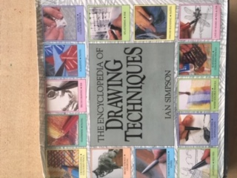
Painting Still Life | Book | School Library | Graham Peter | An introduction to themes composition background light and colour | 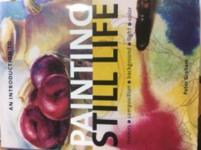

Websites

BBC Bitesize - Elements and principles of art class clips
https://www.bbc.co.uk/bitesize/topics/zdjpyrd/resources/1

