Topic: Graffiti

Books
Title | Author | Where | Images | Dewey  Where to find it in the library | Description
Banksy Art breaks the rules | Bingham, Hettie | Library | 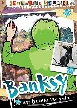 | 759.2 | "Who is Banksy? One of the most famous street artists, he has managed to keep his identity a secret ever since his work first got noticed in the 1990s. He is known for his subversive stencil art that is often political and has a dark sense of humour.
Street Art New York | Harrington, Steven P. | Library | 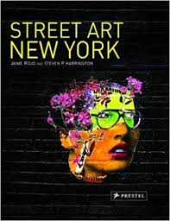 | 751.73097471 | New York is a street art Mecca, boasting a vast outdoor gallery which encompasses walls, fences, sidewalks and just about any other available surface. Featured in this dynamic collection are approximately 200 images of works

Websites

http://www.artbanksy.com/

https://banksy.co.uk/

https://www.moma.co.uk/buy/banksy-prints/

Castle Graffiti
http://wakefieldmuseumsandlibraries.blogspot.com/2019/05/replication-of-civil-war-graffiti-at.html

http://news.bbc.co.uk/local/bradford/hi/people_and_places/history/newsid_8479000/8479239.stm

Video
This is the inside story of Street Art - a brutal and revealing account of what happens when fame, money and vandalism collide. Exit Through the Gift Shop follows an eccentric shop-keeper turned amateur film-maker as he attempts to capture many of the world's most infamous vandals on camera, only to have a British stencil artist named Banksy turn the camcorder back on its owner with wildly unexpected results. One of the most provocative films about art ever made, Exit Through the Gift Shop is a fascinating study of low-level criminality, comradeship and incompetence. By turns shocking, hilarious and absurd, this is an enthralling modern-day fairytale... with bolt cutters.

http://www.banksyfilm.com

Podcasts
https://mylifeinletters.libsyn.com/

