Topic: Pop Art Year 8

Title | Author | Images | Dewey  Where to find it in the library | Description
Pop Art Subject | Tilman Osterwold | 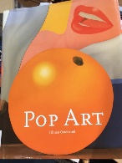 | 759.06 | 1960s artists including, Warhol, Lichenstein, David Hockney etc
Pop Art A Continuing History | Livingstone Marco | 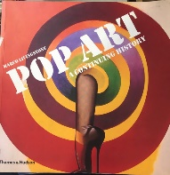 | 709.04071 | 1960s artists including, Warhol, Lichenstein, David Hockney etc
Whaam!: The Art and Life of Roy Lichtenstein | Rubin, Susan Goldman | 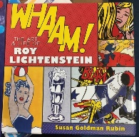 | 709.2 | The life of the great Pop Art painter Roy Lichtenstein, illustrated with his most famous artworks.
Art Revolutions Pop Art | Bolton,Linda | 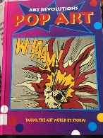 | 759.06 | The ART REVOLUTIONS series looks at the major art movements of the 20th century.
The 1960s Scrapbook  2 Copies | Opie, Robert | 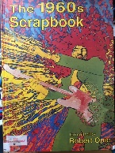 | 941.086  Reference Only | "The Sixties will be remembered for miniskirts and mini cars, The Beatles and The Rolling Stones, boutiques and discotheques, and England winning the World Cup. But The 1960s Scrapbook also covers much more with its 1400 colourful items
Andy Warhol  2 copies | Bolton,Linda | 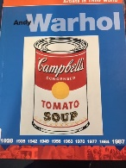 | 759.06 | This new series uncovers the life and times of some of the most important and influential artists of the modern world
Pop Art | Lancashire Libraries Not open till Oct 2020

Web Sources
Tate Galleries UK – This is a huge collection broken down into separate exhibitions around the country over a time period. https://www.tate.org.uk/search?q=Pop+art
Tate has various art galleries dotted about the country but the Grundy Art Gallery Exhibition is interesting because it is in Blackpool just down the road from us!
This exhibition features Roy Lichenstein https://www.tate.org.uk/whats-on/grundy-art-gallery/exhibition/roy-lichtenstein

BBC Bitesize – Pop Idols
Use BBC iplayer and sign in
https://www.bbc.co.uk/iplayer/group/p02zyc25
https://www.bbc.co.uk/search?filter=bitesize&scope=bitesize&q=Pop+Art

BBC TEACH – What is Andy Warhol Doing Now?
https://www.bbc.co.uk/teach/what-is-andy-warhol-doing-right-now/zvrbhbk

Blog by Alistair Sooke
https://www.bbc.co.uk/blogs/tv/entries/bb264f74-20a0-4631-aa07-cbc4956f765b

Video
https://www.tate.org.uk/whats-on/tate-modern/exhibition/andy-warhol/exhibition-guide
This is really short but comprehensive visual history of Andy Warhol. It’s shown through an exhibition at the Tate but nevertheless you get to know more about the artist whilst looking at his work.
Podcast
https://www.tate.org.uk/art/artists/andy-warhol-2121/art-persona
This is several people talking and describing Pop art.

Website
Information about Peter Blake and Razzle Dazzle via Liverpool Biennale.
Peter Blake (b. 1932, UK) is a leading figure in the development of British pop art and his work is synonymous with the use of imagery from modern culture, including comic books, consumer goods and advertisements.
https://www.biennial.com/dazzleferry-education/#/home

