BBC Education Pages
https://www.bbc.co.uk/teach/gcse-national-5-physical-education/zh92vk7

Competing - Junior Badminton
https://www.badmintonengland.co.uk/compete/junior-competition/

Badminton England
https://www.badmintonengland.co.uk/

Rankings and Gradings
https://www.badmintonengland.co.uk/compete/rankings-and-gradings/national-gradings-information/

Player Profiles
https://www.badmintonengland.co.uk/england-squad/england-performance-squad/player-profiles/

PARA-BADMINTON PROGRAMME
https://www.badmintonengland.co.uk/england-squad/para-badminton-programme/

BBC News
https://www.bbc.co.uk/sport/badminton

Videos
https://www.bing.com/images/search?view=detailV2&ccid=Ucyzk2IJ&id=F8E0469BDCBA9BF53445931F2E54E8F730D3A450&thid=OIP.Ucyzk2IJOLFxtl3CYMeCJgHaEK&mediaurl=https%3a%2f%2fi.ytimg.com%2fvi%2fBUFKFKKKAGQ%2fmaxresdefault.jpg&exph=720&expw=1280&q=Badminton+Games&simid=608040074773660123&ck=9F132B2292AC3647D17406911EE2CB47&selectedIndex=0&adlt=strict&ajaxhist=0
Badminton
https://www.biogs.com/biogsdirectory/badminton.html

Books available through our school library or online

Title | Author | Media | Where | Info | Book Image | Dewey No./Class | Barcode
Badminton | Blackall, B | Hardback | Library | A detailed introduction to badminton, explaining the rules and skills the sport requires. It covers equipment and suggests exercises to get the reader started. There are step-by-step photographs and diagrams to illustrate the text | 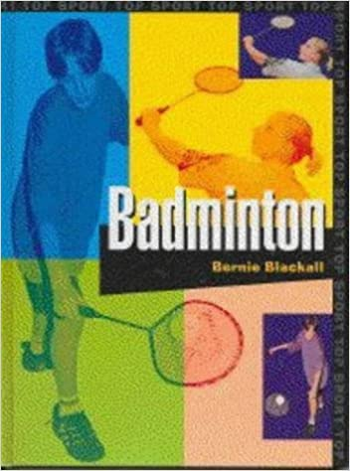 | 796.345 | 7365
How to Play Badminton | Davis, P | Hardback | Not in the library |  |  | 796.345 | 3908
Badminton | Brahms, Bernd-Volker | Hardback | Lancashire Libraries  Currently not open  Link  https://capitadiscovery.co.uk/lancashire/items/1478603?query=badminton&resultsUri=items%3Fquery%3Dbadminton%26offset%3D0 | Badminton A-Z  Technique & training | 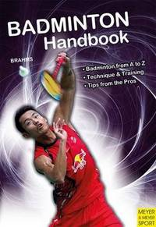
Badminton | Gifford, Clive | Hardback | Lancashire Libraries  Currently not open  Link to book  https://capitadiscovery.co.uk/lancashire/items/503902?query=badminton&resultsUri=items%3Fquery%3Dbadminton%26offset%3D0 | Each book in this series, aimed at seven to 14 year olds, provides youngsters with everything they need to know to participate in - and enjoy - their favourite sport. This title focuses on badminton | 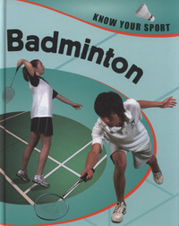
Badminton | Davis, P | Hardback | Lancashire Libraries  Currently not open Lancashire Libraries  Link to book  https://capitadiscovery.co.uk/lancashire/items/457257 | Clear and easy-to-understand, this book provides tips on equipment and clothing, basic and more advanced techniques, explains terminology and rules, and contains a game guide and rules clinic to help you play badminton | 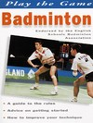
BADMINTON |  | Hardback | Lancashire Libraries  Currently not open Lancashire Libraries  Link to book  https://capitadiscovery.co.uk/lancashire/items/503902?query=badminton&resultsUri=items%3Fquery%3Dbadminton%26offset%3D0 |  | 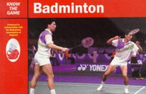
Badminton: steps to success | GRICE, Tony | Hardback | Lancashire Libraries  Currently not open Lancashire Libraries  Link to book  https://capitadiscovery.co.uk/lancashire/items/566216?query=badminton&resultsUri=items%3Fquery%3Dbadminton%26offset%3D0 |  | 