Books available through our school library or online

Title | Author | Media | Where | Info | Image | Dewey No./Class | Barcode
Amir Khan | Townsend, John | Hardback | Library |  |  | 796.83092 | 14286
Manchester United | Various | Hardback | Library | Tribute to the World’s greatest football club, its heroes and legends. | 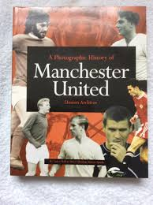 | 796.334 | 11824
Essential History of Liverpool, The | Murphy Alex and Ericdoig | Hardback | Library | The complete story 1892-2003. Foreword by Ian Callaghan. Contains comprehensive statistics with results, tables and player details. 320 pages. Many b/w photographs | 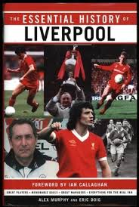 | 796.334 | 11211
British Olympians | Foy, Debbie | Hardback | Library | "21st Century Lives is a fresh and lively approach to the achievements of the most successful British Olympians. Find out about these talented men and women; the British Olympians featured include: Rebecca Adlington, Chris Hoy, Ben Ainslie and Rebecca Romero." | 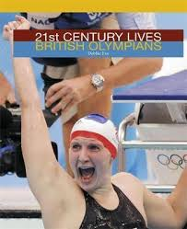 | 920 | 14261
David Beckham | Apps, Roy | Paperback | Library | Ever had a dream -- a dream to win? David had a dream -- to play for Manchester United. This is the story of David's early years and his break through into Manchester United's first team. | 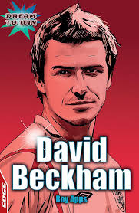 | 920 | 13612
David Beckham | Apps, Roy | Paperback | Library | As above |  | 920 | 13607
David Beckham | Apps, Roy | Paperback | Library | As above |  | 920 | 13602
Paula  My Story So Far | Radcliffe, Paula | Hardback | Library | Her remarkable life story of highs and lows is fully chronicled in this fascinating and inspiring autobiography. | 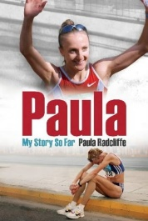 | 796.424092 | 19223
Ellen MacArthur | Wilson, Mike | Paperback | Library |  | 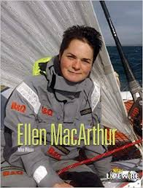 | 920 | 15243
Ellen MacArthur | Townsend, John | Hardback | Library  Also online  Lancashire Libraries  https://capitadiscovery.co.uk/lancashire/items/1234975?query=9781406209563&resultsUri=items%3Fquery%3D9781406209563 | This biography of Ellen McArthur looks at her career as well as her upbringing and early involvement in sailing | 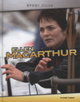 | 920 | 15252
Frank Bruno | Coxley,Jane | Paperback | Library | Heavyweight champion of the world, and one of Britain’s best-loved sports stars | 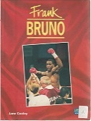 | 920 | 12980
Football Legends | Gifford, Clive | Paperback | Library | From Pele to David Beckham, from Real Madrid to Manchester United, find out all the top facts and stats about the world's best clubs and players and WHY they are considered legends! |  | 796.3340922 | 17382
Kelly Holmes | Croft, Andy | Paperback | Library | Kelly Holmes has battled poverty, injury and depression to become one of the most famous and successful sportswomen in the world. Gripping insight into an Olympic hero. Barrington Stoke specialise in books for reluctant, struggling and dyslexic readers. | 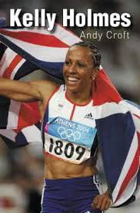 | 920 | 17386
Lewis Hamilton | Belton, Brian | Hardback | Library | Respected sports author Brian Belton takes an in-depth look at the rise of a racing phenomenon and the start of another chapter in the chronicles of black British sport history | 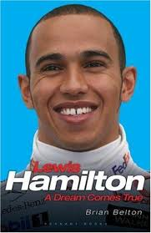 | 920 | 17302
Monty Panesar | Apps, Roy | Paperback | Library | Ever had a dream -- a dream to win? Monty had a dream -- to be a world-class cricketer. This is the story of Monty's early years and his break through into the England cricket team. | 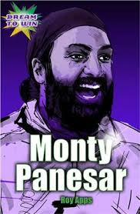 | 920 | 13601
Freddie Flintoff Story, The | Aldred Tanya | Hardback | Library | From Cult Hero To Ashes Icon  Sevenoaks, 2005 Account of the Lancashire cricketer's life and career up to the England victory in the 2005 Ashes series. | 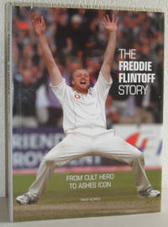 | 920 | 13738
Muhammad Ali | Hook, Peter | Paperback | Library | This book follows Mohammed Ali's life through a combination of simple text, photographs, captions and quotation panels | 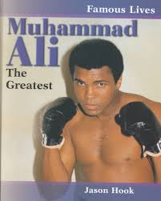 | 920 | 15261
Denise Lewis  Personal Best | Lewis, Denise | Hardback | Library | In September 2000, at the Sydney Olympics, Denise Lewis won the gold medal for the heptathlon. This is the story of a talented, intelligent individual who learned early that you can't have everything you want at once, and who is determined to show that women can be successful at whatever they try. |  | 796.42092 | 1928
Rebecca Adlington | Apps, Roy | Paperback | Library | This is the story of Rebecca's early years and her break through into the British Olympic swimming team. | 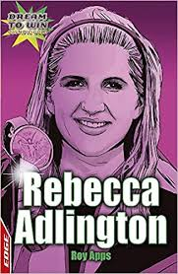 | 920 | 14312
Rio Ferdinand | Croft, Andy | Paperback | Library | Rio Ferdinand is the story of this famous football star's rise to the top. | 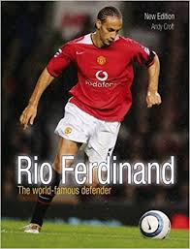 | 920 | 15248
Sol Campbell | Croft, Andy | Paperback | Library | "Sol Campbell's life is as fascinating off the pitch as on it. From poverty, through his struggle against racism to a millionaire lifestyle. Insider info on a sports superstar.” | 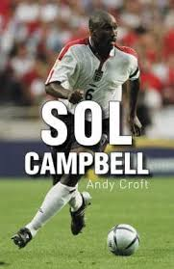 | 920 | 13606
Sports People | Gogerly, Liz | Hardback | Library | "21st Century Lives: Sports People is a fresh and lively approach to the achievements of many of today's most successful sports men and women | 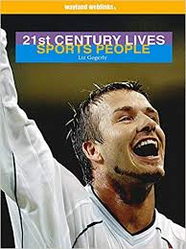 | 920 | 14271
Tanni Grey-Thompson | Townsend, John | Hardback | Library | This work provides simple, motivational biographies of well known sporting stars, looking at their careers, as well as their upbringing and early involvement in sports. | 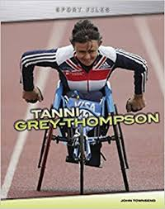 | 920 | 14291
Usain Bolt | Hart, Simon | Paperback | Library | "The series focuses on the people who inspire children today. Each book looks at the background, life and achievements of a personality, their impact on popular culture as well as detailing the everyday facets of their job and how they have gained such success." | 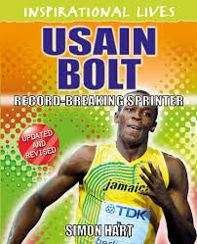 | 796.422092 | 19678
Who's Who of Preston North End | Hayes, Dean | Hardback | Library | Dean Hayes has detailed the careers of every single one of those players. The book is highly illustrated throughout, and various statistics are included to supplement the career details of the players | 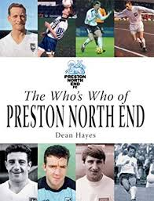 | 796.33 | 14143
Behind the Mask  Tyson Fury  Read by Jake Wood and Tyson Fury | Adult book  By Penguin Books | eAudiobook | Lancashire Libraries  https://fe.bolindadigital.com/wldcs_bol_fo/b2i/productDetail.html?productId=PRH_749702&fromPage=1&b2bSite=5070 | THE GYPSY KING.  A Manchester lad from Irish Traveller stock, born three months premature and weighing just a pound at birth, Tyson (named after his father’s boxing hero) grew up to become one of the most unlikely heavyweight champions in history. | 
Harry Kane - England's Hero | Frank Worral | eBook | Lancashire Libraries  https://fe.bolindadigital.com/wldcs_bol_fo/b2i/productDetail.html?productId=LSB_524550&fromPage=1&b2bSite=5070 | England manager Gareth Southgate's decision to appoint Kane, still just twenty-three years old, as the team captain in 2017 could have been seen as premature, bringing with it pressure that could damage a young player's career. However, he knew that Kane, a modest, humble and inspiring figure was up to the task. | 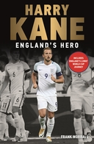
Laura Trott and Jason Kenny  The Inside Track | Michael O'Mara | EAudiobooks and EBooks | Lancashire Libraries  https://fe.bolindadigital.com/wldcs_bol_fo/b2i/productDetail.html?productId=MOM_350053&filter=all&fromPage=1&b2bSite=5070 | Laura Trott and Jason Kenny, Britain’s most successful female and male Olympians, invite us into their world, on to the boards of the velodrome and down the back straight of British pro cycling to give us the inside track on what it takes to become a champion. | 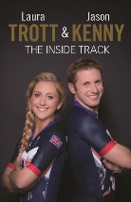
Various | Various | eBooks | Lancashire Libraries  Many Links to sports biography pages to choose your favourites  https://fe.bolindadigital.com/wldcs_bol_fo/b2i/search.html?filter=all&q=sport&offset=0&fromPage=1&b2bSite=5070&searchBy=ALL&orderBy=relevance&loanFormat=eBooks
Various | Various | eAudiobooks | Lancashire Libraries  Many Links to sports biography pages to choose your favourites  https://fe.bolindadigital.com/wldcs_bol_fo/b2i/search.html?filter=all&q=sport&offset=0&fromPage=1&b2bSite=5070&searchBy=ALL&orderBy=relevance&loanFormat=eAudiobooks
How to Be a Footballer  Peter Crouch | Peter Crouch | eAudiobooks | Blackburn with Darwen Libraries  https://fe.bolindadigital.com/wldcs_bol_fo/b2i/search.html?filter=all&q=sport+biographies&offset=0&fromPage=1&b2bSite=5614&searchBy=ALL&orderBy=relevance&loanFormat=eAudiobooks | "The funniest man in British sport" — Metro  "Who knew that a footballer could be funny? ... What you realise, as you laugh out loud, is that football has been taken too seriously by too many people for too long... Most other football books wither by comparison" — Daily Mail Sports Book of the Year  more > | 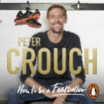
How to Be a Footballer  Peter Crouch | Peter Crouch | eBook | Blackburn with Darwen Libraries  https://fe.bolindadigital.com/wldcs_bol_fo/b2i/productDetail.html?productId=RDH_568232&filter=all&fromPage=1&b2bSite=5614 | As someone who's been there, done it and got the ill-fitting T-shirt, Crouch is well placed to shed light on the bizarre world of the modern player in a funny, down-to-earth way... He made his name on the pitch ... but with this book, Crouch proves he is a good sport off it, too." — Jade Craddock Sun | 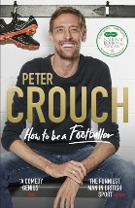
Bradley Wiggins  Tour de Force | - John Deering | eBook | Blackburn with Darwen Libraries  https://fe.bolindadigital.com/wldcs_bol_fo/b2i/productDetail.html?productId=FFP_058780&filter=all&fromPage=1&b2bSite=5614 | Rising from an inner city background, abandoned by his pro cyclist father as a toddler, Bradley Wiggins became a prodigious talent. | 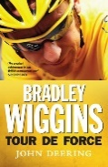
Fantastic Female Adventurers  Truly Amazing Tales of Women Exploring the World | Lily Dyu | eBook | Blackburn with Darwen Libraries  https://fe.bolindadigital.com/wldcs_bol_fo/b2i/productDetail.html?productId=LSB_674734&filter=all&fromPage=1&b2bSite=5614 | Fantastic Female Adventurers by Lily Dyu is a collection of fourteen exciting and inspirational stories about the women that do. Follow them on their incredible journeys around the globe. | 
Various | Various | eBooks | Blackburn with Darwen Libraries  Many Links to sports biography pages to choose your favourites  https://fe.bolindadigital.com/wldcs_bol_fo/b2i/search.html?filter=all&q=sport+biographies&offset=0&fromPage=1&b2bSite=5614&searchBy=ALL&orderBy=relevance&loanFormat=eBooks
Various | Various | eAudiobooks | Blackburn with Darwen Libraries  Many Links to sports biography pages to choose your favourites  https://fe.bolindadigital.com/wldcs_bol_fo/b2i/search.html?filter=all&q=sport+biographies&offset=0&fromPage=1&b2bSite=5614&searchBy=ALL&orderBy=relevance&loanFormat=eAudiobooks

Barcode | Class | Author | Title | Media | URL
14286 | 796.83092 | Townsend, John | Amir Khan | Hardback
 |  |  | Authors: biographies and book information | Website | http://www.booksunlimited.co.uk
14032 | 920 | Parry, Jonathan | Benjamin Disraeli | Paperback
13613 | 920 | Wilkins, Verna | Benjamin Zephaniah | Paperback
 |  |  | Biogs.com | Website | http://www.biogs.com
14261 | 920 | Foy, Debbie | British Olympians | Hardback
14031 | 920 | Desmond, Adrian | Charles Darwin | Paperback
14033 | 920 | Downes, Kerry | Christopher Wren | Paperback
13612 | 920 | Apps, Roy | David Beckham | Paperback
13607 | 920 | Apps, Roy | David Beckham | Paperback
13602 | 920 | Apps, Roy | David Beckham | Paperback
14029 | 920 | Collinson, Patrick | Elizabeth I | Paperback
15243 | 920 | Wilson, Mike | Ellen MacArthur | Paperback
15252 | 920 | Townsend, John | Ellen MacArthur | Hardback
14252 | 920 | Gogerly, Liz | Film Stars | Hardback
17382 | 796.3340922 | Gifford, Clive | Football Legends | Paperback
17392 | 920 | Claybourne, Anna | Gandhi | Paperback
17361 | 920 | Claybourne, Anna | Gandhi | Paperback
 |  |  | Garden of Praise | Website | http://www.gardenofpraise.com/leaders.htm
4069 | 920.B/HIT | Rubenstein, J | Hitler | Hardback
 |  |  | Infoplease | Website | http://www.infoplease.com/people
14030 | 920 | Westfall, Richard S. | Isaac Newton | Paperback
13603 | 920 | Sutcliffe, Jane | John F. Kennedy | Paperback
17386 | 920 | Croft, Andy | Kelly Holmes | Paperback
17302 | 920 | Belton, Brian | Lewis Hamilton | Hardback
19721 | 371.822095491 | Throp, Claire | Malala Yousafzai | Hardback
13608 | 920 | Wilkins, Verna | Malorie Blackman | Paperback
19724 | 540.92 | Throp, Claire | Marie Curie | Hardback
17350 | 920 | Ridley, Sarah | Martin Luther King | Hardback
17341 | 920 | Jeffrey, Gary | Martin Luther King | Hardback
17391 | 920 | Jones, Robert | Martin Luther King | Hardback
13601 | 920 | Apps, Roy | Monty Panesar | Paperback
15228 | 920 | Nelson, Robin | Mother Teresa | Paperback
15261 | 920 | Hook, Peter | Muhammad Ali | Paperback
17387 | 920 | Boothroyd, Jennifer | Nelson Mandela | Paperback
19729 | 968.065092 | Senker, Cath | Nelson Mandela | Hardback
14021 | 920 | Reynolds, K.D. | Queen Victoria | Paperback
14251 | 920 | Sutherland, Adam | Reality TV Stars | Hardback
14312 | 920 | Apps, Roy | Rebecca Adlington | Paperback
15248 | 920 | Croft, Andy | Rio Ferdinand | Paperback
14258 | 920 | Foy, Debbie | Soap Stars | Hardback
13606 | 920 | Croft, Andy | Sol Campbell | Paperback
14271 | 920 | Gogerly, Liz | Sports People | Hardback
19723 | 530.092 | Senker, Cath | Stephen Hawking | Hardback
14291 | 920 | Townsend, John | Tanni Grey-Thompson | Hardback
14253 | 920 | Foy, Debbie | Teen Movie Stars | Hardback
16806 | 920 | Rohr, Ian | Trail Blazers | Paperback
17377 | 920 | Mitchell, Pratima | True Lives: Gandhi | Paperback
17372 | 920 | Mitchell, Pratima | True Lives: Gandhi | Paperback
17376 | Fiction | Shavick, Andrea | True Lives: Roald Dahl | Paperback
17371 | Fiction | Shavick, Andrea | True Lives: Roald Dahl | Paperback
17349 | Fiction | Shavick, Andrea | True Lives: Roald Dahl | Paperback
14256 | 920 | Gogerly, Liz | TV Celebrities | Hardback
19678 | 796.422092 | Hart, Simon | Usain Bolt | Paperback
16860 | 362.4092 | Dryburgh, Nicole | Way I See it, The | Paperback
14143 | 796.33 | Hayes, Dean | Who's Who of Preston North End | Hardback
14027 | 920 | Holland, Peter | William Shakespeare | Paperback
14621 | 133.4309421 | Narayan, Natasha | Witches Wizards and Warlockd of London | Paperback

Biographies Websites A-Z
http://www.biogs.com
Badminton
https://www.biogs.com/biogsdirectory/badminton.html
Football Biographies
https://www.biogs.com/biogsdirectory/footballers.html

Rugby Biographies
https://www.biogs.com/biogsdirectory/rugby.html

Table Tennis Biography
https://www.biogs.com/will-bayley

Others Sports Biographies
https://www.biogs.com/biogsdirectory/sportspeople.html

