Topic: Biomes

Books
Books available through the school library and online
Title | Author | Medium | Where | Description | Image | Dewey/Classification | Barcode
Arctic & Antartic | Taylor,B. | Paperback | Library | From flora and fauna, to human and animal inhabitants, as well as the brave people who explored these extreme regions, often with fatal consequences: let your child learn all about life at the North and South pole. | 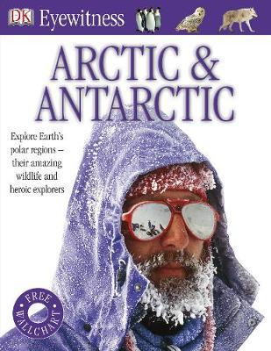 | 998 | 19185
100 Things You Should Know About Polar Lands | Gallagher, Belinda | Paperback | Library | Discover which explorers reached the poles first, and which animals are able to live in such a cold climate. The facts in this book will entertain and enthuse children, while the projects, quizzes and cartoons add an extra element of fun. | 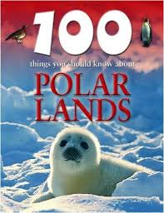 | 577 | 15245
Biomes Atlases: Deserts and Semideserts | Allaby, Michael | Paperback | Library |  | 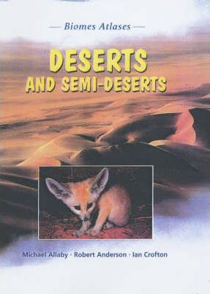 | 577 | 14149
Biomes Atlases: Oceans and Beaches | Day, Trevor | Paperback | Library | Each title in this series provides readers with a deeper understanding of the world's biological communities, with each title focusing on a particular biome, biome type, group of biomes or system. | 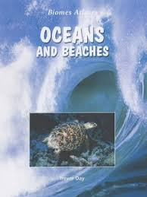 | 577 | 14161
Biomes Atlases: Shrubland | Burnie, David | Paperback | Library | Each title in this series provides readers with a deeper understanding of the world's biological communities, with each title focusing on a particular biome, biome type, group of biomes or system. | 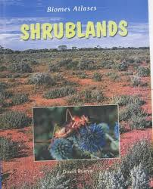 | 577 | 14156
Biomes Atlases: Taiga | Day, Trevor | Paperback | Library | Each title in this series provides readers with a deeper understanding of the world's biological communities, with each title focusing on a particular biome, biome type, group of biomes or system. | 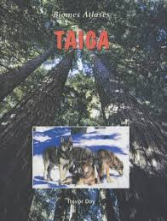 | 577 | 14151
Biomes Atlases: Temperate Forests | Woodward, John | Paperback | Library |  |  | 577 | 14148
Biomes Atlases: Tropical Grasslands | Morgan, Ben | Paperback | Library | Each title in this series provides readers with a deeper understanding of the world's biological communities, with each title focusing on a particular biome, biome type, group of biomes or system. | 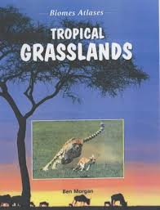 | 577 | 17310
Coastal Habitats | Taylor, Barbara | Paperback | Library |  |  | 577.51 | 14209
Deserts | Davies, N. | Paperback | Library | Introduces readers to the fascinating world of deserts, from he scorching Sahara to the icy Arctic. Learn about the fascinating animals that inhabit these vast expanses, and the people who live there - from Taureg nomads, to opal miners in Australia, to oil drillers in Bahrain. | 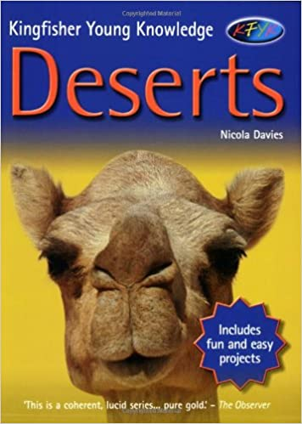 | 551.5 | 14614
Desert Habitats | Bennett, Paul | Paperback | Library | A comprehensive introduction to desert life; where are the world's deserts? What plants and creatures are to be found there? Learn how human industrialisation is endangering the desert habitat, and how we can help to save it for the future. | 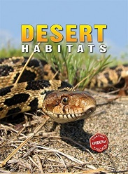 | 577.27 | 14216
Deserts | Bramwell, M. | Paperback | Library | Discusses the formation, plant and animal life, and natural resources of the deserts of the world. | 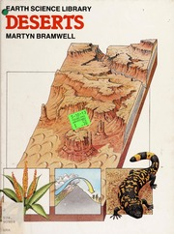 | 550 | 2903
Deserts | Gray, L. | Paperback | Library | This title looks at deserts: the agents of change that form deserts, where they can be found, how they are used by humans and how they are conserved. Maps will show where they are found in the world and diagrams will explain formations and processes, such as how wind scours caves in deserts. | 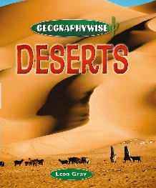 |  | 19190
Deserts and People | Carson, P. | Hardback | Library | An introduction to the climate and vegetation of deserts and the people who live there. Special emphasis is placed on the Sahara. | 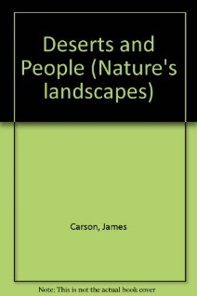 | 551.4 | 2898
Evergreen World, The |  | Hardback | Library |  |  | 579 | 13107
Exploring Habitats | Hudson, T Peacock, G | Hardback | Library |  |  | 577 | 5512
Rainforests | Hunter, Nick | Paperback | Library | Rain Forests are the wettest places on land and are home to so many exotic plants and animals. However, they can be very dangerous places, as well. If you had the chance to explore a rain forest, what would you need to know? What would you pack? Who would you want to come with you? | 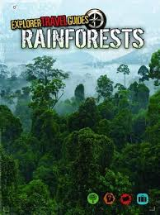 | 910.9152 | 19195
Four Seasons, The | Reader's Digest | Hardback | Library | Part of a compendium of books. This focus is on the British 4 seasons. Detailed photographs and illustrations on flora and fauna. | 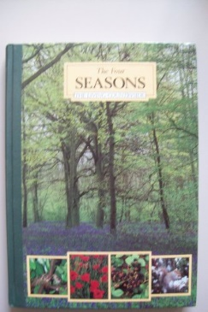 | 579 | 13109
Habitat Destruction | Orme, Helen | Paperback | Library | People often damage Earth's animal and plant habitats to get the resources they need to survive. They clear land to plant crops, cut down forests to get wood, and dig into the ground for oil and coal. As the world's population grows, more and more of these habitats are destroyed because more resources are needed. . | 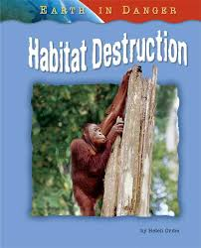 | 577.27 | 15240
Healthy Seas | Inskipp, Carol | Hardback | Library | "Sustainable Futures" explores the current threats to our world resources and the possible solutions to some of the most urgent and difficult problems facing today's decision-makers. How do waste chemicals from farming affect Arctic polar bears? How does climate change affect the seas? Why are the world's fish stocks in decline? "Healthy Seas" answers these questions and many others. | 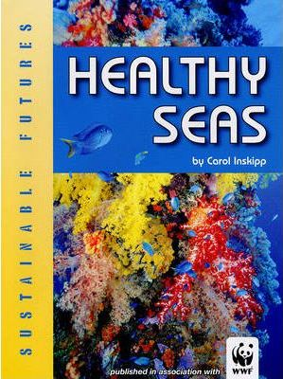 | 333.9164 | 14060
High Kingdom, The | Reader's Digest | Hardback | Library | Part of a group of books fully detailed photos and illustrations based on Britain. | 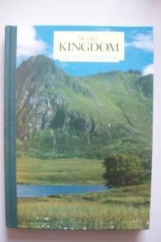 | 579 | 13115
Living Things | Various | Hardback | Library | This exciting and comprehensive encyclopaedia brings scientific principles within the grasp of every child, Clear authoritive text and well-researched, detailed artworks and photos. | 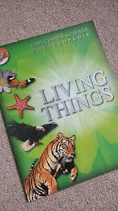 | 577 | 13089
Ocean Habitats | Bennett, Paul | Paperback | Library | This eye-catching, fact-filled series puts the natural world at students' fingertips. Perfect for reports, Exploring Habitats provides an in-depth look at habitats around the world, including detailed .. | 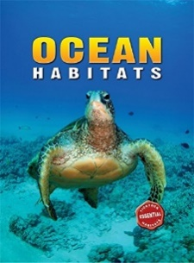 | 577.7 | 14213
Patchwork Landscape, The | Readers Digest | Hardback | Library | Part of a group of books fully detailed photos and illustrations based on Britain. | 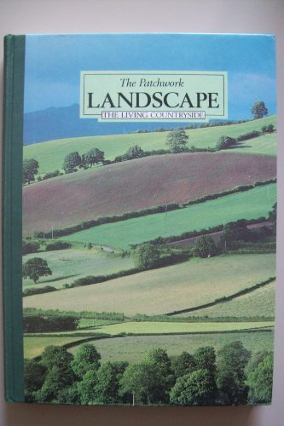 | 579 | 13114
Plants and Planteaters | Chinery, M | Hardback | Library | Tropical rainforests cover only about 6per cent of the earth's surface, yet they are home to more than half the world's species. This book looks at the biology and behaviour of plants and planteaters describing how they live together in harmony and balance. | 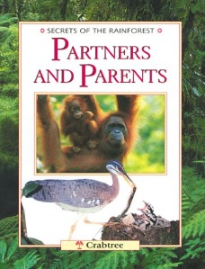 | 577 | 9430
People and Places - Secrets of the Rainforests | Chinery Michael | Hardback | Library | One of a series, this book looks at aspects of life in these threatened wildernesses, revealing how forest people live and interact with a wondrous array of plants and animals. It explains the global importance of the forests and covers how they can be preserved. | 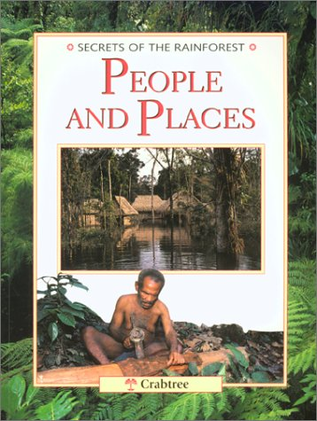 | 577.3 | 9366
Plants and Planteaters | Chinery, M | Hardback | Library | Tropical rainforests cover only about 6per cent of the earth's surface, yet they are home to more than half the world's species. This book looks at the biology and behaviour of plants and plant eaters describing how they live together in harmony and balance. | 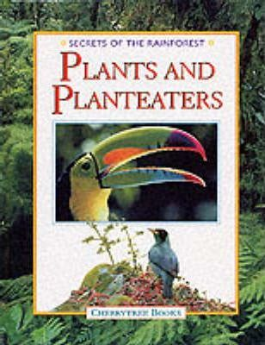 | 577 | 9430
Polar Habitats | Taylor, Barbara | Paperback | Library | Explore the regions of the South and North Poles and the animal life that they support. As the last two major wilderness areas on Earth, discover how, and what type of life is supported in the 'lands of the midnight Sun'. Part of the ESSENTIAL HABITATS series, providing an easily accessible introduction to the world's varied habitats and creatures. | 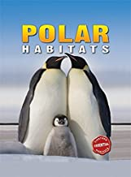 | 577.27 | 14220
Pole to Pole | Taylor, Barbara | Paperback | Library | Looks at the animals, plants and birds that live in Antarctica and the Arctic and how they have adapted to the extreme climate. Includes chapters on people of the Arctic and protecting the poles. Suggested level: intermediate, junior secondary. | 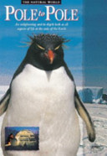 | 577.5 | 19423
Polar Regions in Danger | Ganeri, Anita | Paperback | Library | This series examines some of these endangered environments | 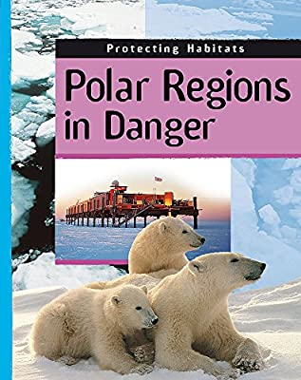 | 577
Rainforest | Greenwood, E. | Paperback | Library | Eyewonder rainforest is full of fantastic facts and colour photographs, is the perfect way for children to learn about rainforest life. | 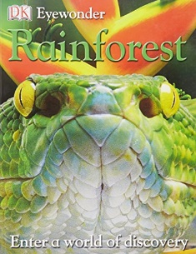 | 577.34 | 17722
Resources and Conservation | Chinery Michael | Hardback | Library | One of a series, this book looks at aspects of life in these threatened wildernesses, revealing how forest people live and interact with a wondrous array of plants and animals. It explains the global importance of the forests and covers how they can be preserved. | 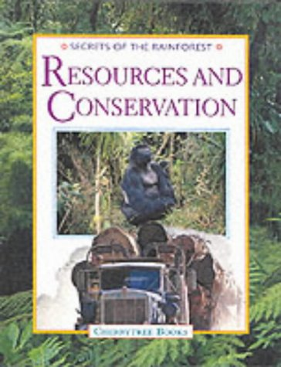 | 577 | 9365
River and Inland Water Habitats | Taylor, Barbara | Paperback | Library | In River and Inland Water Habitats you will discover where on Earth these amazing water plants and animals are found, as well as the important roles they play in the living ecosystem. Included are over 100 stunning full-colour images to take you on a spectacular, educational journey to explore nature. | 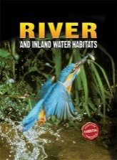 | 577.27 | 14211
Seas and Islands |  | Hardback | Library | This very good book from Readers Digest tells the story of the fish, invertebrates, birds and mammals that inhabit the seas around the UK. The pictures of which are excellent. The text is outstanding and informative. The introductory chapter deals with islands, caves, wrecks beaches and the sea bed. there 24 contributors to this book all of whom seem to be experts in their field | 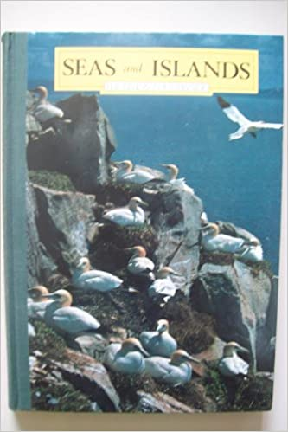 | 577 | 13108
Secrets of the Rainforest  Poisoners and Pretenders | Chinery, M | Hardback | Library | Tropical rainforests cover only about 6% of the earth's surface, yet they are home to more than half the world's species. This book looks at the biology and behaviour of animal, insect and plant poisoners and pretenders. It is one of a series of books which aims to provide an understanding of the unique ecosystems of the rainforest. | 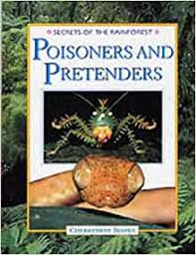 | 577 | 9440
Temperate Forest Habitats | Taylor, Barbara | Paperback | Library | "Temperate forests are green in spring and summer, have beautiful colors in the fall, and are barren in the winter. What kind of life is found here?" | 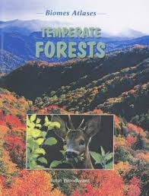 | 577.3 | 14205
The Ocean Biome | Smithyman, Kathryn | Paperback | Library | Oceans and seas form the marine biome, which is the world & apos;s largest biome. It covers three-quarters of the Earth & apos;s surface and reaches from the far north to the far south of the planet. | 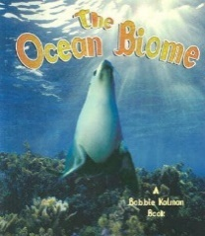 | 577 | 17320
Tropical Rainforest Habitats | Taylor, Barbara | Paperback | Library | At least half of the animal and plant species in the world live in rainforests! Their warm wet climate is home to a vast collection of plant and animal life, yet is under threat from human actions. Learn of the dangers that this habitat faces, and what can be done to help save the world's rainforests | 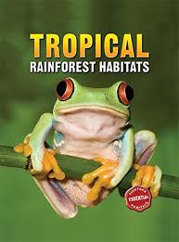 | 577.27 | 14219
Weather and Climate | Pipe Jim | Paperback | Library  3 copies | From a pleasant summer shower to the catastrophic effects of a hurricane, this book explores Earth's weather: what happens and why it happens. | 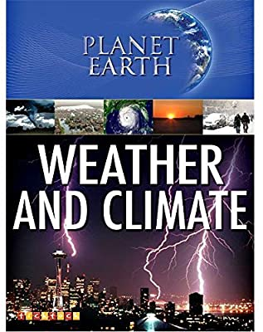 | 551.6 | 15290
What Is A Biome? | Kalman Bobbie | Paperback | Library  2 copies | Earth has over 30 types of biomes, some of which are home to thousands of ecosystems. All of the plants and animals living in these huge natural areas depend on one another for survival. This book explains the life in each major biome. It is illustrated with images and defines the concepts of biome and climate. | 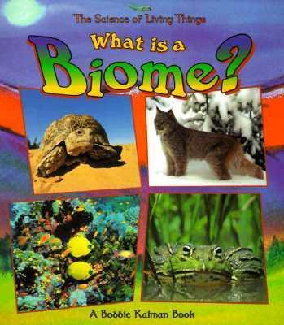 | 577 | 17318
Who Eats Who in Grasslands? | Butterfield, Moira | Paperback | Library | Every day, in every habitat in the world, animals are eating. Some animals hunt for food and some are hunted! But who is eating whom? In Food Chains in Action, readers will become acquainted with the eating habits of various creatures, as well as their relationship to neighboring animals. | 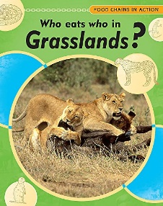 | 577 | 14278
Who Eats Who in Rivers and Lakes? | Campbell, Andrew | Paperback | Library | Read this book to find out how food chains in river and lakes really work | 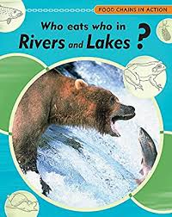 | 591.7616 | 15232
Who Eats Who in the Desert? | Campbell, Andrew | Paperback | Library | With large, full-colour photographs and fascinating fact boxes throughout, this series features real-life food chains and webs in various key habitats. | 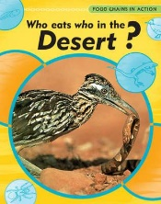 | 577 | 15237
Who Eats Who in the Rainforest? | Snedden, Robert | Paperback | Library | Every day, in every habitat in the world, animals are eating. Some animals hunt for food and some are hunted! But who is eating whom? In Food Chains in Action, readers will become acquainted with the eating habits of various creatures, as well as their relationship to neighboring animals. | 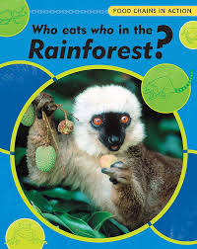 | 577 | 14295

Other web sources

https://www.bbc.co.uk/bitesize/topics/ztgw2hv

Biomes
https://www.bbc.co.uk/bitesize/guides/zh2p34j/revision/1

Polar biomes
https://www.bbc.co.uk/bitesize/guides/zt7hvcw/revision/1

