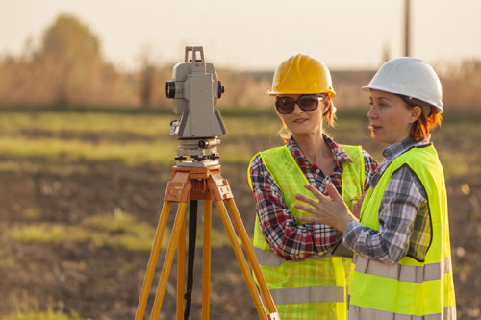
Job title: Cartographer
Job title: Cartographers | Cartographers collect information about the geography of an area to design and produce maps, charts and plans.
Entry requirements: | University:  You can take a degree in:  - geography  - geographical information systems (GIS)  - land surveying  - earth sciences  - oceanography  Employers may also accept degrees in other subjects like computer science, software engineering or graphic design.  A postgraduate qualification may help you to find work in a specialist field of cartography like GIS.  You'll usually need:  - 2 to 3 A levels for a degree  - a degree in a relevant subject for postgraduate study  Apprenticeships:  You could complete a geospatial survey technician advanced apprenticeship, or geospatial mapping degree apprenticeship.  You'll usually need:  - 4 or 5 GCSEs at grades 9 to 4 (A* to C) and A levels, or equivalent, for a higher or degree apprenticeship  Work:  You may be able to get into this job by starting as a trainee cartographic technician and working your way up.  Employers may look for an apprenticeship in geospatial surveying, or A levels or equivalent, in geography, art and design, mathematics or computing.  Other Routes:  If you want to work as a cartographer in the armed forces, you can apply to the British army as a geographic technician, or the Royal Air Force as an air cartographer.  After you leave the services, you could use your experience to find work in commercial cartography and mapping.
Skills required: | You'll need:  - knowledge of geography  - maths knowledge  - to be thorough and pay attention to detail  - analytical thinking skills  - excellent written communication skills  - excellent verbal communication skills  - design skills and knowledge  - the ability to work well with others  - to be able to use a computer and the main software packages confidently
What you'll do: | In this role you could be :  - using desktop publishing and specialist computer software  - designing digital or paper based maps  - checking maps and charts are accurate and to scale  - editing maps, adding and removing new roads, structures or landmarks  - collecting and analysing data from remote sensors on satellites and planes  - using GIS to model and analyse landscape features  - plotting the heights and positions of geographical features from aerial photographs  - carrying out topographic surveys of the land and hydrographic surveys of the sea and coastal areas
What you’ll earn: | £18,000 Starter to £45,000 Experienced
Working hours, patterns and environment: | - 39-41 hours per week  - Evenings occasionally  - You could work in a laboratory.  - Your working environment may be emotionally demanding.
Career path and progression: | With experience you could become a senior cartographer and manage mapping projects and staff.  If you specialise in working with GIS, you could apply for Chartered Geographer (GIS) status.  You could also work on a freelance basis, but you’ll need your own mapping equipment.

