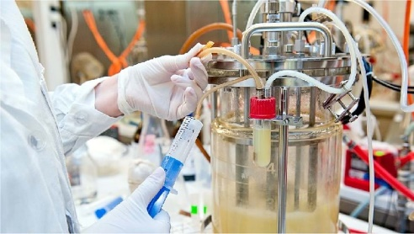
Job title: Chemical Engineer
Job title: | Chemical engineers develop ways to turn raw materials into everyday products.
Routes and Entry requirements: | University  You'll normally need a degree or postgraduate qualification in:  - chemical engineering  - process engineering  - biochemical engineering  You may be able to do a postgraduate conversion course if you have a degree in a related area like engineering, chemistry or polymer science.  A postgraduate master's qualification like an MEng can be studied at university. This course includes independent research and gives you a greater knowledge and understanding of chemical engineering science. It could also prepare you for further postgraduate study like a PhD.  You'll usually need:  - 4 or 5 GCSEs at grades 9 to 4 (A* to C), or equivalent, including English, maths and science  - 2 or 3 A levels, or equivalent, including chemistry  - a degree in a relevant subject for postgraduate study  Apprenticeship  You may be able to do a science industry process engineer degree apprenticeship.  You'll usually need:  - 4 or 5 GCSEs at grades 9 to 4 (A* to C) and A levels, or equivalent, for a higher or degree apprenticeship  Work  You could start as a chemical engineering technician and do training on the job to qualify as an engineer.
Skills required: | You'll need:  - maths knowledge  - knowledge of engineering science and technology  - knowledge of chemistry including the safe use and disposal of chemicals  - design skills and knowledge  - knowledge of physics  - analytical thinking skills  - science skills  - to be thorough and pay attention to detail  - to be able to use a computer and the main software packages competently
What you'll do: | If you work in research and development, you’ll:  - test new ways to develop products in the lab  - use computer models to work out the safest and most cost-effective production methods  - plan how to move lab tests into a pilot production phase, then on to large-scale industrial processing  - develop methods to deal with by-products and waste materials in a safe way  In manufacturing, you’ll:  - work with plant designers to create equipment and control instruments for the production process  - help to oversee the day-to-day operation of the processing plant  - monitor production and deal with problems  - work closely with quality control and health and safety managers
What you’ll earn: | £29,000 Starter to £60,000 Experienced
Working hours, patterns and environment: | - Typical hours (a week) 39 to 41  - You could work evenings, weekends/ bank holidays on shifts  - You could work in a laboratory, in an office or at a manufacturing plant.  - Your working environment may be outdoors some of the time.  - You may need to wear protective clothing.
Career path and progression: | With experience, you could progress to senior process or design engineer, research and development manager. You could go on to be a plant manager, or overall operations manager.  You could also move into consultancy work.

