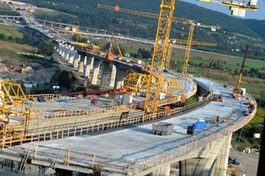
Job title: Civil Engineer

Job title: Civil Engineer | Civil engineers design and manage construction projects, from bridges and buildings to transport links and sports stadiums.
Entry requirements: | - You'll usually need an engineering degree (BEng) or a Master’s degree (MEng) in civil engineering.  - You could start as a technician and study part-time for an HND or foundation degree, leading to a degree in civil engineering.  - You could get into this job through an apprenticeship.  - The Institution of Civil Engineers has information on courses.
Skills required: | You'll need:  - excellent maths, science, and IT skills  - the ability to explain design ideas clearly  - the ability to analyse large amounts of data  - project management skills
What you'll do: | You could work in these areas of engineering:  - structural (dams, buildings, offshore platforms and pipelines)  - transportation (roads, railways, canals and airports)  - environmental (water supply networks, drainage and flood barriers)  - maritime (ports, harbours and sea defences)  - geotechnical (mining, earthworks and construction foundations)  You'll be:  - planning with the client  - analysing surveys, testing and mapping data using computer modelling software  - creating blueprints using computer aided design (CAD)  - judging if projects are worth doing by looking at costs, time and labour  - checking risks and the effects on the environment  - preparing bids for tenders, and reporting to clients and government agencies  - managing and checking progress at each stage  - making sure sites follow health and safety rules
What you’ll earn: | Starter: £24,000 (graduates)  Experienced: £25,000 to £40,000  Highly Experienced: £50,000 to £80,000 (senior chartered engineers)  These figures are a guide.
Working hours, patterns and environment: | You'll usually work 35 to 40 hours a week, Monday to Friday. You may work evenings and weekends.  You'll spend time in an office and on project sites.
Career path and progression: | With incorporated or chartered engineer status, you could move into senior project management roles. You could also specialise in a particular engineering field, work in research or become a consultant. You could work overseas with British consulting firms, and for oil and mining companies.  You could also work for international development and disaster relief agencies.

