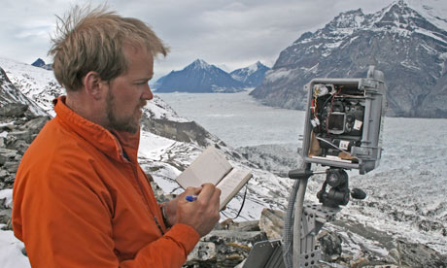
Job title: Climate Scientist
Job title: Climate Scientist  Climatologist | Climate scientists study the influences on the Earth's climate over time and how these might affect it in the future
Entry requirements: | University:  You can do a degree or postgraduate qualification in:  - environmental science  - geography  - physics  - maths and statistics  - oceanography  - meteorology and climate science  - computer science  You'll usually need:  - 3 A levels including maths and a science subject  - a degree in a relevant subject for postgraduate study  Volunteering and Experience:  You could get work experience through an internship or work placement. This would give you an insight into the different types of work you can do as a climate scientist.
Skills required: | You'll need:  - maths knowledge  - knowledge of geography  - knowledge of physics  - excellent verbal communication skills  - science skills  - knowledge of computer operating systems, hardware and software  - the ability to work well with others  - to be thorough and pay attention to detail  - to be able to use a computer and the main software packages confidently
What you'll do: | Your day-to-day tasks may include:  - gathering and analysing data from the atmosphere, oceans and land  - creating computer models to simulate the effects of changes to climate  - designing and building scientific instruments and sensors  - studying past climates to understand what might happen in the future  - monitoring ice packs, sea levels and temperatures  - looking at how global climate affects regional weather patterns  - attending conferences and publishing research findings  - investigating ways to tackle climate change  - advising policy makers  - teaching
What you’ll earn: | £27,000 Starter to £55,000 Experienced
Working hours, patterns and environment: | - 37-42 hours per week  - You could work between 8am and 6pm  - You could work in a laboratory or at a university.  - Your working environment may be outdoors some of the time.
Career path and progression: | You could specialise in an area of climate science, for example polar research, rainfall patterns or ocean changes. You might do this through research and teaching at a university, or by working for a government department.  You could also work as a palaeoclimatologist, studying previous variations in climate and how the Earth adapted to these.  Other career options include working as a consultant for science publishers or broadcasters.

