Websites

BBC Links
https://www.bbc.co.uk/sport/cricket
https://www.bbc.co.uk/sport/cricket/womens

Podcasts
https://www.bbc.co.uk/sounds/category/sport-cricket

Lancashire Digital Library – You will need to login
https://www.worldbookonline.com/student-new/#/search/Cricket/type/ar?searchType=basicsearch

BBC Cricket
http://news.bbc.co.uk/sport/hi/english/cricket/default.stm
The BBC News Web site features information about cricket news, players, and teams presente....

The Guardian Cricket Page
http://sport.guardian.co.uk/cricket/
Information about cricket players, teams, and matches from The Guardian Newspaper Group in....

Title | Author | Media | Where | Info | Book Image | Dewey No./Class | Barcode
Big Test | Cattell,B | Paperback | Library | It really doesn't look like being Hooker's season. Not only does he spend the first match of the league suffering a dropped-catch jinx but now there' civil war in the team over the selections. | 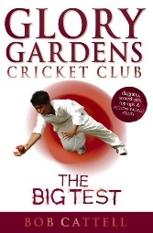 | Fiction | 11976
Bound for Glory | Cattell,B | Paperback | Library | Glory Gardens C.C. are now in the North County Under Thirteen League, and the pressure is really on. Hooker, as captain, worries that the team won't be able to hold it togethe | 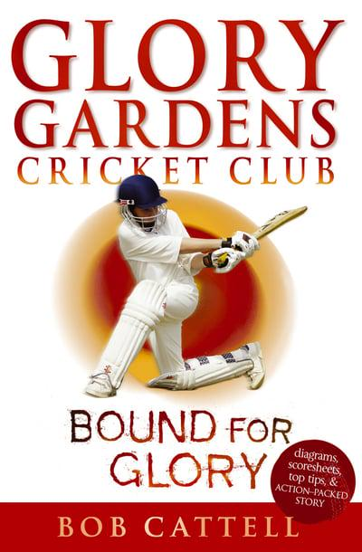 | Fiction | 11996
Brian Lara | Leigh, P | Paperback | Library |  |  | 920.B/LAR | 7147
Butterfingers | Collinson,Roger | Hardback | Library | Theo Lyzzick--one of Nature's non-sporty types--thought the end of the world had come when he found himself Third Man in for cricket and having to face Meltzer's body-liners | 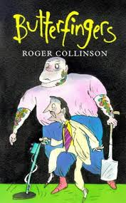 | Fiction | 13730
Cricket | Perchard, P | Hardback | Library | An illustrated book considering many aspects of cricket from practical skills for beginners to the tactics of international stars | 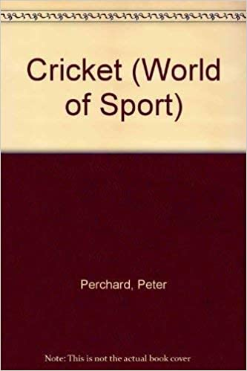 | 796.358 | 3770
Cricket | Blackall, B | Hardback | Library | Cricket - with an explanation of its history, its laws, and the skills it demands, accompanied by step-by-step illustrations. There is also coverage of equipment and preparatory exercises. | 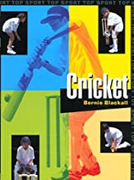 | 796.358 | 7359
Monty Panesar | Apps, Roy | Paperback | Library | Ever had a dream -- a dream to win? Monty had a dream -- to be a world-class cricketer. This is the story of Monty's early years and his break through into the England cricket team. |  | 920 | 13601
Freddie Flintoff Story, The | Aldred Tanya | Hardback | Library | From Cult Hero To Ashes Icon  Sevenoaks, 2005 Account of the Lancashire cricketer's life and career up to the England victory in the 2005 Ashes series. | 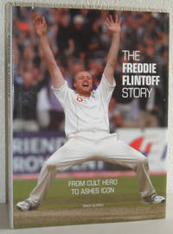 | 920 | 13738
Imran Khan | Leigh, P | Paperback | Library | Biography of Imran Khan is part of the "Livewire: Real Lives" series, which features personalities from sport, film and music, politics and history | 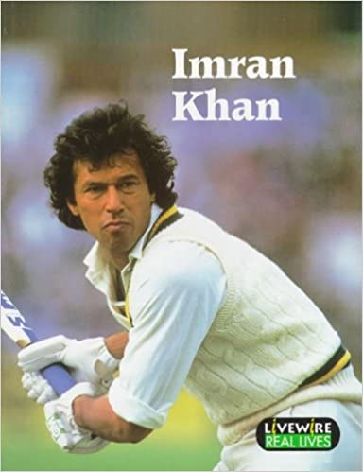 | 920.B/K | 7166
Official 1999 Cricket World CUP Fun Book | Pearce, S | Paperback | Library | A fun and fact filled book for every young cricket fan, filled with interviews, hints and tips from players, facts and stats, games, quizzes and jokes | 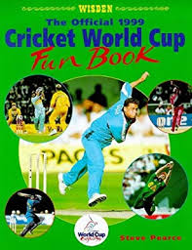 | 796.358 | 9218
Starting With Grace | Murphy, P Willis, B | Hardback | Library | A celebration of cricket 1864-1986. A collection of some 200 astonishing cricket photos dating from the era of W.G. Grace to present day. | 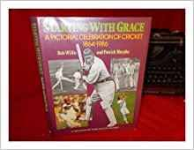 | 796.358 | 3771
War Games | Deary Terry | Paperback | Library | Esther and George have never met but both their lives have been touched by war. Will they be forced to give up their beloved sports, or will sport be the very thing that gets them through? Touching stories of cricket and football set during World War II. | 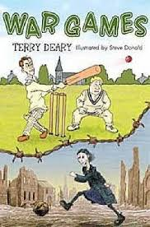 | Fiction | 12766
World-class Cricketer, A | Langley, Andrew | Paperback | Library | Containing fascinating facts about all aspects of the sport, it includes case studies about the sport and its well-known personalities. | 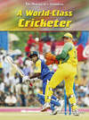 | 796.358 | 14072
Cricket 2.0  Inside the T20 Revolution | Tim Wigmore | eBook | Lancashire Libraries Online  https://fe.bolindadigital.com/wldcs_bol_fo/b2i/productDetail.html?productId=LSB_693159&fromPage=1&b2bSite=5070 | '‘A fascinating insight into how the newest format has impacted on the game at every level including Test cricket. Essential reading for T20 fans and traditional followers’ - ‘An invaluable guide by two smart young writers to the story of T20 cricket, to the strategies that underpin it and to the players who have made the format’ - | 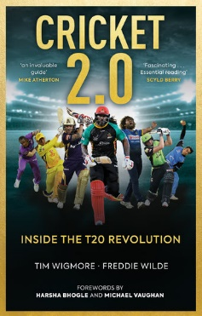
Cricket My Way | Jack Bannister and Ian Botham | eBook | Lancashire Libraries Online  https://fe.bolindadigital.com/wldcs_bol_fo/b2i/productDetail.html?productId=HCU_388074&fromPage=1&b2bSite=5070 | In Cricket My Way, Ian elaborates on his philosophy, explaining just why a positive attitude to all matches can pay dividends and how much he, despite his reputation as a brilliant individualist, places a heavy reliance on the traditional skills of the game. | 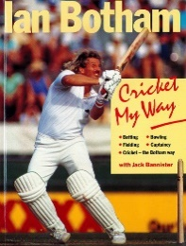
Arlott, Swanton and the Soul of English Cricket | David Kynaston and Stephen Fay | eBook | Lancashire Libraries Online  https://fe.bolindadigital.com/wldcs_bol_fo/b2i/productDetail.html?productId=BLM_481710&fromPage=1&b2bSite= | A fascinating account of how two BBC broadcasters battled for the soul of English cricket during a time of great social change | 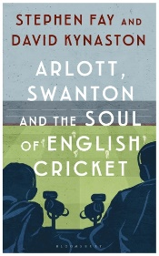
The Taliban Cricket Club | Timeri Murari | eBook | Blackburn with Darwen Libraries  https://fe.bolindadigital.com/wldcs_bol_fo/b2i/productDetail.html?productId=FFP_383817&fromPage=1&b2bSite=5614 | A determined young woman's plan to escape from Taliban-ruled Afghanistan (and a cruel Taliban commander who is determined to marry her) depends on the outcome of an unusual cricket match. | 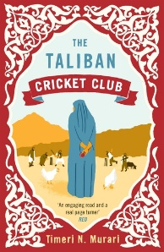
The Joy of Cricket | Graham Tarrant | eBook | Blackburn with Darwen Libraries  https://fe.bolindadigital.com/wldcs_bol_fo/b2i/productDetail.html?productId=EPD_608444&fromPage=1&b2bSite=5614 | Amusing anecdotes and captivating stories and quotes from the world of cricket, is perfect for anyone who knows the incomparable joy of the gentleman’s game. | 
The Spirit of Cricket  What Makes Cricket the Greatest Game on Earth | Rob Smyth | eBook | Blackburn with Darwen Libraries  https://fe.bolindadigital.com/wldcs_bol_fo/b2i/productDetail.html?productId=FFP_055374&fromPage=1&b2bSite=5614 | 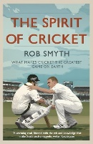
Denis Compton  The Authorized Biography | Tim Heald | eBook | Lancashire Libraries  https://fe.bolindadigital.com/wldcs_bol_fo/b2i/productDetail.html?productId=FFP_765451&filter=all&fromPage=1&b2bSite=5070 | 

