Walton le-Dale High School – Year 6/7 Summer Transition Project
Summer Challenge:
Create a collage, on a piece of paper or card, to introduce yourself to your new classmates and teachers.
You can choose to bring in the collage that you have made or just a photograph of the collage. Your teachers will ask you to refer to this in your first week at Walton le-Dale.
YOU SHOULD INCLUDE: | YOU COULD ALSO INCLUDE:
- Names or nicknames  - Hobbies and interests  - Favourite foods  - Favourite places  - Favourite books/texts  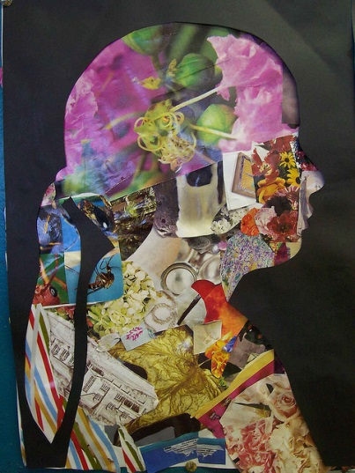  - Pet hates  Aim to:  - Make it colourful  - Use a range of materials  - Be creative! | - Images – photos or sketches  - Information about your pets  - Your hopes and ambitions  - Anything else of importance to you or interesting facts about you
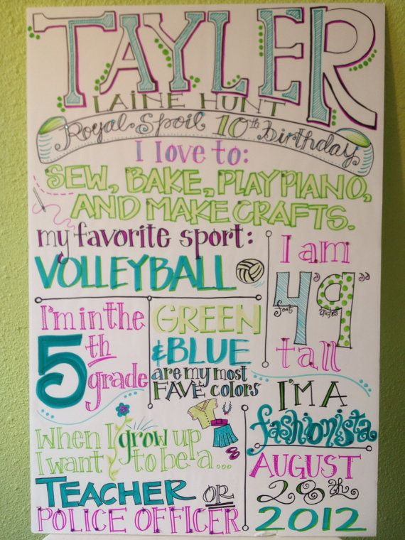

Mathematics
- What makes a number?
- What do you enjoy about Mathematics?
- Here are some prompts to help you:
  - Place value (including decimals)
  - How to order numbers
  - How numbers are used (e.g. money)
  - Percentages
  - Fractions
  - Anything else you can think of related to numbers

ICT
What special ICT jargon (words) do you know and understand? For example:
CPU, hard drive, software, processor, memory, RAM
Add any others that you have heard and understand

Skills
- Overall, what skills do you have?
  - Think about those you demonstrate at school and those in your leisure time?
  - Think about the things you are good at
- What ICT skills do you already have?
- What are you interested in learning about in ICT?

English
- Which books have you read and enjoyed?
- Who are your favourite characters?
- Who are your favourite authors?
- Can you remember any lines from books?
- What is your favourite genre of story?
- Which is your favourite setting for a story (spooky house, school, forest etc.)

Your Dreams and Aspirations
- Ideally, what will your life be like in the future?
- What choices will you make in terms of: house, cars, family, holidays, etc.

