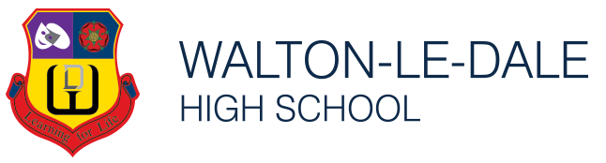
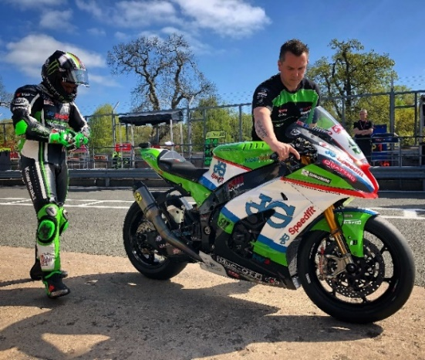
WLD Alumni
Dave Hopkinson - Class of 1995
Current Job Title - Race Mechanic at KWR Ducati (USA)
Career Plan –
‘My eventual career was something that was only a dream
when I was young, never something I actually ever thought
would be my way of paying my mortgage.
I was the kid watching the racing as a fan. Eventually and via a very different kind of education and career to begin with, I fought my way to the top of my chosen career. Even then, I've now taken a new direction again at 41 by taking what I've learnt in the last 20 years across to America in the hope of being just as successful but also building a better quality of life.’
Greatest Achievement/s –
‘I'd say my biggest achievement was building and developing the Superbike that Leon Haslam won the British superbike title on in 2018. It became one of the most successful bikes in the Championships history winning 15 races, 21 podiums and a 100% finish record. Along with numerous lap records, fastest laps and pole positions the bike was probably the proudest achievement of my working life. ‘
Advice to your teenage self –
‘Don't be afraid to take the decision to chase your dreams earlier in life’

