Websites
https://www.britishdancecouncil.info/

About Dance
https://www.britishdancecouncil.info/about-dance/

Ballroom Dancers Federation
http://bdfonline.co.uk/about-us/
http://bdfonline.co.uk/

Associated Board of Dance (ABD)
BDC Teachers Committee
UK Anti-Doping Rules
Allied Dancing Association (ADA)
Ballroom Dancers' Federation
British Association of Teachers of Dancing (BATD)
Blackpool Entertainment Centre Ltd
Dancesport Scotland
Dancesport Wales
Dance Promoters Association (DPA)
English Amateur Dance Sport Association
Northern Counties Dance Teachers Association
Imperial Society of Teachers of Dancing (ISTD)
International Dance Teachers Association (IDTA)
National Association of Teachers of Dancing (NATD)
Scottish Dance Teachers Alliance (SDTA)
United Kingdom Alliance Limited (UKA)
Welsh Alliance of Professional Teachers of Dancing (WAPTD) https://www.facebook.com/welshallance/

Dance Biography
ITV Dance Dance Dance
https://www.biogs.com/dance-dance-dance

Some of these took part in TV Dance competitions - Dancing with the Stars – Dancing On Ice - Strictly Come Dancing Celebs
Kurt Warner's Biography
https://www.biogs.com/dancing/warner.html
Chad Ochocinco's Biography
https://www.biogs.com/dancing/ochocinco.html
Sebastien Foucan's Biography
https://www.biogs.com/ice/foucan.html
https://www.biogs.com/james-cracknell
Shawn Johnson's Biography
https://www.biogs.com/dancing/johnsonshawn.html
Warren Sapp's Biography
https://www.biogs.com/dancing/sapp.html
Imperial Society of Teachers of Dancing (ISTD)
https://www.istd.org/modern-ballroom/

A selection of fiction and non-fiction books available in our school library and online
Title |  | Author | Media | Where | Info | Image | Class | Barcode
Ballet | Thomas, A |  | Paperback | Library | Provides information on ballet history, shoes, exercises, movements, classes, professional productions, and careers, and looks at famous choreographers, dancers, and ballets. | 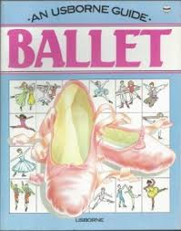 | 792.8 | 3613
Ballet | Thomas, A |  | Paperback | Library | Provides information on ballet history, shoes, exercises, movements, classes, professional productions, and careers, and looks at famous choreographers, dancers, and ballets. |  | 792.8 | 3612
Ballet | Thomas, A |  | Paperback | Library | Provides information on ballet history, shoes, exercises, movements, classes, professional productions, and careers, and looks at famous choreographers, dancers, and ballets. |  | 792.8 | 6903
Break Dancing | Alford, L |  | Hardback | Library |  | 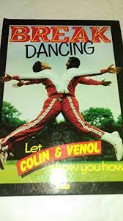 | 793.3 | 3601
Dance | Van Zandt, E |  | Hardback | Library | An examination of dance history and traditions from all over the world and thoughout the ages, which also looks at the social aspects and specific forms and movements of dance, and provides information about the different forms of dance and where to see it or take part in it. | 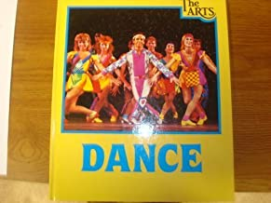 | 791 | 3585
Dance History: An Introduction | Adshead-Lans |  | Paperback | Library | Rationale, process, techniques and methodologies specific to the study of dance history | 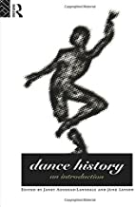 | 792.8 | 14970
Dance Superpack | E Jay |  | Audio | Library |  | 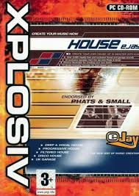 |  | 14119
To Be A Ballet Dancer | Morris, G |  | Hardback | Library |  |  | 792.82 | 3608
When I Dance | Berry, J |  | Hardback | Library |  |  | 821 | 3777
Great Performances | Dunning, Jennifer |  | Paperback | Library | Presents a collection of photographs taken during the taping of performances throughout the past twenty-five years. | 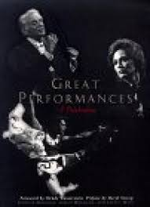 | 792 | 17005
Music and Dancing | Gunthorp, D |  | Hardback | Library |  |  | 793 | 3671
Performing Arts |  |  | Paperback | Library |  |  | 371.4 | 11065
World of Ballet, The | May, R |  | Hardback | Library |  | 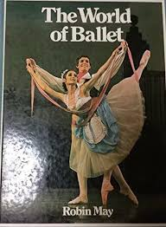 | 792.8 | 3611
Gymnast Gilly the Dancer | Aykroyd, P |  | Hardback | Library |  |  | Fiction | 1363
Save the Last Dance |  |  | Film | Library |  |  | 12 | 12847
Sky Dancer | Gill Lewis |  | Book | Library |  |  |  | 14705
Star Dancer | Webb, Beth |  | Hardback | Library |  |  | Fiction | 13980
Step Up 2 |  |  | Film | Library |  |  |  | 15454
Step up 3 |  |  | Film | Library |  |  |  | 17156
Your First Book of Ballet | Lemaitre, O J |  | Hardback book | Library |  | 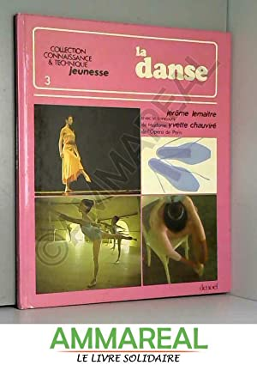
Ballet School Confidential: The Complete 3-Book Bundle | Charis Marsh |  | Online eBook | Blackburn Libraries  https://fe.bolindadigital.com/wldcs_bol_fo/b2i/productDetail.html?productId=LSA_560299&fromPage=1&b2bSite=5614 | Presenting the three titles in the Ballet School Confidential series, which follows a group of friends (and sometimes adversaries) during their time attending the Vancouver International Ballet Academy. | 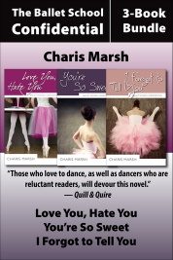 | Fiction
Ballet Shoes  A Story of Three Children on the  Stage | Noel Streatfeild |  | Online eAudiobook | Blackburn Libraries  https://fe.bolindadigital.com/wldcs_bol_fo/b2i/productDetail.html?productId=PRH_571546&fromPage=1&b2bSite=5614 | A masterpiece — Telegraph  'Ballet Shoes is one of my all-time favourite children's books - and you don't have to be a ballet fan to enjoy it.' - Dame Jacqueline Wilson | 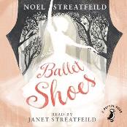 | Fiction
Ballet Shoes  A Story of Three Children on the  Stage | Noel Streatfeild |  | Online eBook | Blackburn Libraries  https://fe.bolindadigital.com/wldcs_bol_fo/b2i/productDetail.html?productId=PRU_191642&fromPage=1&b2bSite=5614 | She longs to be an actress.  Petrova, is a Russian orphan. She is happiest when playing with cars and engines.  Polly was handed over with just a pair of ballet shoes to her name. If she could, she would dance all day! | 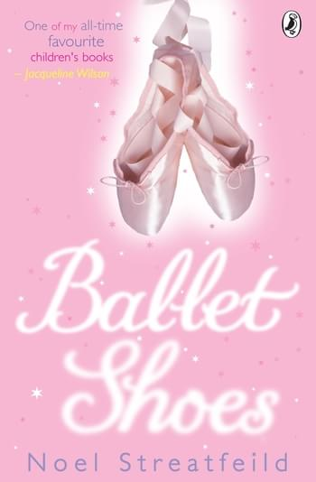 | Fiction
No Ballet Shoes in Syria | Catherine Bruton |  | Online eBook | Lancashire Libraries  https://fe.bolindadigital.com/wldcs_bol_fo/b2i/productDetail.html?productId=LSB_618000&fromPage=1&b2bSite=5070 | With beautiful, captivating writing, wonderfully authentic ballet detail, and an important message championing the rights of refugees, this is classic storytelling - filled with warmth, hope and humanity. | 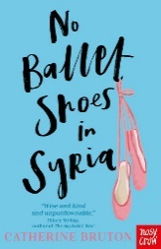 | Fiction
Ballet Shoes  A Story of Three Children on the  Stage | Noel Streatfeild |  | Online eBook | Lancashire Libraries  https://fe.bolindadigital.com/wldcs_bol_fo/b2i/productDetail.html?productId=PRU_191642&fromPage=1&b2bSite=5070  Library | She longs to be an actress.  Petrova, is a Russian orphan. She is happiest when playing with cars and engines.  Polly was handed over with just a pair of ballet shoes to her name. If she could, she would dance all day! |  | Fiction
Ballet Shoes  A Story of Three Children on the  Stage | Noel Streatfeild |  | Online eAudiobook | Lancashire Libraries  https://fe.bolindadigital.com/wldcs_bol_fo/b2i/productDetail.html?productId=PRH_571546&fromPage=1&b2bSite=5070 | A masterpiece — Telegraph  'Ballet Shoes is one of my all-time favourite children's books - and you don't have to be a ballet fan to enjoy it.' - Dame Jacqueline Wilson |  | Fiction

