Creative Digital Virtual Work Experience
Another group of Year 10 students spent their Work Experience week working virtually with Vic Turnbull, founder of MIC Media (http://www.micmedia.co.uk/). She supported them through various tasks, focusing on Photography, Branding and Website Design, to produce creative digital work including following a real life brief. The students completed workshops to learn more about these areas from industry professionals, while incorporating their ideas to produce individual work.
Creativity and digital skills are highly sought after by employers in the majority of sectors and, through this opportunity, the students created their own electronic portfolio to display their skills, interests and experience. These can now be used at future interviews and on application forms to allow them to demonstrate, not only their talents, strengths and achievements but also, importantly, their personality to potential F.E/H.E providers and employers and these can be built upon as they progress through Year 11 and on to their next steps.
Vic was extremely pleased with the standard of work that they produced and is was great to see their enthusiasm! Well done for their effort and a big thank you to Digital Advantage for making this happen.
Walton-le-Dale Careers Department Logo
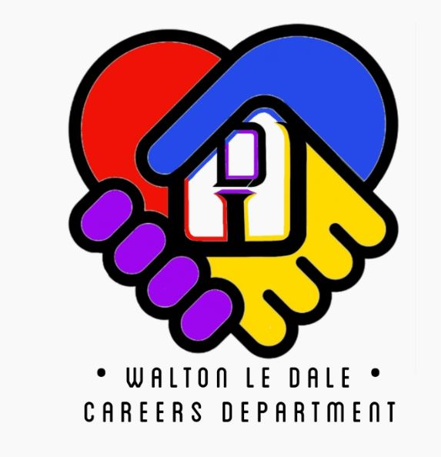
The students were given a brief to follow to create a logo for our Careers Department. Here are just some of the fantastic entries we received and we look forward to sharing with you the chosen design very soon -
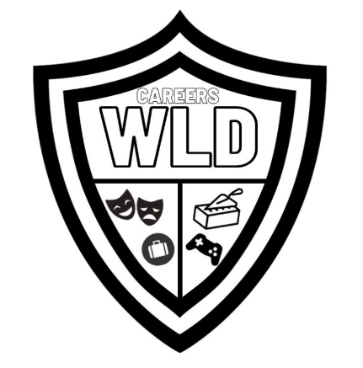
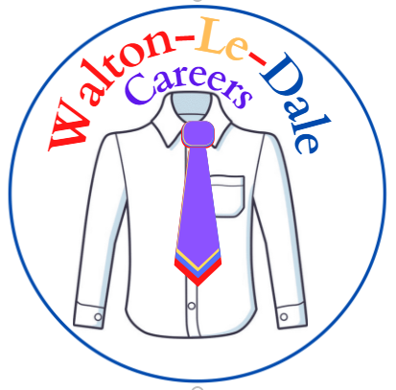
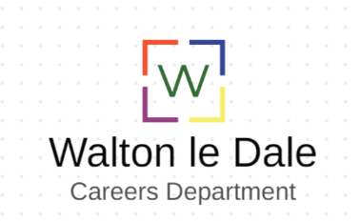

The students enjoyed working with Vic and here is some of their feedback –
‘The experience was great and showed me opportunities’
‘I now know a lot more that would help me with my aspirations’
‘I am now more open to creative jobs’
‘now I've experienced this and know how many things creative work really consists of I'm definitely considering it as a path I can go down’
‘I really enjoyed the time with Vic and she was really helpful in learning about Photography, branding and web design.’
‘It was awesome, I got to design a nice website with flair and details.’
‘Great experience hoping to do more in the future and thank you’

And here are some of their photographs…we had plenty of gorgeous pets showing off their modelling skills…
