Disadvantaged students progress – mid-year review
Feb 2018
Progress
The following charts include the Progress 8 figures from the last 3 years and the current projections for the next two years (current Year 11 and current Y10). The dip in disadvantaged performance has been thoroughly analysed and is understood as a cohort-related dip (for example, the disadvantaged Progress 8 figure improves to -0.5 if students who were not in school during KS4 are not considered).
The projections for 2018 and 2019 show the P8 figures continuing their rise towards national non-PP, with the gaps becoming smaller, or reversing so that disadvantaged students are projected to perform better than their non-PP peers in some cases. This is explained by considering the individual students in each cohort. Please note that the horizontal line is the 2017 benchmark (national non-PP performance).
The progress of students in EBacc subjects is particularly positive – this is explained by the change in the curriculum so that more students take EBacc subjects and the close focus on performance in Geography and French.
Key action: The performance of disadvantaged students in English is less positive and is being closely monitored with appropriate intervention.
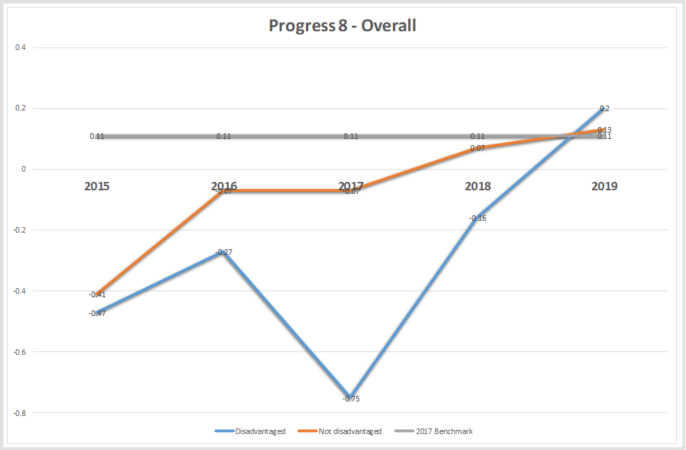

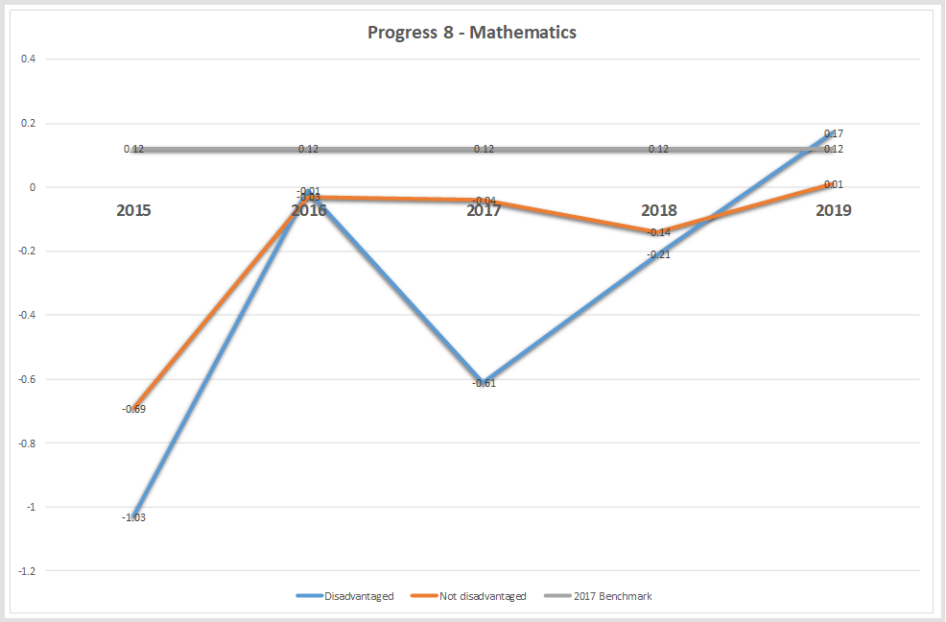

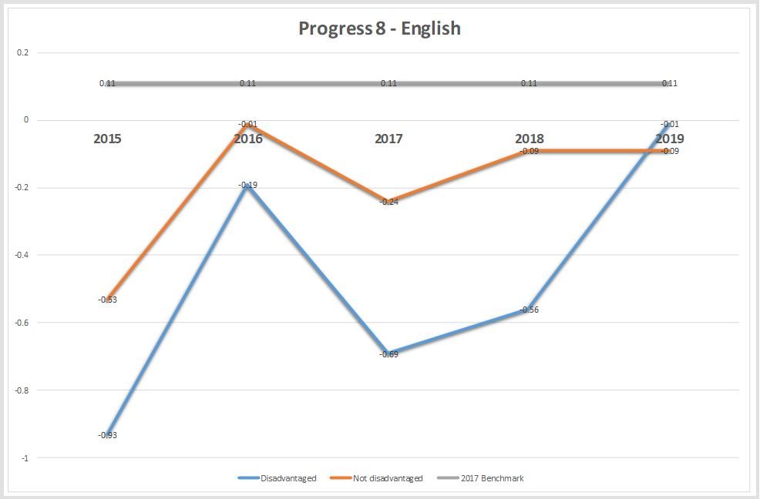

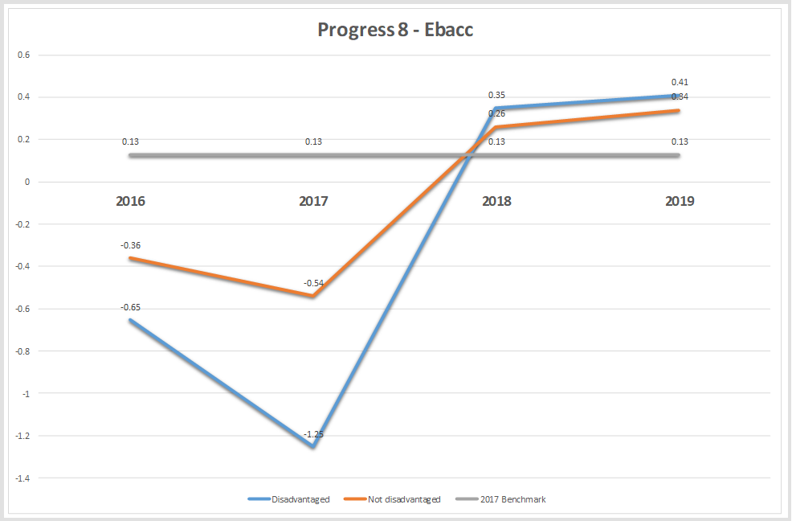

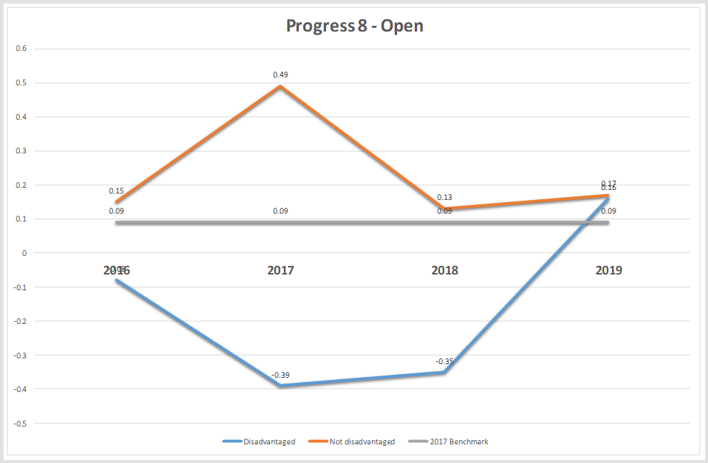

Attendance
The attendance of disadvantaged students is a cause for concern with the figures being too high for absence and persistent absence over the last couple of years. At the end of last term the PP PA figure (24.2%) was in line with the same point the previous year (23.8%), which was a good sign. However this has risen slightly over the following 5 weeks to 27.5% which is a cause for concern. Each student is being very closely monitored, with attendance meetings and targets as appropriate. The recent approval by the governing body of the use of fixed penalty notices is expected to have a positive impact over the coming months and we expect to bring the persistent absence figure for disadvantaged students in below last year’s final outcome. We strongly believe that if a student is not in school they cannot be taught and therefore attendance of all students, but particularly the attendance of vulnerable students, is a top priority.
Key Action: Intervention and monitoring of PP students who are currently persistently absent.

