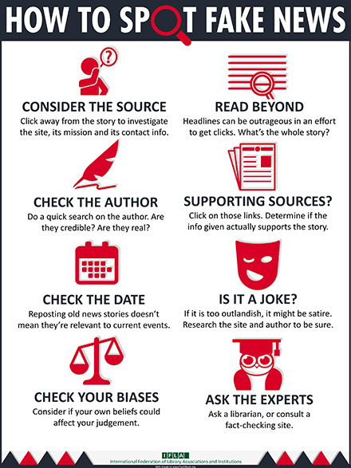

**Thought for the Week:**

**25th March 2019**