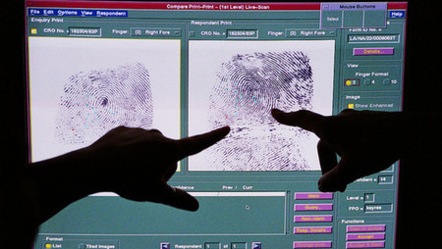
Job title: Fingerprint Officer
Job title: Fingerprint Officer | Fingerprint officers check and compare fingerprints taken from crime scenes.
Entry requirements: | University:  You could give yourself an advantage by doing a relevant degree in:  - forensic science  - criminology  - applied science  - chemistry  - biology  Entry requirements  You'll usually need:  - 2 to 3 A levels for a degree  Direct Application:  Each police service sets its own entry requirements, but to start as a trainee fingerprint officer you'll find it useful to have:  - 5 GCSEs at grades 9 to 4 (A* to C) including maths, English and a science subject  - A levels or equivalent qualifications  - experience of working in the police, analytical work or work involving attention to detail  Police services will carry out checks into your background and employment history. This might also include checking on your close family members.
Skills required: | You'll need:  - to be thorough and pay attention to detail  - patience and the ability to remain calm in stressful situations  - the ability to accept criticism and work well under pressure  - knowledge of public safety and security  - customer service skills  - to be flexible and open to change  - the ability to work on your own  - legal knowledge including court procedures and government regulations  - to be able to carry out basic tasks on a computer or hand-held device
What you'll do: | Your day-to-day duties might include:  - comparing crime scene prints with those of suspects  - scanning police fingerprint forms into the National Automated Fingerprint Identification System  - comparing fingerprints against the National Fingerprint Database to produce a list of likely matches  - analysing prints and marks to uncover links between crime scenes  - eliminating prints found at the scene of people not under suspicion  - classifying records and maintaining fingerprint databases  - preparing evidence statements and presenting evidence in court  - attending crime scenes to offer specialist advice  - getting fingerprint samples from the deceased at the morgue
What you’ll earn: | £16,000 Starter to £35,000 Experienced
Working hours, patterns and environment: | - 42-44 hours per week  - evenings / weekends / bank holidays on a rota  - You could work in a laboratory.  - Your working environment may be emotionally demanding.
Career path and progression: | With experience you could become a scenes of crime officer (SOCO).  With further training you could move into forensic science or become a criminal intelligence officer.

