Websites

Women’s Football
https://www.bbc.co.uk/sport/football/womens
Junior Football -Archived link – still worth a look
http://www.bbc.co.uk/juniorfootball/
Football Biographies
https://www.biogs.com/biogsdirectory/footballers.html
BBC News Coverage
https://www.bbc.co.uk/sport/football
BBC – Education

Podcasts
Forgotten Stories of Football
https://www.theguardian.com/football/series/forgotten-stories-of-football
https://www.thefootballhistoryboys.com/2019/09/the-football-history-boys-podcast-so-far.html
That Peter Crouch Podcast Contains some strong language and adult humour.
https://www.bbc.co.uk/sounds/play/p08jhp3y
Football Daily
Fantastic Fernandes and why Sane is leaving Man City
https://www.bbc.co.uk/sounds/play/p08jhqkj
Sport Podcast
https://www.bbc.co.uk/sounds/category/sport?sort=popular

Anatomy and physiology

The circulatory system
https://www.bbc.co.uk/bitesize/guides/z4tfr82/revision/1

Youth Sport Trust
https://www.youthsporttrust.org/pe-home-learning

BBC: Get Inspired
https://www.bbc.co.uk/sport/get-inspired
BBC Sport
https://www.bbc.co.uk/sport

Revisionworld: PE
https://revisionworld.com/gcse-revision/pe-physical-education
https://www.echalk.co.uk/PE/PE.html

NHS: Teen Healthy Eating
https://www.gosh.nhs.uk/teenagers/staying-healthy/healthy-eating

Title | Author |  | Media | Where | Info | Book Image |  | Dewey No./Class
Ultimate Football | Baddiel, Ivor |  | Paperback | Library | This title presents the quickest way to gen up on everything about everybody in time for the Euro 2004 finals! From Arsenal's FA cup history to Zidane's scoring record - get your facts right or face the penalty! | 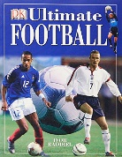 |  | 796.334
"Match" Book of Football Records, The: From the Makers of Britain's Bestselling Football Magazine | Match |  | Hardback | Library | The Big Match Book of Records is a one-stop celebration of the biggest and best from the football archives. | 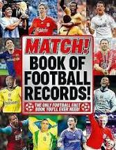 |  | 796.334
Hope Powell | Apps, Roy |  | Paperback | Library | Ever had a dream -- a dream to win? Hope had a dream -- to play in, and manage, the England women's football team. This is the story of Hope's early years and her break through into world-class women's football. | 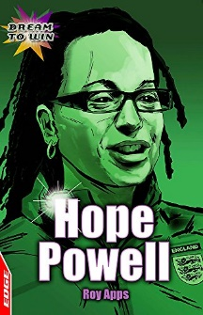 |  | 920
American Football | Barrett, N |  | Hardback | Library |  |  |  | 796.332
Away from Home | Hardcastle, Michael |  | Paperback | Library |  |  |  | Fiction
A-Z of the World Cup | Hurley, Michael |  | Hardback | Library | This title takes you on a journey through the alphabet, in which each letter reveals a fun and interesting fact about football. | 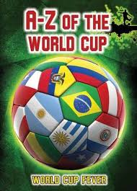 |  | 796.334668
Bad Boys | Cattell,B |  | Paperback | Library | This aspirational, near-reality series carries a sly slant on recognisable names, faces and issues from the world of football, providing the glitz and excitement of the Premier League.' | 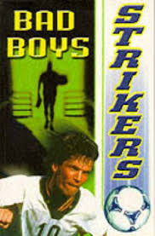 |  | Fiction
Bad Boyz K.O. Kings | Durant Alan |  | Paperback | Library | Are you always getting detention? Do you like playing football? If so, then Bad Boyz is the team for you! | 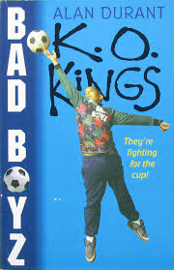 |  | Fiction
Bale: Real Madrid | Oldfield, Matt |  | Paperback | Library | Bale tracks the Welsh wizard's impressive rise from talented schoolboy to Real Madrid star. This is the inspiring story of how Bale beat the odds and became the most expensive player in football history. | 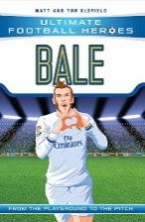
Bare Bum Gang and the Football Face-off, The | McGowan, Anthony |  | Paperback | Library | Their number 1 enemies have challenged them to a football match, and the prize at stake is the gang den. And guess what - they're all completely rubbish at football! | 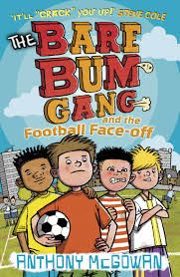 |  | Fiction
Big Deal | Ross & Cattell |  | Paperback | Library |  |  |  | Fiction
Big Football Frenzy, The: "The Big Win", "The Big Fix", "The Big Freeze" | Childs, Rob |  | Paperback | Library | THE BIG WIN Midfielder Mark Towers has just struck lucky: his family has won the Lottery! But Chris Weston, captain of Danebridge School football team, wants a different kind of big win - on the football pitch...THE BIG FIX Can Danebridge beat their arch-rivals.. |  |  | 796.334
Big Match Manager | Sheldon, Tom |  | Paperback | Library | This is brilliant fun for all budding football stars, and also has a great and pacy mystery to solve. |  |  | 793.7
Big Match Manager 2 | Sheldon, Tom |  | Paperback | Library |  |  |  | 793.2
Big Win, The | Childs, R |  | Paperback | Library |  |  |  | Fiction
Blast from the Past, A Time Rangers | Childs, R |  | Paperback | Library |  |  |  | Fiction
Boss-The Many Sides of Alex Ferguson, The | Crick Michael |  | Paperback | Library | THE BOSS is essential reading not just for Manchester United fans and football followers in general, but for anyone interested in the skills of successful management | 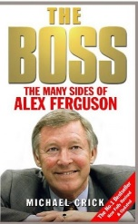 |  | 920
Boys United | Palmer, Tom |  | Paperback | Library | Boys United: the first book in the Football Academy series by Tom Palmer. Jake loves football and dreams of becoming a professional footballer. He's worried about his height though - what if he's too small for football? | 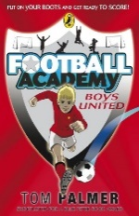 |  | Fiction
Burnley Football Club | Dean Hayes |  | Paperback | Library |  |  |  | 796.33
Captain Fantastic | Palmer, Tom |  | Paperback | Library | It is an exciting football series, following the adventures of United's under-twelves side. Since Ryan Flynn got into trouble for bullying, he's been determined to pull his socks up and be the best captain United's ever had | 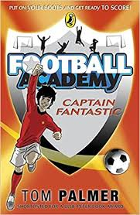 |  | Fiction
Celtic | Wilson, M |  | Paperback | Library |  |  |  | 796.334
Celtic Miscellany, The | Andrew, Smith |  | Hardback | Library | Presents facts, stats, lists, quotes and anecdotes from the rich history of one of the world's most famous and best-supported football clubs - the Celtic football club. | 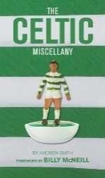 |  | 796.334
Charlie Merrick's Misfits | Dave Cousins |  | Book | Library
Cosmos and the Five A Side CUP | Woodcock P |  | Paperback | Library |  |  |  | Fiction
Crash | Spinelli, Jerry |  | Paperback | Library |  |  |  | Fiction
Cristiano Ronaldo | Oldfield, Tom |  | Paperback | Library | Ronaldo overcame sickness and poverty to become one of the best footballers ever. | 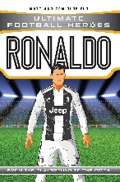
Cristiano Ronaldo: The Rise of a Winner | Part, Michael |  | Paperback | Library | Michael Part tells the tale of this celebrated footballer growing up and learning the game loved by millions. | 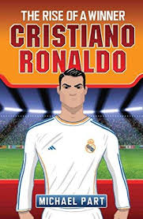 |  | 796.334092
CUP Run | Wadell Martin |  | Paperback | Library | Inventively illustrated in just two colours, these stylish first readers use several different media - posters, letters, video diary - to tell stories about subjects with strong child appeal, such as football, giants, dragons and highwaymen | 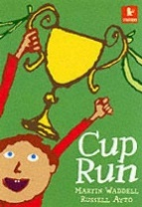 |  | Fiction
David Beckham: My Son | Beckham, Ted |  | Hardback | Library | Ted Beckham's story is the ultimate dream of every father who has kicked a football with his son | 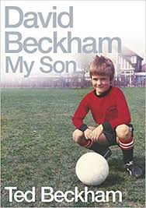 |  | 796.334092
Dazzer Plays on | May,Steve |  | Paperback | Library |  |  |  | Fiction
Divided we Fall - Total Football |  |  | Book | Library
Don't Stop Thinking About Tomorrow | Siobhan Curham |  | Book | Library | Stevie is determined not to be beaten and she takes inspiration from the lyrics of her father's 1980s record collection and dreams of a life as a musician. Then she meets Hafiz, a talented footballer and a Syrian refugee. | 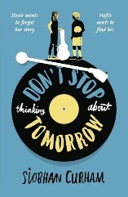
Don't Stop Thinking About Tomorrow | Siobhan Curham |  | Book | Library | Stevie is determined not to be beaten and she takes inspiration from the lyrics of her father's 1980s record collection and dreams of a life as a musician. Then she meets Hafiz, a talented footballer and a Syrian refugee.
Don't Stop Thinking About Tomorrow | Siobhan Curham |  | Book | Library | Stevie is determined not to be beaten and she takes inspiration from the lyrics of her father's 1980s record collection and dreams of a life as a musician. Then she meets Hafiz, a talented footballer and a Syrian refugee.
Dream on | Rai Bali |  | Paperback | Library | Much to the disapproval of his parents, Baljit is mad on football and dreams of playing for Liverpool. So when he is invited to trials at Leicester City, he has to lie about his whereabouts. | 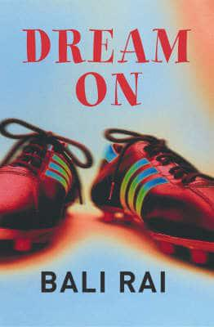 |  | Fiction
Encyclopedia of Football | Heatley, M Welch, I |  | Hardback | Library |  | 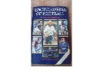 |  | 796.334
Manchester United | Various |  | Hardback | Library | Tribute to the World’s greatest football club, its heroes and legends. | 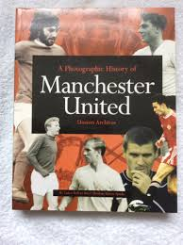 |  | 796.334
Essential History of Liverpool, The | Murphy Alex and Ericdoig |  | Hardback | Library | The complete story 1892-2003. Foreword by Ian Callaghan. Contains comprehensive statistics with results, tables and player details. 320 pages. Many b/w photographs | 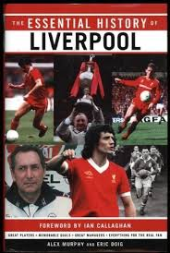 |  | 796.334
David Beckham | Apps, Roy |  | Paperback | Library | Ever had a dream -- a dream to win? David had a dream -- to play for Manchester United. This is the story of David's early years and his break through into Manchester United's first team. | 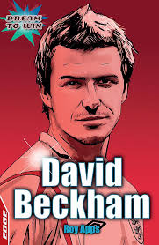 |  | 920
David Beckham | Apps, Roy |  | Paperback | Library | As above |  |  | 920
David Beckham | Apps, Roy |  | Paperback | Library | As above |  |  | 920
Football Legends | Gifford, Clive |  | Paperback | Library | From Pele to David Beckham, from Real Madrid to Manchester United, find out all the top facts and stats about the world's best clubs and players and WHY they are considered legends! | 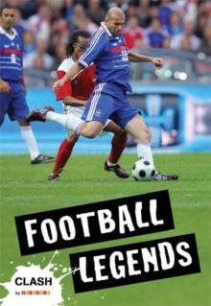 |  | 796.3340922
Rio Ferdinand | Croft, Andy |  | Paperback | Library | Rio Ferdinand is the story of this famous football star's rise to the top. | 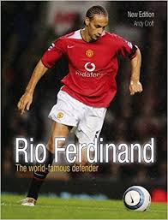
Sol Campbell | Croft, Andy |  | Paperback | Library | "Sol Campbell's life is as fascinating off the pitch as on it. From poverty, through his struggle against racism to a millionaire lifestyle. Insider info on a sports superstar.” | 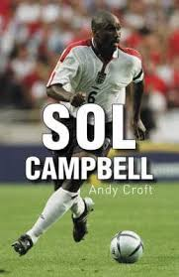
Sports People | Gogerly, Liz |  | Hardback | Library | "21st Century Lives: Sports People is a fresh and lively approach to the achievements of many of today's most successful sports men and women | 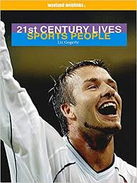
Wayne Rooney Annual: A Year in the Life of a Footballer: 2006 | Rooney, Wayne |  | Hardback | Library | Everything you ever wanted to know about Wayne Rooney can be found here in his official football annual | 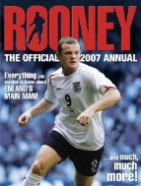 |  | 796.334092
Wicked World Cup | Coleman, Michael |  | paperback (B format) | Library | This international guide to World Cup football provides information on the Brazilians, the Argentinians, the Italians and the Germans. It also reveals the secrets of Pele, Maradona and the English heroes of the 1966 World Cup. | 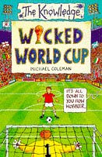 |  | 796.334668
Who's Who of Preston North End | Hayes, Dean |  | Hardback | Library | Dean Hayes has detailed the careers of every single one of those players. The book is highly illustrated throughout, and various statistics are included to supplement the career details of the players | 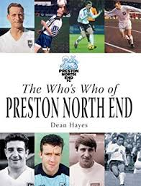 |  | 796.33
Harry Kane - England's Hero | Frank Worral |  | eBook | Lancashire Libraries  https://fe.bolindadigital.com/wldcs_bol_fo/b2i/productDetail.html?productId=LSB_524550&fromPage=1&b2bSite=5070 | England manager Gareth Southgate's decision to appoint Kane, still just twenty-three years old, as the team captain in 2017 could have been seen as premature, bringing with it pressure that could damage a young player's career. However, he knew that Kane, a modest, humble and inspiring figure was up to the task. | 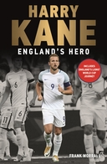
How to Be a Footballer  Peter Crouch | Peter Crouch |  | eAudiobooks | Blackburn with Darwen Libraries  https://fe.bolindadigital.com/wldcs_bol_fo/b2i/search.html?filter=all&q=sport+biographies&offset=0&fromPage=1&b2bSite=5614&searchBy=ALL&orderBy=relevance&loanFormat=eAudiobooks | "The funniest man in British sport" — Metro  "Who knew that a footballer could be funny? ... What you realise, as you laugh out loud, is that football has been taken too seriously by too many people for too long... Most other football books wither by comparison" — Daily Mail Sports Book of the Year  more > | 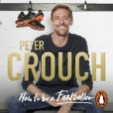
How to Be a Footballer  Peter Crouch | Peter Crouch |  | eBook | Blackburn with Darwen Libraries  https://fe.bolindadigital.com/wldcs_bol_fo/b2i/productDetail.html?productId=RDH_568232&filter=all&fromPage=1&b2bSite=5614 | As someone who's been there, done it and got the ill-fitting T-shirt, Crouch is well placed to shed light on the bizarre world of the modern player in a funny, down-to-earth way... He made his name on the pitch ... but with this book, Crouch proves he is a good sport off it, too." — Jade Craddock Sun | 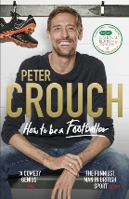
A Book of Heroes Or a Sporting Half-Century | Simon Barnes | eBook |  | Blackburn and Darwen Libraries online  https://fe.bolindadigital.com/wldcs_bol_fo/b2i/productDetail.html?productId=FFP_069459&fromPage=1&b2bSite=5614 | In this gripping new book, Simon Barnes brings together his 50 sporting heroes of the last 50 years and looks at what it is that elevates them to a state of grace and greatness. |  | 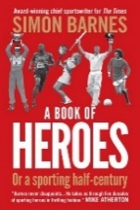
The Bud Collins History of Tennis | Bud Collins | eBook |  | Blackburn and Darwen Libraries online  https://fe.bolindadigital.com/wldcs_bol_fo/b2i/productDetail.html?productId=IPG_381272&filter=all&fromPage=1&b2bSite=5614 | Compiled by the world's foremost tennis historian and journalist, this book is the ultimate collection of historical tennis information |  | 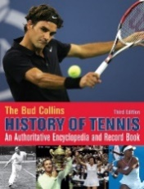
Sport Books online |  | eBooks  eAudiobooks |  | More links to Sport Books Blackburn And Darwen Libraries online  https://fe.bolindadigital.com/wldcs_bol_fo/b2i/search.html?b2bSite=5614&searchBy=ALL&q=sporting+heroes  https://fe.bolindadigital.com/wldcs_bol_fo/b2i/search.html?filter=all&q=sporting+heroes&offset=60&fromPage=1&b2bSite=5614&searchBy=ALL&orderBy=relevance&loanFormat=all  https://fe.bolindadigital.com/wldcs_bol_fo/b2i/search.html?filter=all&q=sporting+heroes&offset=120&fromPage=1&b2bSite=5614&searchBy=ALL&orderBy=relevance&loanFormat=all
Allez Allez Allez | Simon Hughes | eBooks  eAudiobooks |  | Lancashire Libraries  https://fe.bolindadigital.com/wldcs_bol_fo/b2i/productDetail.html?productId=RDH_695877&fromPage=1&b2bSite=5070 | Allez Allez Allez is the inside account of Liverpool FC’s 2018/19 season, a campaign which saw the club compete in the most gripping Premier League title race in history and become Champions of Europe for the sixth time. |  | 
The Age Of Football | David Goldblatt | eBook |  | Lancashire Libraries  https://fe.bolindadigital.com/wldcs_bol_fo/b2i/productDetail.html?productId=MCU_667304&fromPage=1&b2bSite=5070 | Reading David Goldblatt, you don't just understand football better. You understand the world a bit better, too. The breadth of his research is unmatched, and the writing is always a pleasure. — Simon Kuper  David Goldblatt is not merely the best football historian writing today, he is possibly the best there has ever been — Dominic Sandbrook Sunday Times |  | 