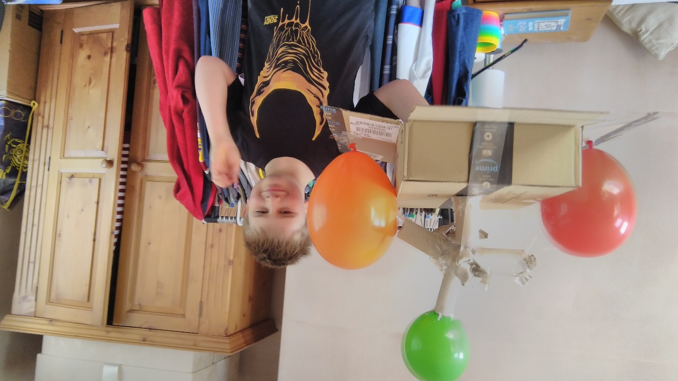

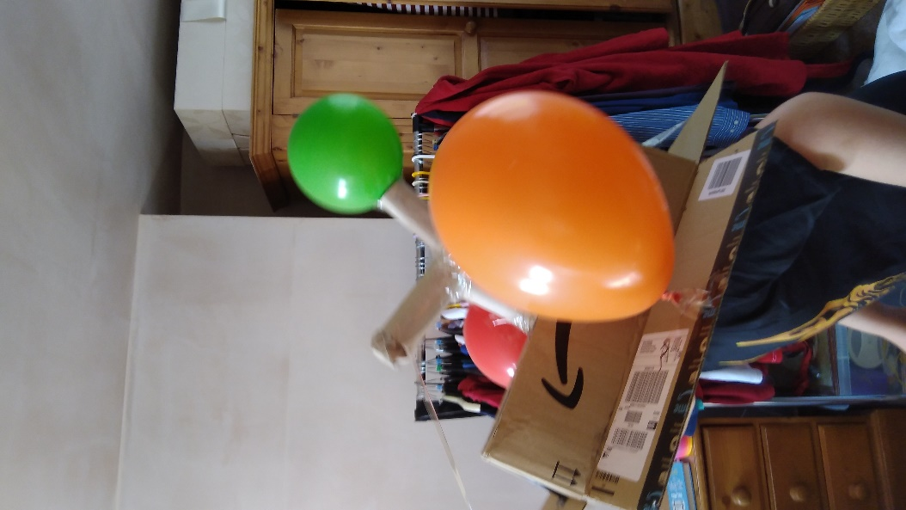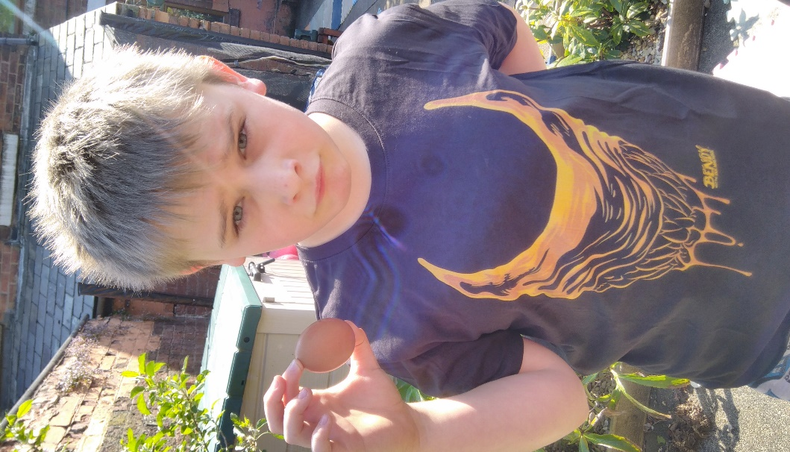
George made a nest for his egg ready to be launched from the dormer windo two floors up. The egg was inside one of the cardboard toilet roll inserts. It succesfully landed without cracking., even though he looks disappointed by the outcome.

George then proceeded to go to the kitchen with said egg, break it and mix it with blue food colouring to have a blue fried egg!!
Unfortunately as it cooked the blue colouring disappeared which was quite disappointing. George enjoyed the egg anyway

