Half Term Activities
Monday 25th May– Friday 29th May
Art Activities
MAKE A SUNSET BOX - Inspired by J.M.W. Turner, make your own magical landscape with a real sunset effect! For instructions and examples look online at: https://www.tate.org.uk/kids/explore/make-sunset-box

PAINT LIKE TURNER - Learn the styles and techniques of this famous painter. Learn how to create a Turner-style watercolour landscape or self-portrait online at:
https://www.tate.org.uk/kids/make/paint-draw/paint-turner

Send a photo of your finished work to Mr Sharples: d.sharples@waltonledale.lancs.sch.uk and they will be added to the school website.

P.S. Introduced in February 2020, on what can you find a portrait of J.M.W. Turner? (Hint: There might be one in your house!) Email Mr Sharples with your answer and he will give you a Class Chart point if you get it right!

Produce an image through photography, drawing or painting that reflects how you feel in lock down? Email your image to Mrs Miller s.miller@waltonledale.lancs.sch.uk and she will collate for an online gallery.
You may also want to watch Grayson Perry's Art Club for inspiration which is on Channel 4
Can you create spreadsheet art?
Have a look at Mr Moorcroft’s attempt and how to here.
Email your best efforts to Mr Moorcroft: j.moorcroft-jones@waltonledale.lancs.sch.uk
Could you make a music video involving your family?
Design and make a maths based board game that could be played with your family. All submissions will get classcharts points. The best submission will get a prize (at some point!) - Keep safe – The Maths department.
7 day | Expressive | Arts | Challenge
Day 1 | Day 2 | Day 3 | Day 4 | Day 5 | Day 6 | Day 7
Ask a member of your household who their favourite actor is and find 5 facts about them. | Recommend a film to your friends/family on social media/messaging. | Research a film director and try to watch at least 2 films they have directed. Are they similar? Can you see the director’s style in both films? | What is your favourite film soundtrack? Can you name all the songs used on it? | Come up with a “top 10” all-time greatest films list. | Can you name 10 films that have the word “House” in the title. | Write a short review of your current favourite film. Can you convince me I need to watch it?

Materials Technology

Practical activity - feeders for birds (and squirrels!) - can be made from up-cycled containers that would otherwise go in the bin or you may be able to make a more permanent, attractive look to the home with for instance a bird table. Also, bird boxes and insect 'lodges' may be nice long term addition (birds will be looking for next year rather than this season). Google image ideas, Pinterest etc. will start your creative journey.
Indoors - you tube - search 'how it's made ?????' - substitute the question marks for something that interests you - start with Haribo Gummies, - some of the food ones are fascinating.

Graphics – Watch some of these videos and have a go at the projects. Some of them require some basic equipment and/or materials:
Paper marbling - will require some paint/ink and a large basin for water.
Make a family of origami elephants - you just need paper for this one!
Make an origami dragon - This one is a bit harder for those who want a challenge!
Paint a cool slogan onto a T-shirt - You will need to get hold of some acrylic paint for this.
Make a paper quill picture - The video uses one or two tools. You can do this without them quite easily if you can’t get hold of a quilling tool. Have a go!
Create a picture frame from rolled up paper! - No tools needed. Just some decent glue.
Play with Stencils! - You will need paint, card and possibly a craft knife, and of course something to stencil! Get a parent or guardian to help you with this one! Brighten up your room with some funky stencils!
Make a fruit bowl or plant pot. - You will need help from a parent or guardian for this one.
Join the biggest Art Club in the world, with artist, Grayson Perry - New episodes every Thursday at 8:00, after we #clapforcarers

FOOD. Cupcakes – bake and decorate cupcakes if you have the ingredients to do so. Add flavours and fillings. Theme your cakes for example, rainbows adding food colouring to the cake batter and layer up in the cupcake cases to create different coloured layers of sponge. You could decorate the top with chocolate, glaze icing or buttercream. Another theme could be nature and use any element of nature. Just have fun baking it is a great activity and lots of people have taken up the art of baking. You can send me photos of your creations.

Here are 20 fun ideas for families to try out during half-term
(adapted from Teachit languages website):

From board game Olympics to round the world night, here are 20 ideas to banish boredom in lockdown, learn new skills and have family fun when schools are closed:
The great outdoors. Fresh air and exercise will help to banish boredom and housebound blues. The National Trust has offered free access to all their gardens and outdoor spaces during the pandemic, or go for a walk or bike ride, giving your kids the map to plan the route. With younger children, give them a bag and collect ‘treasures’ on the way – a beautiful leaf, stone or flower. Nearer to home, try tree climbing in your local park or set up camp in your garden and use stargazing apps like Nightsky.
Create a routine. Many children will benefit from a daily routine – it’s something they are used to at school. Build a plan that works for everyone and is age-appropriate. Ensure there are regular breaks and a set lunch hour and include screen-time as part of your schedule so children know what to expect.
Reading for pleasure. Encourage your child to read daily. Set older children book reading challenges such as ‘a book a day/week’ to motivate them, or create virtual book clubs with their friends using video chat apps, Google hangouts or Group FaceTime. If you run out of books, swap with friends (while following the guidelines for social distancing) or search for free audio and ebooks online. With younger children, create book-themed treasure hunts around the house or encourage them to make their own books or draw book covers featuring their favourite characters.
Free resources. Many educational websites (including Teachit) are offering free access to learning resources during the Coronavirus (Covid-19) pandemic. Ask your child which subject/s they think they need to work on most and search online together to find worksheets and resources to suit.
Train like a champion. Keeping physically active is particularly important for children. Research the training regime of a famous sportsperson or idol and get your child to create their own daily or weekly training programme, using videos and apps to help. Keep a record to track their progress and use rewards to motivate them, or set them the challenge of creating a family workout with DIY circuits and time trial challenges. Younger children might enjoy Go Noodle or Cosmic kids yoga for their daily workouts and millions are following Joe Wicks’ workouts on YouTube every morning.

Learn a lingo. While foreign travel may not be possible, virtual language lessons are. You can find a rich selection of videos and free apps to help your child learn some of the basics of any language in the world. Set them a challenge – how many languages can they count to ten in by the end of the week? How do you say hello in Japanese?
Good neighbours. Think of ways your family could help neighbours or older people in your community by running errands, picking up shopping or walking a dog, while following the guidance on social distancing. Could your children write letters to residents of local care homes, create little gift boxes, bake some biscuits or simply pick a bunch of flowers from your garden to brighten someone’s spirits?
Be more Greta! Take this opportunity to get back to nature as a family. Plant a few veg seeds or a bee-friendly wildflower patch. Try your hand at making seed bombs, a bug hotel or a birdbath and feeder. Trees for schools and the RSPB have lots of child-friendly ideas, upcycling projects and resources online.
Family jobs. With families at home, even very young children can be encouraged to help with jobs around the house. Older children might enjoy projects such as room makeovers and DIY, mowing the lawn or cooking family meals. Younger children might like to get involved in looking after pets, cleaning the car, sweeping up or using the vacuum cleaner.
Making movies. Encourage your children to make stop motion shorts and Lego-style movies with apps like Stop Motion Studio, or use Telestory to make themed tv shows with backgrounds, costumes and special effects, or create cartoons with Toontastic. They might also like to experiment with green screen apps.
Time travelling. Keep a daily diary for future historians studying the Coronavirus pandemic or create and bury a time capsule for future generations to find.
Pinspiration. Pinterest is a great source of ideas and step-by-step photo guides. Search for craft tutorials, fitness workouts, ideas for rainy days, tips for room makeovers and incredible recipes. If your child has a special interest, you’ll find something to excite them.

Photo Diary. Get your children to make a photo diary, collage or scrapbook for something they are learning about, cutting and sticking images or using a tool like Bookcreator to make their own digital book. Older children could use this for school work or revision.
A night at the movies. Dim the lights, get your favourite snacks or popcorn and settle down for a family night in with a favourite film. Work your way through the classics or let a different family member choose each night’s entertainment.
Friends in need. Help your children feel connected to others. Younger children might enjoy exchanging messages with friends in secret code or swapping drawings with each other. Older children can sign up for an international pen pal online or join Post Crossing to send and receive postcards from around the world, while teenagers will enjoy virtually hanging out with friends using Zoom or Skype.
Board game Olympics. A great way for siblings to play together at home, set up a board game competition based on the Olympics including all your favourite family games. Compete for medals in each ‘category’ and keep a medal tally.
Learn a new skill. Encourage your child to try something they have always wanted to do – learn to touch type, bake a cake without adult help, use Morse code, make a fire or master football tricks etc. Challenge them to perfect their skill over a week by practising regularly.
Round the world night. Take it in turns to cook a meal or order a takeaway from a different country. Make it more authentic by listening to music and watching films, cooking or travel programmes or even cartoons from that country – search YouTube or Spotify for playlists.
Virtual museum trips. While museums still remain closed, you can still visit their collections online. The Science Museum, British Museum, Museum of London and Natural History Museum all have resources for children, and NASA has a range of space projects for kids. You can even do a virtual tour of over 500 international museums using Google Arts and Culture.
Wonders of the world. Extend children’s natural curiosity about the world with specially selected Ted talks, or use Common Sense Media for suggestions for children’s documentaries and podcasts, along with reviews and age ratings. The Week Junior and the BBC’s Newsround will help to keep kids up-to-date, along with a weekly online news quiz.

Lancashire Archives are running a creative writing project called ‘Escaping lockdown’. There are lots of images to choose from and if one appeals to you then you can write a response – a poem, essay, story based on it. The website tells you more about the project.
The link is: https://redrosecollections.lancashire.gov.uk/news
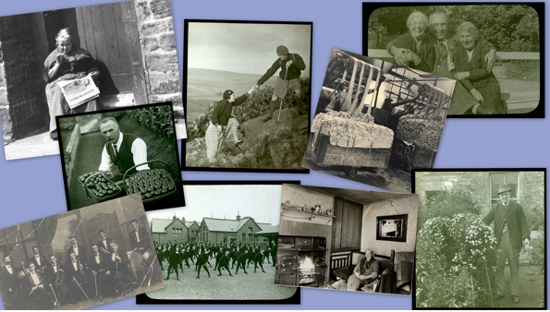

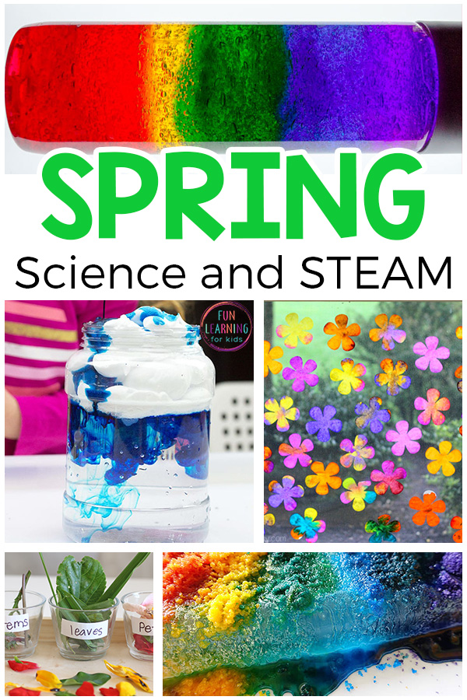Follow the link below to a website with lots of fun Science activities easy to do at home.
https://funlearningforkids.com/spring-science-activities/
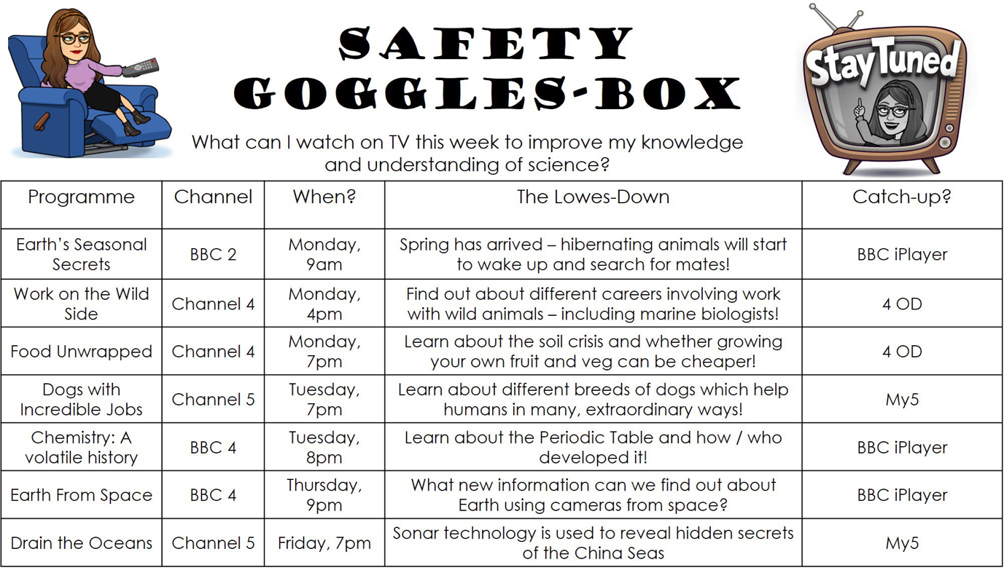
__________________________________________________________________________________
Start Profile - Home Activities https://guest.startprofile.com/workbook/module/84
Careers Family – Interview family members about their job, have fun recording the interview if you wish - interview other relatives and friends over the phone.
How is technology changing jobs, how to build an enterprise and more activities
Explore careers, the world of work and look at how your favourite subject can open many different doors in the future...
https://guest.startprofile.com/world-of-work
Dama and Dance Activities:
Why not have a go at learning this dance routine.
http://www.bbbpress.com/2020/03/remote-drama-activity-dance-tutorial-greatest-showman/

Drama research and reading….useful websites.
https://www.royalexchange.co.uk/
https://www.shakespearesglobe.com/learn/secondary-schools/
https://www.rsc.org.uk/

_________________________________________________________________________________

