Topic: World War 1

Books
Title | Author | What? | Comments | Cover | Classification/ in School Library
First World War 1914-1918, The | Robson, P | Booklet | Discover how the First World War began, what life was like for soldiers in the trenches but also what life was like for the civilians left at home. Find out what kind of weapons were used | 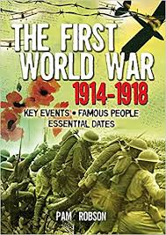 | 940.3
Causes and Consequences of the First World War | Ross Stewart | Book | Concise accessible account of events that led up to WW1 | 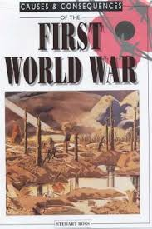 | 940.3
War Girls | Geras, Adele | Book | Through these and other tales, War Girls presents a moving portrait of loss and grief, and of hope overcoming terrible odds. | 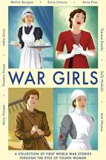 | Fiction
Great War: Stories Inspired by Objects from the First | Kay, Jim | Book | "A moving anthology of stories inspired by objects from the First World War, illustrated by Jim Kay." | 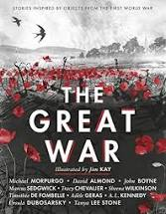 | Fiction
Stories of the First World War | Eldridge, Jim | Book | STORIES OF THE FIRST WORLD WAR tells the story of 1914-1918 through the experiences of twelve children and young people | 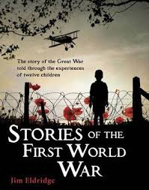 | 940.3
First World War, The | Ross, S | Book

Web Sources
First World War 100
https://www.nationalarchives.gov.uk/first-world-war/

Plays about South Asia and the First World War
https://media.nationalarchives.gov.uk/index.php/tag/loyalty-and-dissent/

Podcasts
https://media.nationalarchives.gov.uk/index.php/somme-tales/

War Girls Poetry
https://media.nationalarchives.gov.uk/index.php/war-girls-poetry-prose-women-first-world-war/

Indian Soldiers of the Western Front
https://media.nationalarchives.gov.uk/index.php/king-another-country-indian-soldiers-western-front/

Video
https://media.nationalarchives.gov.uk/index.php/germans-londons-first-zeppelin-raid/

