Topic: Lancashire

Books

Title | Author | Comments | Image | Classification  in School Library
Lancashire Witch Craze | Lumby, J | Jennet Preston and the Lancashire Witches, 1612 | 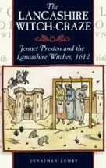 | 942.766
It Happened in Lancashire | Greenhalgh, Malcolm | From the world's largest tripe factory to the Battle of Wigan Lane; from the Peterloo massacre to the first British canal - Lancashire can claim it all. | 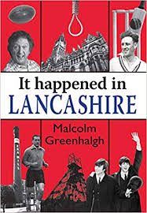 | 942.76
Lancashire Hot-Pot | Hayes, D | Essential Reading for the Lancashire Know-All. Facts and heritage, people and places. | 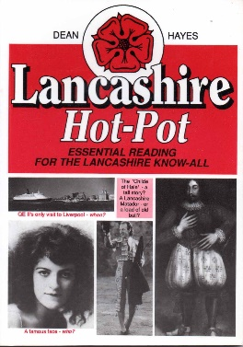 | 942.74
Victorian Lancashire | Bell, S P | Social history 19th Century, county municipal administrations, the police, the press, entertainment & entrepreneurs. | 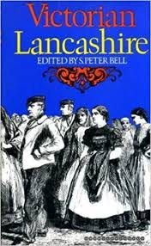 | 942.74
Traditions of Lancashire | Roby, J A | Nowhere in England is there such a rich store of characters and humorous tales as to be found in Lancashire | 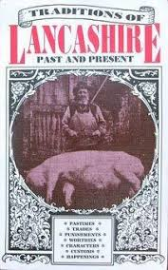 | 942.7665
Memories of the Lancashire Cotton Mills | Freethy, Ron | "A nostalgic look back at the county's cotton industry. Includes the workers' recollections and anecdotes, the events, both happy and tragic and the jobs and what they entailed. Profusely illustrated with both old and recent photographs." | 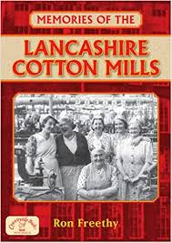 | 338.17351094276

Web Sources

British History Online is a not-for-profit digital library based at the Institute of Historical Research
https://www.british-history.ac.uk/search?query=Lancashire
https://en.wikipedia.org/wiki/History_of_Lancashire

http://www.forl.co.uk/online-resources/brief-history-of-lancashire

https://www.historic-uk.com/HistoryMagazine/DestinationsUK/HistoricSitesinLancashire/

https://www.lancashirelife.co.uk/people/a-history-of-lancashire-in-70-objects-1-5265505

https://www.lfhhs.org.uk/home.php

https://www.visitlancashire.com/things-to-do/historic-houses

http://www.lancashirehistory.org

http://www.lancashireway.com/history/

http://www.eastlancsrailway.org.uk/history-of-the-east-lancashire-railway.aspx

https://www.geni.com/projects/Old-Historic-Families-of-Lancashire/15657

Lancashire Witches – from British History Online
https://www.british-history.ac.uk/vch/lancs/vol6/pp514-518

