How fair is Fairtrade?
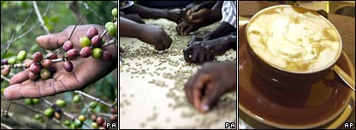

The Fairtrade label is increasingly common. But while shoppers seem keen to pay a little over the odds for fair trade products, some observers question how effective it really is in helping developing world farmers.
Fair trade products are popping up everywhere.
Gone are the days when you had to trek to an off-the-beaten-track shop that smelt of hemp in order to buy a fair trade woolly jumper or bar of chocolate. Now you just need to visit the High Street.
Topshop, once a bastion of cheap and cheerful garments, sells fair trade tunics, bubble tops and racer-back vests. And Marks and Spencer works with more than 600 fair trade cotton farmers in the developing world, using their cotton to produce chinos (for men), jeans (for women), hooded tops (for the kids), and a host of other fair trade fashion items.
Sainsbury's sells fair trade chocolate and coffee, and recently announced that the only bananas it will sell in future will come from fair trade producers.
There are more than 2,500 product lines in the UK that carry the Fairtrade mark. Last year we spent £290m on fair trade food, furniture and clothing - an increase of 46% on the previous year.
It is currently Fairtrade Fortnight, organised by the Fairtrade Foundation. Events at schools, colleges, universities and workplaces up and down the country consist of everything from makeovers (swap those ordinary store-bought clothes for fair trade threads) to food exchanges (bring along your favourite brand of tea, coffee or jam and swap it for a fair trade alternative).
The aim of fair trade is clear - to get a better deal for Third World farmers.
In order to win the Fairtrade tag, the application of which is monitored by Fairtrade Labelling Organisations International, companies have to pay farmers higher than the market price for their products. This means fair trade farmers are not at the mercy of the market's whims, and have extra money to invest in education for their children and other social needs.
Thought for the Week: Fairtrade Fortnight

