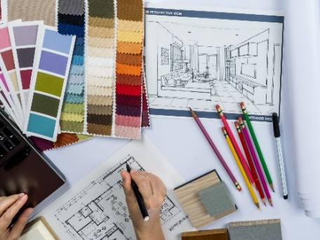
Job title: Interior Designer
Job title: Interior Designer | Interior designers plan and supervise the layout and decoration of the inside of buildings.
Entry requirements: | University  You could take a foundation degree, higher national diploma or degree in a relevant subject like:  - interior design  - art and design  - interior architecture  - spatial design  You'll usually need:  - 1 or 2 A levels, or equivalent, for a foundation degree or higher national diploma  - 2 to 3 A levels, or equivalent, for a degree  College  You could take a college course to get started, for example:  - Level 3 Diploma in Interior Design  - Level 3 Diploma in Art and Design  - A Level in Art and Design  You may need:  - 4 or 5 GCSEs at grades 9 to 4 (A* to C), or equivalent, including English, maths and a creative subject  Apprenticeship  You could do a furniture design technician advanced apprenticeship to get into interior design.  To get onto an apprenticeship, you'll find it useful to have:  - 5 GCSEs at grades 9 to 4 (A* to C), or equivalent, including English and maths, for an advanced apprenticeship  Work  You could start as a design assistant with a company and take further training and qualifications on the job.  Further information  You can get more details about careers and training in design from the British Institute of Interior Design.  You can get information on working in this and other creative careers from Discover Creative Careers.
Skills required: | You'll need:  - design skills and knowledge  - to be thorough and pay attention to detail  - customer service skills  - the ability to come up with new ways of doing things  - the ability to accept criticism and work well under pressure  - knowledge of building and construction  - the ability to use your initiative  - the ability to work well with others  - to be able to use a computer and the main software packages confidently
What you'll do: | Your day-to-day tasks may include:  - meeting clients to discuss their requirements and ideas  - developing designs to suit clients' needs, their budget, and the type of building  - preparing initial sketches and mood boards for the client to approve  - advising on use of space, colour schemes, fabrics, fittings and furniture  - working out costs and preparing estimates  - creating detailed drawings from the initial sketches, usually on a computer  - finding suppliers of fittings, furniture, fabrics, and wall and floor coverings
What you’ll earn: | Average salary (a year) - £18,000 Starter to £45,000 Experienced
Working hours, patterns and environment: | - You could work in an office, from home, in a creative studio or at a client's business.  - Typical hours (a week) 40 to 42 variable  - You could work evenings / weekends attending events or appointment
Career path and progression: | You could move into related work like theatre set design, visual merchandising, exhibition design or furniture design.

