Introduction to the School Improvement Conference January 2020

James Harris

Why am I giving this talk and then circulating it in writing and publishing it on the website? There is one simple reason - I think that everyone has a part to play, a stake in our school and something to contribute. To contribute fully we all need to have a shared understanding of where we are now - and that is my job to summarise that in a way that I hope everyone can relate to. I appreciate that, depending upon your role in the school, you may think that some of the things that I say do not apply to you, but actually they do - we are all part of the same school community. I am going to talk about our principles, the last 2 years and what comes now...

We review the overall direction of the school every 2 years and it creates the School Improvement Plan (SIP) which determines the actions that the school takes. There is an impression that such plans are put on shelves gathering dust, but that is not the case with us. All our decisions have been driven by the SIP and the Senior Leadership Team (SLT) have reviewed a section of it every week. All the plans and the ongoing comments and reviews are available online to all members of staff and all governors. Each member of SLT is responsible for one or more sections and each member of SLT is linked to one or more governors who meet with them each term to look at progress. What is done at the School Improvement Conference every 2 years really matters.

In 2018 the School Improvement Conference was absolutely inspirational - it was such a privilege to hear so many intelligent people contributing who care so much about the future of the school. The nice problem to have was the sheer number of ideas that had to be synthesised into what looked like a sensible plan! The actions from Ofsted had to be built in and prioritised, but not to the exclusion of everything else. Reading back through the questions and responses it is interesting and positive to see how much we have done in 18 months.

This first meeting of two will focus on Ofsted preparation given that we will be inspected in the next 12 months. Ofsted is, in my view, the major strategic threat that we face in the coming 2 years. The second meeting will link to the first, but will adopt the same format as in 2018 where everyone will be free to discuss and contribute to a whole range of questions. All responses will be captured, a response will be given to everything raised, and then amalgamated into the School Improvement Plan for the next 2 years.

The starting point for all that we do is our ethos. This is clearly stated on our website and, interestingly, when I interview people for jobs here it is something that they almost always mention. It also leads to our identity as a highly inclusive school.

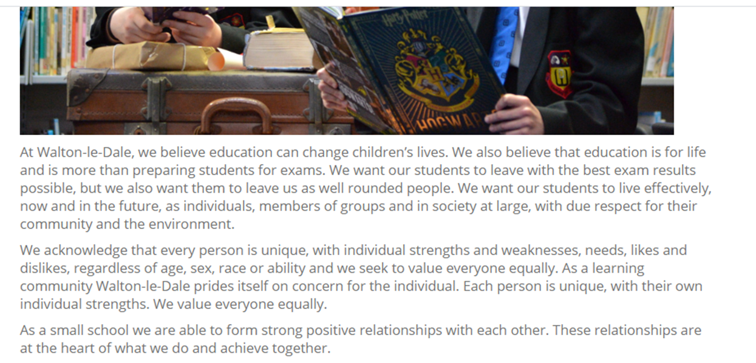

It needs to be noted that the context of our school has changed. We are broadly average for intake ability across all years, we have broadly the same number of boys as girls (12 more boys than girls currently), we are average for deprivation across England. We have higher numbers of students with Education and Health Care Plans (EHCPs), but not radically. Our student mobility is now in line with the rest of Lancashire and the national situation. That is significantly different from even a few years ago. What we do have is lots of students who need individual care - lots of families choose us because of our reputation for our focus on each individual child and most of our in-year transfers have struggled in other schools. This has meant that the school is full and that the Ofsted rating has not affected our intake. This however means that we face challenges when we increase the level of academic challenge, particularly in the context of high stakes examinations. The coursework and vocational approach to assessment was typically positive for our students as we could provide nurture and support.

The plan that followed the conference 18 months ago was based upon the following structure (8 sub plans overall) with a member of SLT responsible for each strand of the plan and each member of SLT linked to a governor. I attempted to create a framework that defined the operation of a great school. Simply put . . . .Students with a positive attitude to learning + brilliant teaching + appropriate support from school and home = great results.

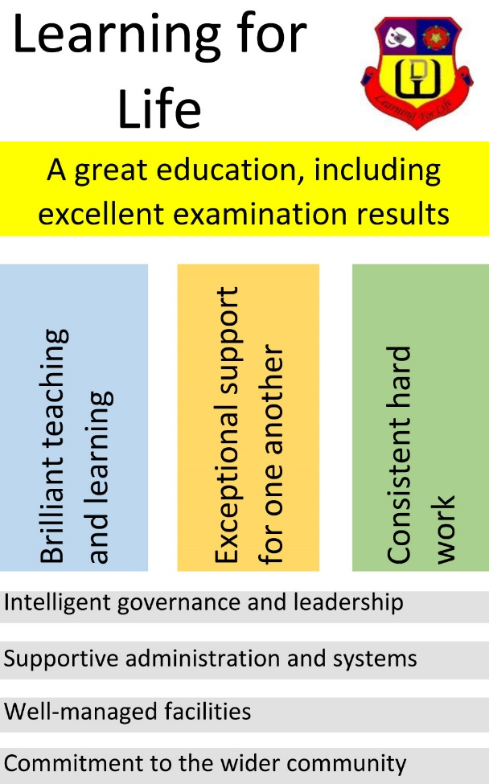

Each of the plans has been available online to all staff and governors and the link has been circulated via the staff bulletin each week. SLT have reviewed sections each week adding comments and actions

The focus over 2018-19 was clearly on developing consistently brilliant teaching and learning to address issues identified by Ofsted. Influential research by Professor Becky Francis of University College London clearly identified great teaching for all as being the most effective way of raising standards for disadvantaged students and a rigorous Pupil Premium review by Chris Morris, National Leader of Education and Head of Broughton High School, identified this as the necessary route forward. The "Brilliant teaching and learning" plan identified clear actions prioritising consistent and improving practice - development of the toolkit, approaches to feedback, improvements to the environment through new screens and visualisers and frequent CPD in various forms (e.g. top tips, “Pastries and Progress”, study groups, T&L bulletin...). Integrated into this has been the emphasis on the professional skill of setting high levels of challenge for all, and ensuring a focus on learning without losing our relationships with our young people. If anyone has missed the focus on T&L I am not sure what else we can do to make you aware….!

From the website… “Our current absolute top priorities are, firstly, to further improve teaching and learning across the school, thereby improving the academic results for all students and, secondly, to be consistent across everything that we do so that every student gets a great education.” https://www.waltonledale.lancs.sch.uk/about-us/school-improvement

The exceptional support plan is focusing on attendance which has been identified as a key issue - particularly the persistent absence of disadvantaged girls. The appointment of a Family Support Worker in the summer of 2019 is supporting the work of the attendance officer and the pastoral team and the figures are moving in the right direction. The School Improvement Conference in June 2018 identified a need to review the behaviour management and rewards policies and this became a focus from Sept 2019 with the appointment of a new Deputy Headteacher. This was further supported by the review work done by John Doyle, School Adviser, in June 2019, which identified the need for a common in-class behaviour policy across the school. Investigations with schools who had done well with boys also indicated that clear behaviour systems were key to their success. This has been introduced in Sept 2019, along with a pilot of Classcharts, and has been supported by the creation of a pastoral "hub" in November 2019. These are positive developments but the rate of change means that there is a need to spend the rest of the academic year embedding and refining the appropriate systems.

The consistent hard work plan has meant a focus on attitude to learning, independent work including homework and the further development of a resilient growth mindset. We know that those students who work hard do well. We all work hard - many of our students are not as aspirational for themselves or as hard working as we are. This is a complex challenge and depends upon all of us , along with the families and wider community to solve it. This links to the context of our school with a lot of students who need individual care and are not resilient for a wide variety of reasons.

The governance and leadership of the school has been significantly reviewed and altered - examples include a positive governance review, a restructure of SLT and the admin team, the removal of the faculty structure and a lot of work on consistency across middle leadership in the school including significant work with corresponding middle leaders at Broughton. This year is about embedding the changes.

The administration and management of our facilities has involved staying solvent - we are one of very few secondary schools operating within their in-year budget. We have invested a lot in the teaching and learning environment - screens and storage for example as well as spending money on solving particular problems around school e.g. accommodating examinations...

Our work with the wider community has necessarily been focused on maintaining our numbers with a lot of good liaison work with primary schools. We are full and the Ofsted report appears to have had no impact on our intake. We must not take our intake for granted, but we have been full in Year 7 for the last few years. Our inclusive ethos is a non-negotiable foundation of our school as recognised by our IQM Flagship status. Our pastoral support, SEND support and careers guidance provision are essential to our students' wider success. It is a tension that our intake of vulnerable students from many primary schools across a wide geographical area is a success in terms of intake and income, but works against the development of rigorous academic standards. It is a tension that we all tackle on a daily basis.

The impact of these positive developments have yet to be felt in the overall results although the 2019 results showed very clearly that we know what we are doing with the new specifications. It was clear that a small number of students on our roll, but who did not access their GCSE examinations for a variety of reasons, had a detrimental effect on our overall progress figures. We cannot blame the results on them alone though - on average we need each student to do half a grade better in each of our subjects than has been the case in previous years. This is absolutely possible and it is interesting to note that, upon close analysis it is clear that our gender and disadvantage gaps are not the issue - they are less than in many other places. Interestingly, if context is taken into account our students do as well as similar students in any other school. This is the single greatest challenge for us – keeping our student-focused, pastoral, inclusive ethos at the same time as ensuring a rigorous approach to the academic nature of the current GCSE curriculum.

A great education is more than GCSE results and we have developed our ASPIRE skills framework to explicitly develop and reward the characteristics that we want to see in all our young people.

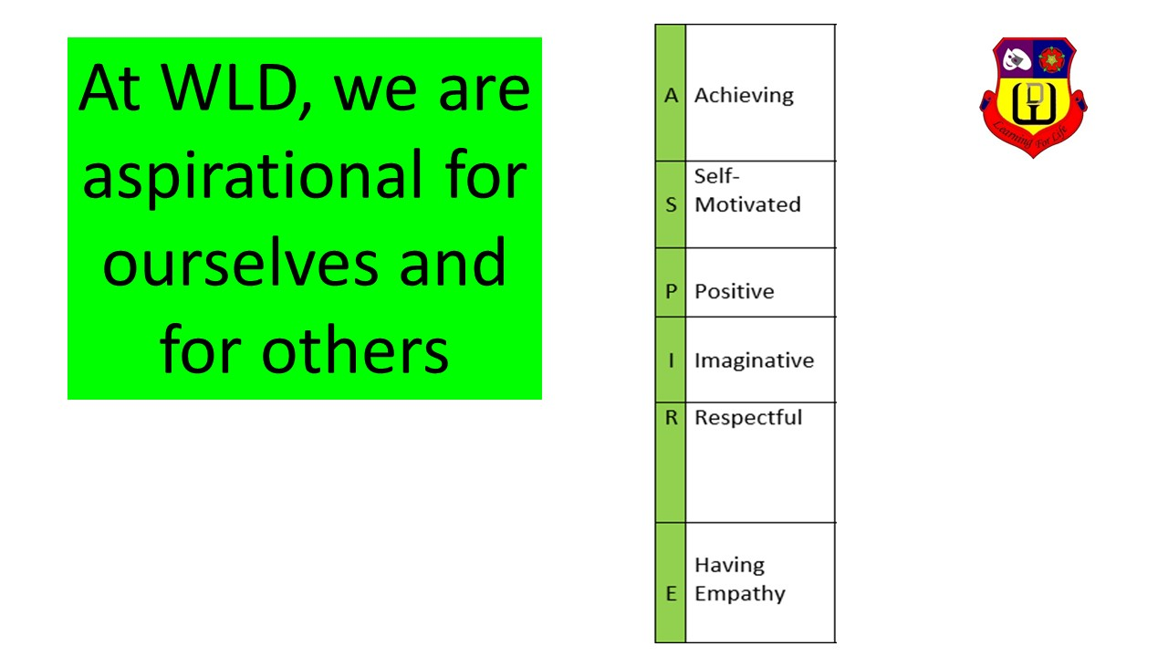

Consistency is important and that is why there was work on the staff handbook, the Basics@WLD and monitoring of the basic requirements of good teaching and learning. That only takes us so far. A great school is one where each individual is able to use and develop their skills within a supportive and challenging ethos - each of us seeking to collaborate and thrive as respected professionals. This applies to teachers and support staff alike. Part of that is being resilient and open to challenge and criticism seeing them as routes to improvement - hence I will continue to work with people who challenge us! September 2019 saw changes to the performance management focus with a clear focus on self-improvement through ongoing professional development - the responsibility of the individual professional to improve their own practice , taking advantage of opportunities provided. We have reduced data collection to a minimum, rationalised year 9 options and parents evenings, given departments control over homework and feedback policies, removed compulsory Monday meetings, consulted on changes as much as possible and tried generally to treat people as professionals with a balance of trust and accountability. We want WLD to be a genuinely good place to work. I cannot change the nature of what we do - young people are always interesting and variable and wet and windy Friday afternoons will always be challenging, but we need be a place where our commitment and hard work is recognised and we are trusted to do the excellent job that we all want to do.

We have done a lot in 18 months! There is a lot going a in each of the plans, for example embedding the toolkit by linking it the IQM project "Brilliant Teaching in an Inclusive Classroom", appointing 3 temporary TLRs for development of T&L practice, focusing our attention on student literacy, embedding new behaviour and reward systems, embedding ASPIRE and explicitly preparing for Ofsted...

I always urge us not to do things specifically for Ofsted but our lack of Good status is the biggest strategic threat facing the school. So we have to put effort into addressing the issue. Much of the new framework is a positive development - for example I think that the work that has been going on with our curriculum, tightening up on schemes etc... and thinking about why we teach what we do is a good thing to do anyway. We have evaluated ourselves against the new framework and that identifies the actions that we need to take to get to "Good". While Ofsted are keen to point out that there is much less focus on the raw numbers the single most important thing that we can do to address our Ofsted rating is to ensure good GCSE results by each individual student.

There are 2 aspects to our preparation - the actions that we take for improvement and the preparation for the inspection itself. As the new inspection framework is used more often we will get more information, but we know, more than anything, that all teachers will be expected to understand the curriculum that they teach also refer to teaching strategies. Each department has assessed itself against the Quality of Education judgement (that is the SEF) and has its own improvement plan. As a whole school we have done the same task and the summary is distributed with this document.

So, as we take time to reflect and plan let's be positive, aspirational and hopeful for ourselves, our school and our students. There is much to be positive about - in the end we believe that each child is an individual and that what we do has the potential to change their lives for the better....

