WLD Alumni
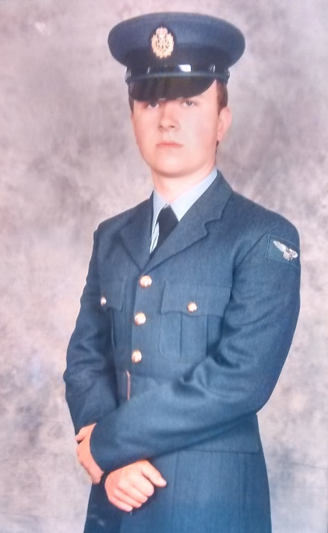
Lewis Potter – Class of 2018
Current Job Title – Weapons Technician Apprentice in the RAF
Career Plan –
‘Throughout high school I aspired to have a career in BAE alongside my mum but as an aircraft mechanic,…some time towards the end of year 11 I got through to the final interview stages of the application process and got turned down, this was disappointing as I always wanted to work with my mum from an early age… So after… my dad suggested for me to join the RAF, something that I was never physically fit enough for so I didn’t really consider it, however after thinking about it, it stuck with me and I was determined to get in shape. So I applied as a weapons technician and spent all summer 2019 getting in shape and by August I had passed all my interviews and tests and was given my start date …for my 10 week basic training at RAF Halton. And that brings us up to now, I’m currently awaiting my phase 2 training… at RAF Cosford.
Greatest Achievement/s – ‘Passing all my test to join the RAF especially the physical ones’
Advice to your teenage self – ‘One bad decision does not form your future self’

