KIDSLitFest 22nd May 2022

Whether you have keen or reluctant readers at home, the following free events hosted by the University of Central Lancashire may be the inspiration needed!
We are extremely lucky to have a book publishing company at UCLan University in Preston as they are all usually in London.
These kinds of events are great to springboard readers into new stories, meet authors and create exciting things in the workshops.

To make it easy, I have put the programme below with each link below with the blurb.

10 am – 2 pm Magical Story Jars and the Chief Story Makers (free drop in activity)

2 pm – 4 pm Create an Alien Storytelling Workshop (free drop in activity)

These below are with authors – they look amazing!!

- https://www.eventbrite.co.uk/e/kidslitfest-all-the-lols-tickets-295263379717
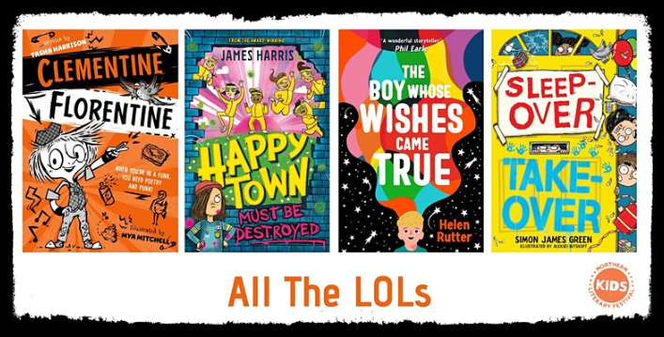
Join Simon James Green as he chats to Tasha Harrison, Helen Rutter and James Harris.
- 12 pm – 12:45 pm https://www.eventbrite.co.uk/e/kidslitfest-frank-cottrell-boyce-and-noah-tickets-294576364837 (followed by a signing).

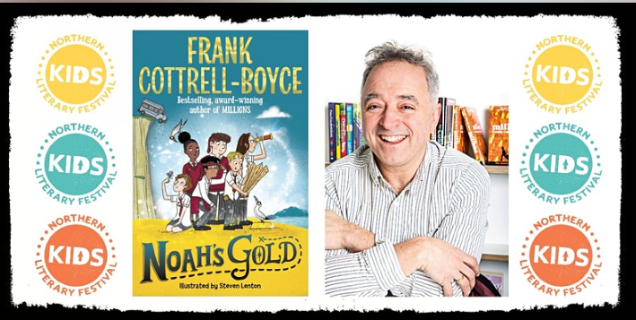

- 1 pm – 1:45 pm Adventure Awaits https://www.eventbrite.co.uk/e/kidslitfest-adventure-awaits-tickets-295291132727 Vashti Hardy, Annaliese Avery and Ross Welford, Chaired by Jasmine Richards). Followed by a signing.
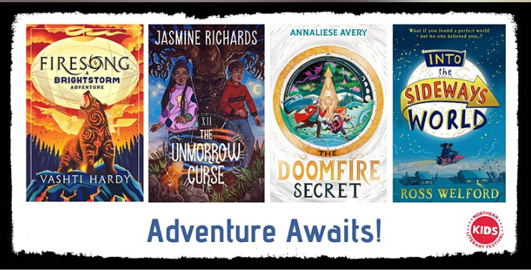
- 2 pm – 2:45 pm How Are You Feeling? https://www.eventbrite.co.uk/e/kidslitfest-how-are-you-feeling-tickets-295295034397 (Darren Simpson, Gabriela Houston chaired by Paul Jenkins). Followed by a signing.
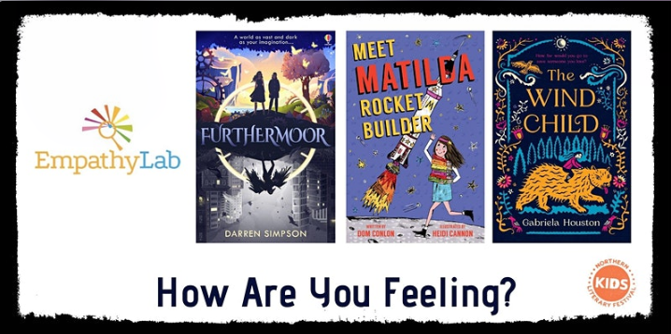
- 3pm – 3:45 Mystery and Mayhem https://www.eventbrite.co.uk/e/kidslitfest-mystery-and-mayhem-tickets-295302928007 (Jo Clarke, Susan Brownrigg and Anna James. Chaired by Katherine Woodfine). Followed by a signing.
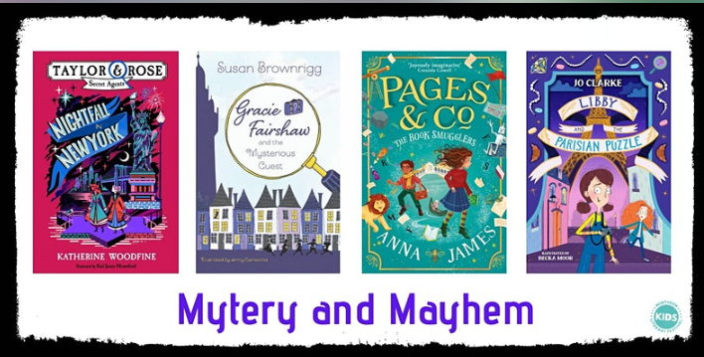
- 4 pm – 4:45 pm You Have the Power https://www.eventbrite.co.uk/e/kidslitfest-you-have-the-power-tickets-295347832317 (Tamsin Mori, Elle McNicoll and Ross MacKenzie. Chaired by Jennifer Claessen). Followed by a signing.
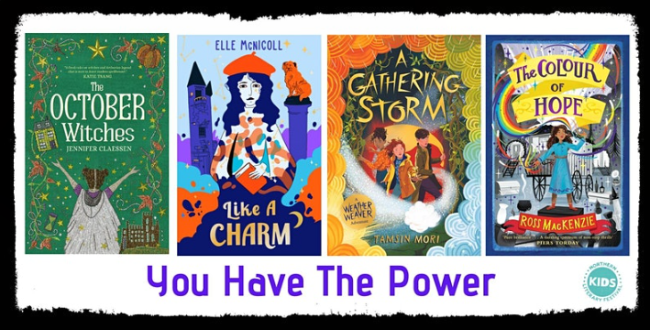
- 5:30 pm CLOSE
Hope you get booked on – please tell us how the event goes.
Miss Knowles - Librarian

