Reading: Part of the ASPIRE Ethos

Where are we now? The journey so far…
2017: the first Walton le Dale ‘Brilliant Teaching and Learning Toolkit’ came into being. This model provided a ‘front line’ view of what teachers deemed to be Brilliant Teaching and Learning strategies, each addressing the school’s core priorities; one of these priorities is Understanding and Memory, which of course, includes reading. Vocabulary instruction and reading widely and reading for pleasure were prioritised as focuses across school. WLD became a Lancashire ‘We Are Reading’ School, promoting wider reading through English lessons and in other subjects where possible. The other key literacy focus is ‘oracy: structured group talk’. In 2021-22, ’scaffolding extended writing’ will be prioritised.
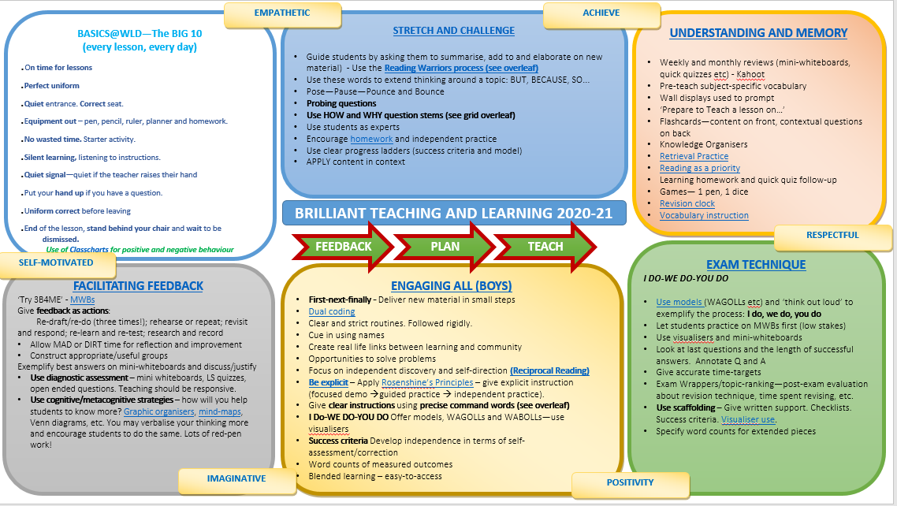

Form time reading was encouraged for one form period per week. Each form room had a book box, created by the school librarian. Students were, however, encouraged, to bring their own books to school.

Each year, the school and the library fund the Book Buzz initiative to allow each Year 7 student to be ‘gifted’ a brand new book by a highly-acclaimed children’s author. These books are then read in English (and other subjects) and ‘book swaps’ have been organised to allow students to read further titles.

2018-19: three members of staff help Teaching and Learning Responsibility (TLRs) for aspects of these priorities: vocabulary and structured talk. All staff delivered CPD and offered resources to support implementation (i.e. Frayer Model and Kagan strategies). The Frayer Model for vocabulary teaching was launched and implemented across many departments. The generic template is also part of the Walton le Dale planning PowerPoint template. Bespoke teacher planners were also created to incorporate the Academic Word Lists (AWL) and also to prompt staff to list vocabulary for instruction within each lesson.
Also in this year, classrooms were equipped with desktop computers, larger BENQ screens and visualisers to allow teachers use hardware to scaffold writing with ease. All classrooms now have this equipment and it is being used effectively following CPD sessions and materials to embed. During this period, mini-whiteboards were also used widely to encourage an inclusive approach built on an ethos promoting achievement for all.

Autumn 2019: In Autumn 2019, the Teaching and Learning Policy: Feedback-Plan-Teach was created. It is underpinned by core evidence such as the EEF’s report ‘Improving Literacy in Secondary Schools’, Barak Rosenshine’s ‘Principles of Instruction’, Alex Quigley’s ‘The Vocabulary Gap’ and David Didau’s ‘The Secret of Literacy’. This draft policy was put out to consultation with staff during the autumn term; it then became policy in January 2020.
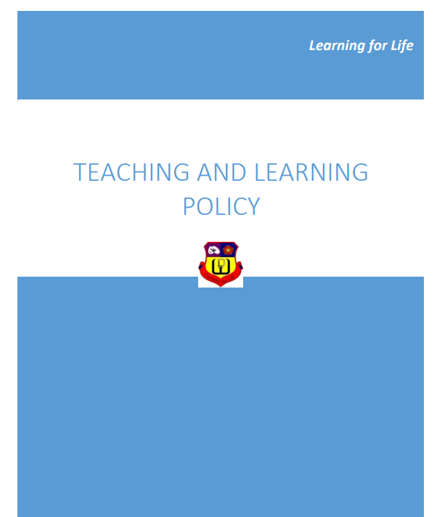
Clearly, an effective CPD programme needed to work alongside this policy to ensure that its implementation was effective and comprehensive. The CPD model for the year was centred upon the recommendations of the ‘Improving Literacy in Secondary Schools’ report, namely:
- Provide targeted vocabulary instruction in every subject (READING)
- Develop students’ ability to read complex academic texts (READING)
- Break down complex writing tasks (WRITING)
- Provide opportunities for structured talk (ORACY)
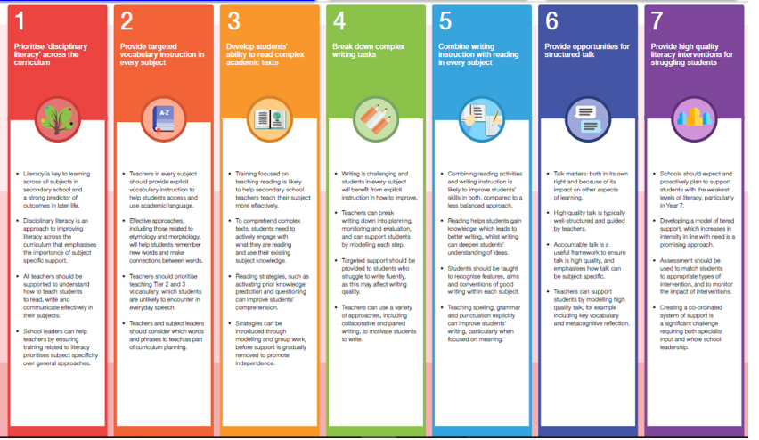
As part of a structured form time provision, the Word of the Week (WoW) was publicised each week and then picked up in English lessons (and other areas if appropriate). As well as this, all students in Year 7 are expected to carry a reading book with them at all times, to encourage them to make use of any free time to read (preferably fiction).

Autumn 2019: As part of the reading focus within the Feedback-Plan-Teach T&L Policy, Reciprocal Reading (under the WLD name of Reading Warriors) was introduced to staff and launched at a Pastries and Progress CPD event.
In this year, reading and WoW was removed from the form timetable to allow for prioritisation of well-being and attendance.

January 2020: As a follow-up CPD session, a member of the English department modelled this approach with one of his classes. Unfortunately, the C-19 pandemic struck and this was put on hold. T&L and CPD focuses turned to remote learning and IT platforms (Teams, Classcharts etc) to ensure effective blended learning.

September 2020: As school reopened, reading was put back on the CPD calendar as the focus for the first term initially. Strategies were offered through Top Tips in Two Minutes and also through the weekly Teaching and Learning Digest (published as a blog on the website here).
  - 28/9/20 – Reciprocal Reading
  - 5/10/20 – Reciprocal Reading and vocabulary
  - 12/10/20 – Questioning techniques to ensure understanding of written texts
  - 19/10/20 – Say It Again Better – encouraging more sophisticated vocabulary
  - 9/11/20 – EEF Reading Comprehension strategies
  - 16/11/20 – Reciprocal Reading and the Frayer Model
  - 23/11/20 – writing learning objectives to enhance reading skills
  - 30/11/20 – Reading Warriors (WLD’s version of Reciprocal Reading linked to Bloom’s Taxonomy
  - 15/12/20 – Reciprocal Reading (Reading Warriors) – ACH’s approach to embedding
Mini-whiteboards, whilst still being used, were not a central focus due to C-19 risk assessments; they were used when possible and useful. Visualisers continue to be embedded across the curriculum and are a key element in some remote learning lessons.
December 2020 - ACH provided INSET to middle leaders to provide them with a ‘quick win’ resource to aid them in implementing Reciprocal Reading within their departments in the spring term.
Unfortunately, lockdown came again and activity on this was halted to allow departments to embed their teaching approaches for remote learning to ensure that student engagement was optimised.
Lockdown Literacy
- During both national lockdowns, Walton Reads one-to-one reading programmes has been offered to small cohorts of students (approximately 8) with varying degrees of success due to student buy-in. Students are invited to read, via Teams, a book with a volunteer staff member each day for 15 minutes.
- Over lockdown #1 the school established a School Newspaper: The Walton Times. This has been coordinated remotely and there are plans to release a new edition each term.
- The Gift of Reading – over 40 reading books have been posted home to allow some students to continue reading, even whilst they are not in school.
- Library visits – carefully coordinated library visits have been arranged for KWV students.
- ASPIRE wider reading homework – set for all students for Classcharts rewards
- Reading groups – a history reading group has been established. The school’s Librarian also leads, remotely, a reading Team. They offer book reviews that are published on the website. This group also participates in the Lancashire Book of the Year award.
- Parents/Carers are kept up-to-date with library links/audio book links over lockdown through the Headteacher’s and Librarian updates.
- Bedrock Learning – as part of catch-up strategy, the school has invested in every student by securing a Bedrock account for them for the next three years. Students will spend at least one English lesson (during national lockdown) and/or homework completing these online lessons to improve their vocabulary knowledge. This is a tried and tested platform which has previously been successful with Year 8 students.

Looking Ahead
- Over the first half-term of 2021, CPD has had to shift its focus towards IT platforms to ensure high quality provision for all students during this period of digital learning.
- After February half-term, the focus will shift back towards reading widely and reading for pleasure and this will remain the focus until the end of the year.
- By the end of the year, we hope to have embedded two major initiatives: Bedrock (for building vocabulary) and Reading Warriors (WLD’s approach to Reciprocal Reading). We envisage that both of these initiatives will allow students to become strong independent readers.
- The English Department, in partnership with the school library, are purchasing an e-library resources called e-Platform. Students will be able to loan audio and e-text versions of a range of books.
- We also hope to build the reading ethos of the school by continuing to develop interdisciplinary literacy approaches to encourage students to ‘read like an artist’ or ‘read like a historian’. Part of this approach will involve a continuation of the work around development of wider reading lists to complement students’ understanding of a topic. These lists are a work in progress and are stored here.

