Topic: Map skills

Books available for loan through our school library:

Title | Author | Medium | Where | Description | Image | Dewey/Classification
Maps and Globes | Crewe, S | Book | Library | Introduction to the concepts of human and physical geography which examines how people have influenced their environment and how human lives have been shaped by their natural surroundings. | 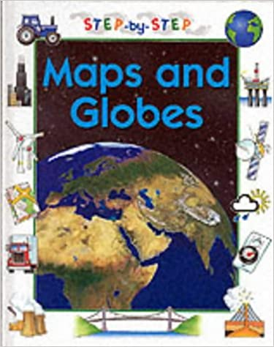 | 912
Collins-Longman Student Atlas | n/a | Book | Library | A revised and updated edition of an atlas, suitable for National Curriculum requirements for Key Stage 3 and 4, working towards GCSE. | 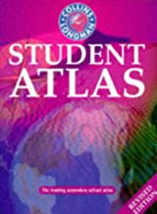 | 912
Pocket World Atlas | n/a | Book | Library | Information about area, population, capital cities, annual income, currencies and national governments. | 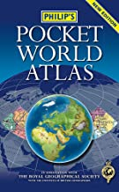 | 912
Maps and Mapping | Chancellor, Deborah | Book | Library | Learn how maps work and how to make your own simple maps of the world around you. | 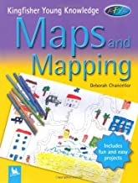 | 912
Geography: Mapping Skills | Green, Mary | Book | Library | Detailed info on looking at different angles, plans, symbols and keys, base plans, locations, routes, directions and grid squares, scale, heights and contours, The British Isles & World. | 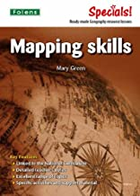 | 912.014
The Eco Atlas | Anthony Mason | Book | Library | The Earth is constantly changing, both by forces of nature and by forces of humankind. Use this atlas to find where and how the planet is being damage and what you can do to help. | No image avail. | 912
Foundation Atlas | Collins/longman | Book | Library | An atlas which is suitable for National Curriculum Key Stage 3. With maps, satellite images with supporting maps, data and statistics from international sources, and a focus on the mapping of contrasting regions. | 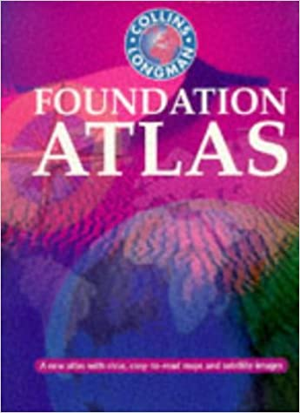 | 912 Ref. Only.  This means you can read it only in the library or ask for Library Assist. To Scan 5% of book
Lancashire Street A-Z Atlas | Various | Book | Library | Accrington to Southport | 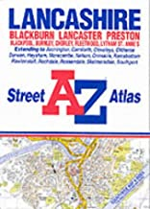 | 912
Atlas of the World | McNally Rand | Book | Library | Maps, photographs, illustrations, and text present information about the countries of the world, arranged by continents. | 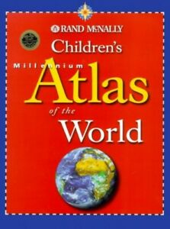 | 912
Collins School Atlas | Harper Collins Publishers | Book | Library | Introductory atlas for secondary schools, perfectly designed to support and motivate students in geographical and mapping skills. An easy to follow introductory 'map and atlas skills' section | 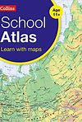
Philip's Children's Atlas | Wright, D and Wright, J. | Book | Library | Maps, illustrations, info on major countries of the worlds, intro to our planet Earth and features, special section on understanding maps.  Quiz, activities and puzzles. | 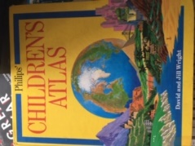
GCSE Geography | Parsons, Richard | Book | Library | See section 14 – Maps, Graphs & Charts. This book is full of clear revision notes, detailed diagrams and practice exam questions for GCSE Geography students | 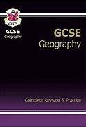 | 371.3
Oxford School Atlas | Wiegand, Patrick | Book | Library | Country data, earthquakes volcanoes, climate, economic activity, British Isles, Italy – Antarctica – tsunami/hurricane. | 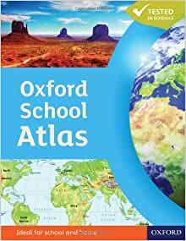 | 912

Other web resources:

Magic - INTERACTIVE MAPPING AT YOUR FINGERTIPS
https://magic.defra.gov.uk/

Website

Lancashire County Council

MARIO (Maps & Related Information Online) – Lancashire County Council’s interactive mapping website.

You can layer old and new maps and photographs over each other. Change the translucency to see the overlaps. See if you can find Walton-le-Dale High School and what was there in 1950s or earlier?

http://mario.lancashire.gov.uk/agsmario/

http://mario.lancashire.gov.uk/agsmario/default.aspx

Follow this link then login your Library Borrow Number - https://www.lancashire.gov.uk/libraries-and-archives/libraries/digital-library/?page=9
Maps and More
https://www.worldbookonline.com/kids/home#mapsmore

Royal Society of Geography

https://www.rgs.org/schools/teaching-resources/

BBC – Education

This series introduces the satnav and online maps generation to the traditional skills of reading detailed paper maps.

Videos

https://www.bbc.co.uk/bitesize/guides/z3jbdmn/revision/1

https://www.bbc.co.uk/teach/class-clips-video/gcse-geography-get-lost/z4sxgwx

https://www.bbc.co.uk/teach/class-clips-video/geography-gcse-national-5-what-is-geocaching/z4cb47h

https://www.bbc.co.uk/teach/class-clips-video/geography-gcse--national-5-map-reading-challenge-in-the-hills/zvvs382

https://www.bbc.co.uk/teach/class-clips-video/geography-gcse-national-5-map-reading-challenge-on-the-yorkshire-coast/zhhxpg8

https://www.bbc.co.uk/teach/class-clips-video/geography-gcse--national-5-map-reading-challenge-on-the-moors/zdd9wty

https://www.bbc.co.uk/teach/class-clips-video/geography-gcse--national-5-what-are-public-rights-of-way/zm2jmfr

https://www.bbc.co.uk/teach/class-clips-video/geography-gcse--national-5-understanding-contour-lines-and-gradients/zbvs382

https://www.bbc.co.uk/teach/class-clips-video/geography-gcse--national-5-using-maps-to-work-out-distance/zjd9wty

https://www.bbc.co.uk/teach/class-clips-video/geography-gcse--national-5-understanding-map-co-ordinates/znhxpg8

