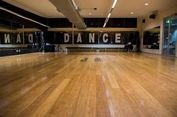
WLD Alumni
Nicole Adrienne Oram – Class of 2010
Current Job Title –
Fee Earner (Claims Handler) and Dance Instructor
Career Plan –
‘I did everything I planned to do in high school!’
Greatest Achievement/s –
‘Becoming a claims handler and qualified dance teacher and hosting my own charity event’
Advice to your teenage Self –
‘Never give up, always aim higher than you think you’re capable of and trust yourself’

